

Logic Builder Guide
EPMware ®

EPMware, Inc.
Updated: September 2025

Information in this document, including URL and other Internet Web site references, is subject to change without notice. Unless otherwise noted, the example companies, organizations, products, domain names, e-mail addresses, logos, people, places, and events depicted herein are fictitious, and no association with any real company, organization, product, domain name, e-mail address, logo, person, place, or event is intended or should be inferred. Complying with all applicable copyright laws is the responsibility of the user. Without limiting the rights under copyright, no part of this document may be reproduced, stored in or introduced into a retrieval system, or transmitted in any form or by any means (electronic, mechanical, photocopying, recording, or otherwise), or for any purpose, without the express written permission of EPMware Inc. EPMware, Inc. may have patents, patent applications, trademarks, copyrights, or other intellectual property rights covering subject matter in this document. Except as expressly provided in any written license agreement from EPMware, Inc., the furnishing of this document does not give you any license to these patents, trademarks, copyrights, or other intellectual property.

© 2025 EPMware, Inc. All rights reserved. www.epmware.com | 408-614-0442
EPMware is a registered trademark of EPMware, Inc. in the United States and/or other countries.
All other trademarks are the property of their respective owners.

Contents
 1
Introduction 7
Security Provisioning for Logic Builder Module 7
Create Logic Builder Scripts 8
Logic Builder Script Types 8
Logic Script Associations 9
Logic Script Usage Report 10
Logic Builder Script Body 11
Logic Script Structure 12
Validate Logic Scripts 12
Logic Script Type Assignments 13
Debug and logging and Exceptions Handling 14
Debug Message Retrieval 16
Input Parameters 17
Output Parameters 17
Common Parameters 19
Logic Script Events 20
Dimension Mapping 20
Overview 20
Input Parameters 21
Output Parameters 23
Example 31
Property Mapping 36
Overview 36
Input Parameters 37
Output Parameters 39
Example 39
Property Derivations 41
Overview 41
Input Parameters 42
Output Parameters 43
Example 44
Property Validations 46
Overview 46
Input Parameters 47
Output Parameters 48
Example 49
Standard Property Validations 50
Pre-Hierarchy Actions 51
Overview 51
Input Parameters 52
Output Parameters 53
Example 53
Seeded Script : EW_SHARED_NODE_POSITION 57
Post Hierarchy Actions 57
Overview 57
Input Parameters 58
Output Parameters 59
Example 60
Seeded Script : EW_HFM_ENT_SEC_CLASS_AUTOMATION 63
Deployment Pre/Post Tasks 63
Overview 64
Input Parameters 64
Output Parameters 65
Example 65
ERP Interface Tasks 67
Overview 67
Input Parameters 68
Output Parameters 68
Example 69
On Submit Workflow Task 73
Overview 73
Input Parameters 74
Output Parameters 74
Example 75
Workflow Custom Task 78
Overview 78
Input Parameters 79
Output Parameters 80
Example 80
Pre/Post Export Tasks 82
Overview 82
Input Parameters 83
Output Parameters 83
Example 84
On Request Line Approval 85
Overview 85
Input Parameters 86
Output Parameters 86
Example 86
Logic Builder API Library 90
Database Views 90
EW_APPS_V 90
EW_APP_DIMENSIONS_V 90
EW_REQUEST_LINE_MEMBERS_V 91
EW_MEMBERS_V 92
EW_HIERARCHY_MEMBERS_V 93
EW_LOOKUP_CODES_V 94
Record types 94
EW_LB_API.G_WF_TASK_REC 94
Database Package APIs 95
In Memory Functions 95
Email APIs 98
Request API Functions 99
Hierarchy API Functions 125
Hierarchy Statistics API Functions 148
Application API Functions 152
Workflow API Functions 153
String API Functions 154
Lookup Functions 158
Security API Functions 160
Export API Functions 164
Agent API Functions 164
Appendix A 172
Request Line Action Codes 172
Appendix B - Out of the box Logic Scripts 173
Standard Validation Scripts 173
Standard Property Validations 173
Pre-Hierarchy Action Logic Scripts 174
Post-Hierarchy Action Logic Scripts 176
Appendix C - ERP Import table EW_IF_LINES 178

Introduction
The Logic Builder Module allows users to build custom logic in various modules within EPMware to provide solutions for custom requirements such as custom property validations, execute custom tasks in a workflow etc.

The Logic Builder utilizes Oracle PL/SQL as a programming language and the scripts reside within the EPMware database. You can develop stored database functions and refer to them in the Logic Scripts, but this option is available for On Prem Customers only. This method allows you to not expose Logic Scripts in the front-end.

All Logic Scripts are assigned to their respective configurations. For example, if the Logic Script type is “Dimension Mapping” then when referred to in the dimension mapping configuration screen it will get executed. In other words, the Logic Script execution is a two step process. First, create a Logic Script in the Logic Script module and second refer to it in its related configuration page. The Logic Scripts get executed when an event occurs that refers to the Logic Script. For example, a dimension mapping script will be executed when a new line is created in a request if the dimension mapping rule exists in the source dimension.

Security Provisioning for Logic Builder Module
Use the sidebar option Configuration -> Security -> Security Provisioning screen to enable the Logic Builder to the appropriate security group so that users of that group can create or update Logic Scripts.

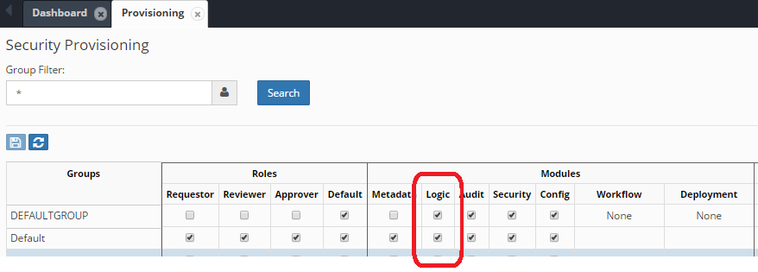

Create Logic Builder Scripts
In the scripts menu, click on the + sign () to create a new Logic Script. To edit existing scripts, use the right click menu and select “Edit Properties”. The popup will allow configuration of the following items.

- Script Name: Enter the name of the script. This must be unique among all script types and can be up to 50 characters long. All EPMware out of the box Logic Scripts will have a prefix of “EW_”. Please use a common prefix for all your custom Logic Scripts.
- Description: This is an optional field. Enter the description of the Logic Script.
- Script Type: Select one of the script types from the drop down list. See table below for script type and its purpose.
- DB Function Name: This is an optional field. You can specify a standalone stored Oracle Procedure name OR stored packaged procedure name here. If this field is populated, then the Script Editor gets disabled for this record. This option is available for On Prem Customers only. For All Cloud customers this option should not be used.
- Enabled: This checkbox enables or disables this script. If the script is disabled then it will not be executed..

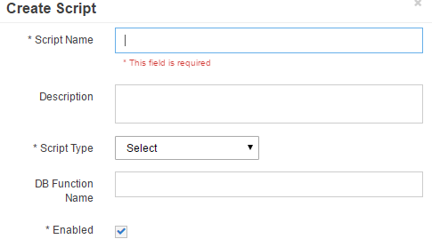

Logic Builder Script Types

The following table describes Logic Script Types and where they can be used.

# | Script Type | Purpose
1 | Dimension Mapping | Synchronize hierarchies across applications.
2 | Property Mapping | Synchronize property values across applications using custom logic mapped nodes
3 | Pre Hierarchy Actions | Execute custom logic before a specific hierarchy action is performed on a member, such as Create Member.
4 | Post Hierarchy Actions | Execute custom logic after a specific hierarchy action is performed on a member, such as Create Member.
5 | Property Derivations | Derive Property Values
6 | Property Validations | Validate Property Values
7 | On Submit Workflow | Execute the script whenever a request is submitted to the workflow. If the Logic Script returns with the Error status, then the request will not be submitted into the workflow and all error messages returned by the script will be shown to the requestor.
8 | Pre Request Line Approval | Execute the script before the user approves a request line OR performs Mass Approval on a request.
9 | Workflow Custom Task | Used to perform custom tasks in workflow (custom type of task)
10 | Deployment Tasks | Used in Pre and Post Deployment Tasks
11 | ERP Interface Tasks | Used in Pre and Post ERP Import execution tasks
12 | Pre Export Generation Tasks | Execute custom script before Export module generates file
13 | Post Export Generation Tasks | Execute custom script after Export module generates file

Logic Script Associations

The following table describes Logic Script Types and its corresponding configurations required before they can be executed..

# | Script Type | Associated Configuration Menu | Field
1 | Dimension Mapping | Configuration -> Dimension -> Mapping | Mapping Option
2 | Property Mapping | Configuration -> Property -> Mapping | Mapping Option
3 | Pre Hierarchy Actions | Configuration -> Dimension -> Hierarchy Actions | Pre Action Script Name
4 | Post Hierarchy Actions | Configuration -> Dimension -> Hierarchy Actions | Post Action Script Name
5 | Property Derivations | Configuration -> Property -> Derivations | Script Name
6 | Property Validations | Configuration -> Property -> Validations | Script Name
7 | On Submit Workflow | Workflow -> Builder | On Submit Logic Script
8 | Pre Request Line Approval | Workflow -> Tasks | Validation Script
9 | Workflow Custom Task | Workflow -> Tasks | Custom Function
10 | Deployment Tasks | Deployment Configuration | Pre (Post) Deployment Script
11 | ERP Interface Tasks | ERP Import -> Builder | Pre (Post) Execution Script
12 | Pre Export Generation Tasks | Administration -> Export | Pre Export Logic Script
13 | Post Export Generation Tasks | Administration -> Export | Post Export Logic Script

Logic Script Usage Report

A standard report is available to view all Logic Scripts configured and where it is applied in the application under the Audit module. Below is an example on how to run this report.

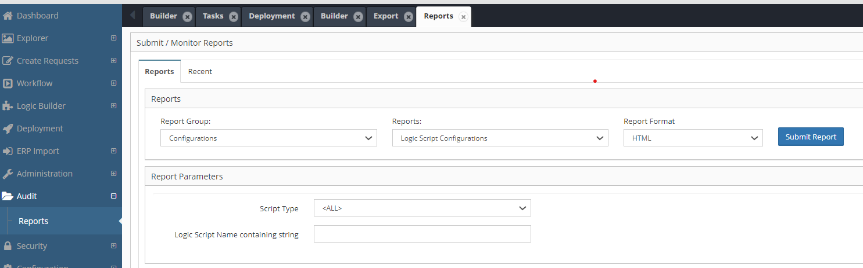

Sample Report output is as shown below.

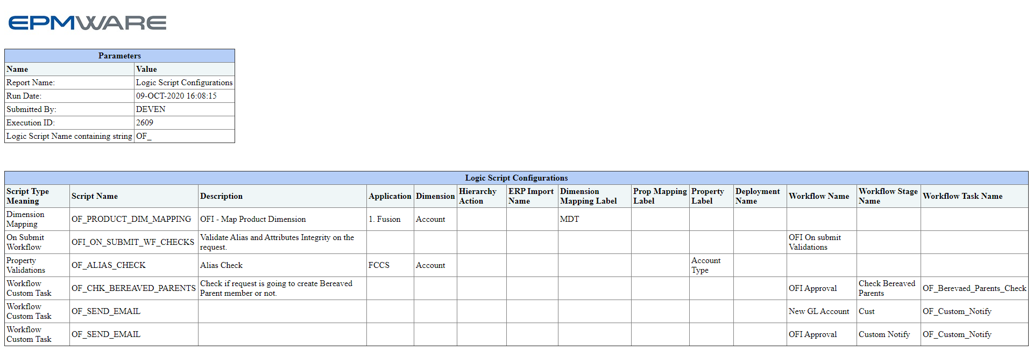

Logic Builder Script Body
Logic Builder Scripts can be created in one of two ways. One option is to create a stored database procedure (or packaged procedure) and refer to it in the script record in the DB Function name field. This option is only available for the On-Premise version of EPMWARE. The second option is to write the script in the script editor as shown below.
Note: For all cloud applications, the Stored DB Function option is not available.

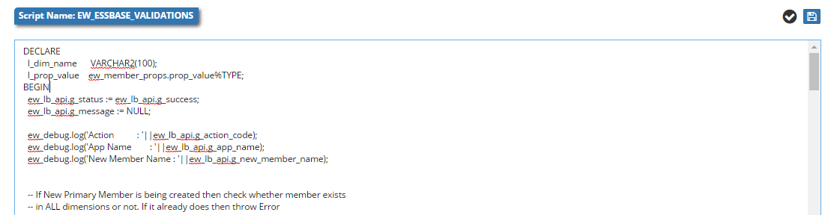

Logic Script Structure

Logic Scripts are based on the Oracle PL/SQL language. EPMWARE has provided a rich library of APIs that can help reduce script size significantly and also provide solutions to many complex requirements. Please refer to the Appendix in this document for a list of all APIs.

Depending on the Logic Script Type, various input parameters will be provided using global variables declared in the EW_LB_API package, such as.g_member_name, g_acton_code,g_app_name etc.. Please refer to Appendix A for a full list of all Input variables that can be leveraged in your Logic Script. Note: Not all input variables are required to be set, depending on when the event (or Logic Script type) is being invoked.

Every Logic Script must provide expected Output parameters apart from a status and message. If these values are not set by the Logic Script, then the default values (Success code “S” for the status and NULL or blank message for Message parameters) will be passed to the Logic Script engine.

Validate Logic Scripts

Clicking the “Save” icon automatically validates the script for any syntax errors. Business logic will still need to be tested by performing transactions in the application where the relevant Logic Script is applied. For example, if the Logic Script type is “Property Validation”, then testing this script requires the property of the member to be changed to trigger the validation error based on the script logic.

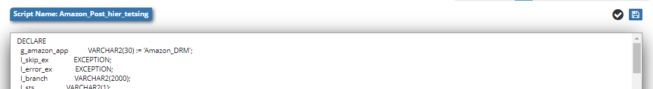

Logic Script Type Assignments

Once scripts are created in the Logic Builder Module, they must be assigned to relevant events (except for Pre Request Line approvals). Until a Logic Script is assigned, it will not be executed by the EPMware rules engine.

For example, a custom Logic Script is created to validate member names as shown below.

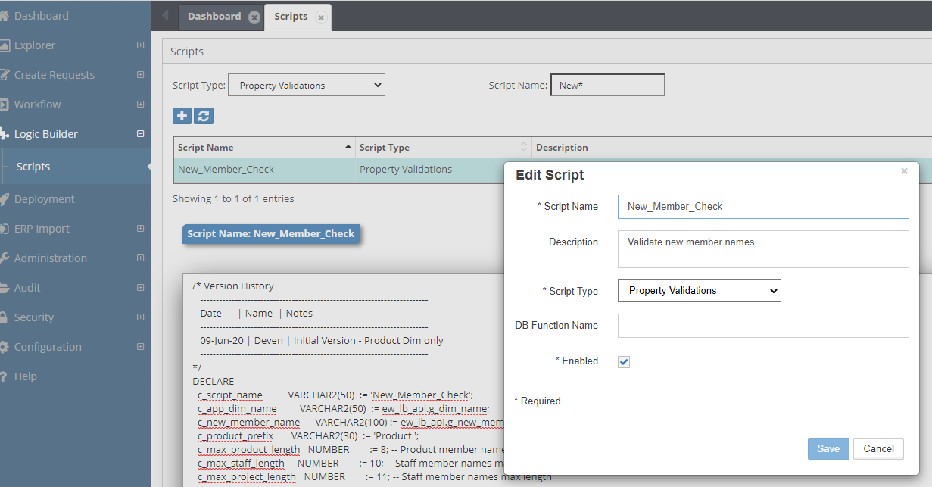

This script needs to be assigned to the Member Name under Configuration -> Property Validation screen as shown below.

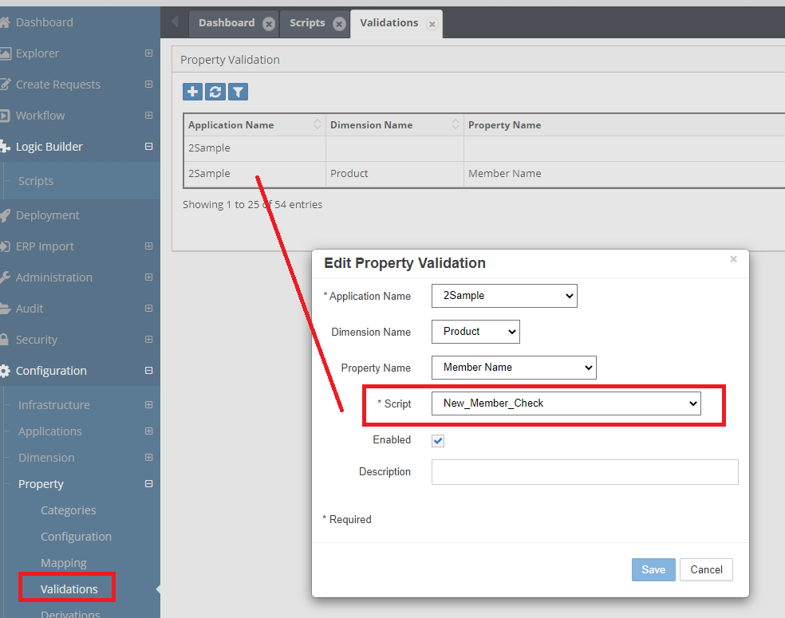

Debug and logging and Exceptions Handling

It is highly recommended to use the “EW_DEBUG.LOG” procedure to record debug messages in the centralized debug table. (Debug messages can also be downloaded from the Admin report “Debug messages”).

In this example, a default value is assigned to a member alias when a new member is created. The following Logic Script illustrates how to register debug messages.
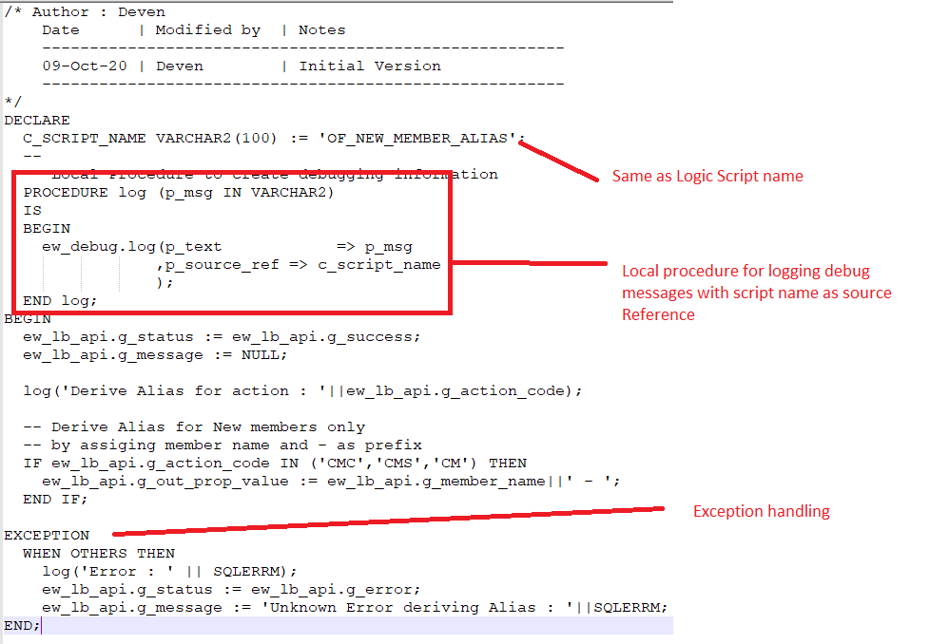

Script Text

/* Author : Deven
Date | Modified by | Notes
-------------------------------------------------------
09-Oct-20 | Deven | Initial Version
-------------------------------------------------------
*/
DECLARE
C_SCRIPT_NAME VARCHAR2(100) := 'OF_NEW_MEMBER_ALIAS';
--
-- Local Procedure to create debugging information
PROCEDURE log (p_msg IN VARCHAR2)
IS
BEGIN
ew_debug.log(p_text => p_msg
,p_source_ref => c_script_name
);
END log;
BEGIN
ew_lb_api.g_status := ew_lb_api.g_success;
ew_lb_api.g_message := NULL;

log('Derive Alias for action : '||ew_lb_api.g_action_code);

-- Derive Alias for New members only
-- by assigning member name and - as prefix
IF ew_lb_api.g_action_code IN ('CMC','CMS','CM') THEN
ew_lb_api.g_out_prop_value := ew_lb_api.g_member_name||' - ';
END IF;

EXCEPTION
WHEN OTHERS THEN
log('Error : ' || SQLERRM);
ew_lb_api.g_status := ew_lb_api.g_error;
ew_lb_api.g_message := 'Exception : '||SQLERRM;
END;

Debug Message Retrieval

Once debug messages have been tagged using script names as a reference (OF_NEW_MEMBER_ALIAS), running the Debug Messages report will provide debug messages specifically from the script as shown below.

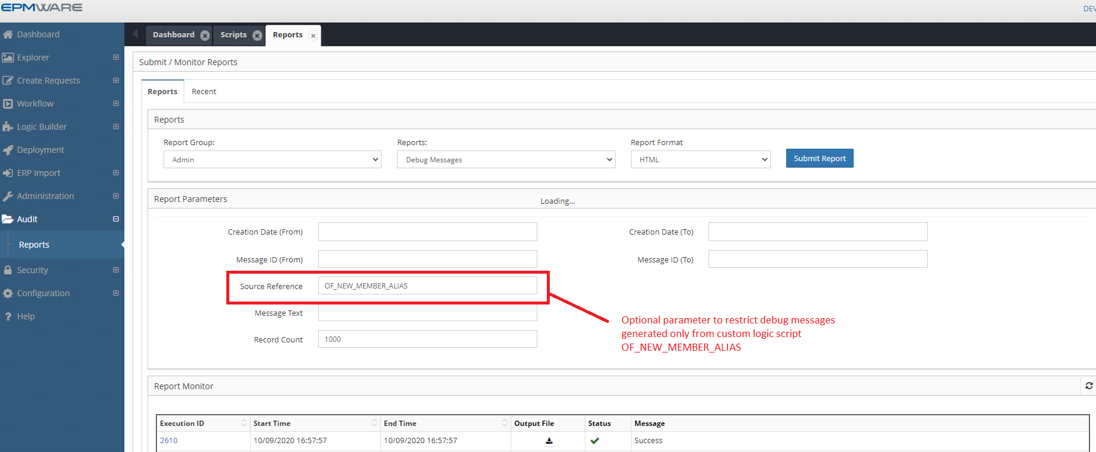

Note: Source Reference is for an optional parameter to restrict the debug messages generated from the custom Logic Script, OF_NEW_MEMBER_ALIAS

Input Parameters

Depending on the Logic Script type, various input parameters may have values assigned. Please refer to Appendix A for a full list of all Input variables that can be accessed by the custom Logic Scripts. All Input Parameters are declared in the Package EW_LB_API.

For example, if the Logic Script type is “Property Validation” then it may be relevant to know the value entered by the user, its member name, and the parent member name, so that the complex validation can be completed.

Depending on the script type, input parameters will be automatically populated into the global variables of the EW_LB_API package. In addition to this, various APIs can be leveraged to fetch metadata information to build custom Logic Scripts. For example, to know whether a member is a base member OR belongs to a specific branch within the dimension or not. Refer to Appendix C for more information.

Refer to Appendix A for Input/output parameters for every Logic Script type.

Output Parameters

Depending on the Logic Script type, various output parameters can be populated that can help determine the outcome of the transaction. All Output Parameters are declared in the Package EW_LB_API. Some of the output parameters are optional and some are mandatory. If mandatory parameters are not populated, then it can throw errors or provide unexpected results. For example, if the Logic script type is Property Derivation and it is assigned to the Member Name property of the dimension, then it is expected that the “g_out_new_member_name” output parameter will be populated with a value else the request action will fail.

Example

Requirement: Whenever a new member is created, Assign member name with a dash character in its alias. Users will then assign text at the end later on..

To achieve this automation, we will use the “Property Derivation” Logic Script.

/* Author : Deven
Date | Modified by | Notes
-------------------------------------------------------
09-Oct-20 | Deven | Initial Version
-------------------------------------------------------
*/
DECLARE
C_SCRIPT_NAME VARCHAR2(100) := 'OF_NEW_MEMBER_ALIAS';
--
-- Local Procedure to create debugging information
PROCEDURE log (p_msg IN VARCHAR2)
IS
BEGIN
ew_debug.log(p_text => p_msg
,p_source_ref => c_script_name
);
END log;
BEGIN
ew_lb_api.g_status := ew_lb_api.g_success;
ew_lb_api.g_message := NULL;

log('Derive Alias for member : '||ew_lb_api.g_member_name);

-- If the member already has alias assigned then
-- no need to derive the alias. Otherwise assign default alias
IF ew_lb_api.g_prop_value IS NULL
THEN
ew_lb_api.g_out_prop_value := ew_lb_api.g_member_name||' - ';
ELSE
ew_lb_api.g_out_prop_value := ew_lb_api.g_prop_value;
END IF;

EXCEPTION
WHEN OTHERS THEN
log('Error : ' || SQLERRM);
ew_lb_api.g_status := ew_lb_api.g_error;
ew_lb_api.g_message := 'Unknown Error deriving Alias : '||SQLERRM;
END;

Assign this Logic Script to the Property Derivation configuration as shown below.

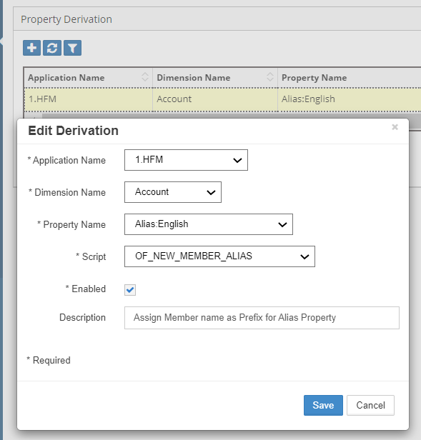

Common Parameters

The following Parameters are common across all Logic Script Types.

Output Parameter | Description
g_status | Status Values are either ‘S’ for Success or ‘E’ for Error.  Alternatively use the following method to set values in your code.  ew_lb_api.g_status := ew_lb_api.g_success  OR  ew_lb_api.g_status := ew_lb_api.g_error
g_message | Pass an Error Message if the status is Error.
g_out_ignore_flag | Y or N to indicate whether action needs to be ignored in the mapped dimension or not. Default value is N.

Logic Script Events
Events in EPMware are actions performed by a user or by a scheduled process in various modules. These interactions may need a Logic Script to execute specific transformations either prior to or after the event is run. The following section will provide details on where Logic Scripts are associated for all Logic Script event types.

Dimension Mapping

Overview

Dimension mapping Logic Scripts are used to map nodes between two or more applications. Whenever an action is performed on the source application such as Create Member, Rename Member or Edit Properties, the corresponding action will be performed on the mapped application.

There are the three options for dimension mappings:
- Sync
- Smart Sync
- Dimension Mapping Logic Script

“Sync” and “Smart Sync” options do not require any Logic Scripts. “Sync” and “Smart Sync” options automatically replicate any action performed in the source application to the mapped applications. Sync will throw an error if the node is not found in the mapped application, but Smart Sync will not. Refer to the Administrator’s Guide for more details on these options.

If these two options are not sufficient and custom logic is needed, then Logic Script type “Dimension Mapping” can be leveraged.

The Logic Builder will provide input parameters for each request action such as member name, parent Member name etc. so that the Logic Script can take appropriate action and provide expected output parameters for the mapped dimension. Please refer to the table below for what Input Parameters are provided for each hierarchy action and what output parameters are expected for successful mapping of the action in the mapped application.

Note: All Input and Output parameters are declared in the EW_LB_API package. For example, ew_lb_api.g_member_name.

These scripts are associated in the Dimension Mapping screen as shown below.

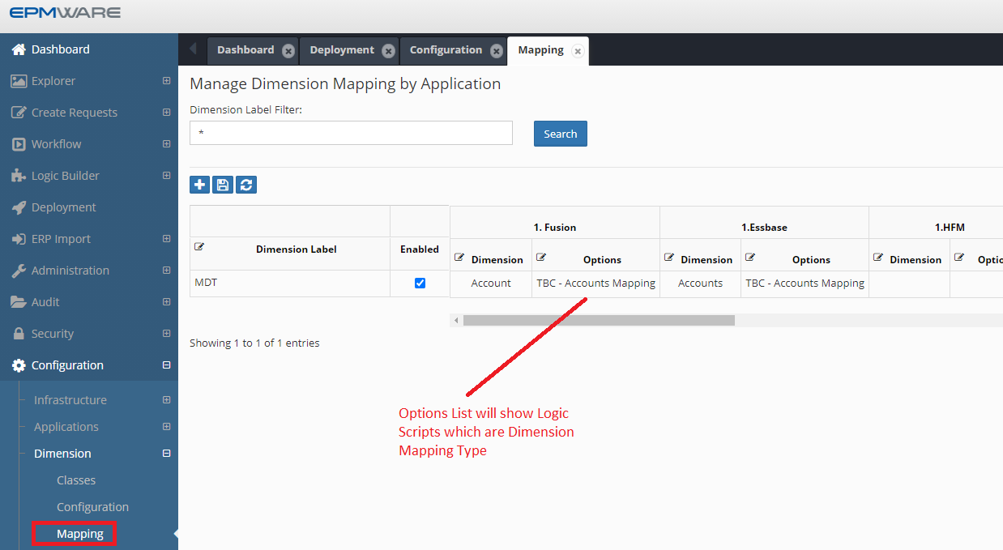

Input Parameters

The following table lists Input Parameters that are available for all Hierarchy Actions.

Input Parameter | Description
g_user_id | Current logged User ID
g_lb_script_name | Logic Script Name being executed
g_request_id | Request ID
g_member_name | Member Name
g_renamed_from_member_name | Original Member name before it was Renamed. Use this variable for the Rename Member action to get the original member name.
g_parent_member_name | Parent Member’s Name
g_prev_sibling_member_name | Previous Sibling Member Name
g_moved_from_member_name | When a member is moved from a source parent member to the target parent member then this variable provides the member name of the source parent member.
g_moved_to_member_name | When a member is moved from a source parent member to the target parent member then this variable provides the member name of the target parent member.
g_array_member_name | Member Name of the associated Alias or Languages (Such as Default, English etc.)
g_app_name | Application Name
g_dim_name | Dimension Name
g_dim_class_name | Dimension Class Name
g_mapped_app_name | Mapped Application Name
g_mapped_dim_name | Mapped Dimension Name
g_wf_code | Workflow Code
g_wf_stage_name | Workflow Stage Name (if request is submitted in the workflow)
g_action_code | Request Line Action Code such as CMC, CMS (Create member as child / sibling), P (Edit Properties), RM (Rename Member) and so on. See full list of Action Codes in Appendix B
g_action_name | Request Line Action Name such as Create member, Edit Properties, Rename Member and so on. See full list of Action Codes in Appendix B
g_req_rec | Request Header Record
g_dim_rec | Dimension Record
Internal IDs
g_request_line_id | Request Line ID
g_hierarchy_id | Unique node id. Each combination of Parent Member/Member is given a unique internal numerical value called hierarchy_id
g_member_id | Unique member id. Each member in EPMware is given a unique internal numerical value called member_id
g_parent_member_id | Parent member’s Member ID
g_moved_from_hierarchy_id | When a member is moved from a source parent member to the target parent member then this ID provides the hierarchy id of the source parent member.
g_moved_from_member_id | When a member is moved from a source parent member to the target parent member then this ID provides the member id of the source parent member.
g_moved_to_hierarchy_id | When a member is moved from a source parent member to the target parent member then this ID provides the hierarchy id of the target parent member.
g_moved_to_member_id | When a member is moved from a source parent member to the target parent member, then this ID provides the member id of the target parent member.
g_app_dimension_id | Application dimension ID
g_app_id | Application ID
g_prop_id | Property Configuration ID
g_array_member_id | Member ID of the Associated alias members (referred internally in EPMware as Array Members)
g_mapped_app_dimension_id | Used in Dimension and Property Mappings only. Dimension ID of the mapped application
g_mapped_hierarchy_id | Used in Property Mapping. Hierarchy ID of the node in the mapped dimension
g_wf_stage_task_id | Workflow Stage Task ID

Output Parameters

Depending on the hierarchy action, specific output parameters can be populated to perform the same hierarchy action on the mapped dimension.

Hierarchy Action: Create Member

The “Create Member” action has two sub actions. “As Child” or “As Sibling”. Depending on the sub action, Member Name, Parent Member Name get populated for Input Parameters and correspondingly Output Parameters will be required for the mapped dimension.

Output Parameter | Description
g_out_ignore_flag | Y or N to indicate whether action needs to be ignored in the mapped dimension or not. Default value is N.
g_out_parent_member_name | Parent Member Name from the mapped dimension
g_out_member_name | Member Name from the mapped dimension
g_out_new_member_name | New Member name for the mapped dimension
g_status | Status Values are either ‘S’ for Success or ‘E’ for Error.  Alternatively use the following method to set values in your code.  ew_lb_api.g_status := ew_lb_api.g_success  OR  ew_lb_api.g_status := ew_lb_api.g_error
g_message | Error Message if the status is Error.

Note: Parent Member Name and Member Name of the mapped dimension determines where the new member will be created in that mapped dimension.

If the Action Code is CMS (Create Member as Sibling) then a New Member will be created after the Member Name under the parent member name provided in the output variables.
If the Action Code is CMC (Create Member as Child) then a New Member will be created under the Member Name. In this case g_out_member_name will be used as a parent member under which a new member will be created in the mapped dimension.

For example, if the user chooses “As Child” versus “As Sibling” action on the member “300-10” then different values will be populated for Input Parameters and corresponding Output Parameters will be anticipated in the Logic Script. New Member Name is 300-90. In the mapped application, you are required to add prefix P against member names such as P300-90

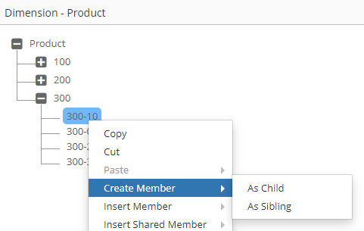

Input Parameters

Parameter | Create Member - As Child | Create Member - As Sibling
g_parent_member_name | 300 | 300
g_member_name | 300-10 | 300-10
g_new_member_name | 300-90 | 300-90
g_action_code | CMC | CMS

Output Parameters

In this example, we will add prefix P for all member names to create a new member in the mapped application.

Parameter | Create Member - As Child | Create Member - As Sibling
g_out_parent_member_name | P300 | P300
g_out_member_name | P300-10 | P300-10
g_out_new_member_name | P300-90 | P300-90
Result | P300-90 will be created as the Last child member of P300-10 | P300-90 will be created as a sibling member of P300-10 (Child member of P300)

Hierarchy Action: Rename Member

The following table will provide a list of Input and Output Parameters specifically for Rename Member Action. Please refer to the main table above under Dimension Mapping for a complete list of all Input Parameters.

Input Parameter | Description
g_renamed_from_member_name | Original Member name before it was Renamed. Use this variable for the Rename Member action to get the original member name.
g_action_code | RM

Output Parameter | Description
g_out_ignore_flag | Y or N to indicate whether action needs to be ignored in the mapped dimension or not. Default value is N.
g_out_parent_member_name | Parent Member Name from the mapped dimension
g_out_member_name | Member Name from the mapped dimension
g_out_new_member_name | Renamed Member Name for the Mapped dimension
g_status | Status Values are either ‘S’ for Success or ‘E’ for Error.  Alternatively use the following method to set values in your code.  ew_lb_api.g_status := ew_lb_api.g_success  OR  ew_lb_api.g_status := ew_lb_api.g_error
g_message | Error Message if the status is Error.

Hierarchy Action: Edit Properties, Remove Shared Member, Delete Member

The following table will provide a list of Output Parameters required for Edit Properties, Remove Shared and Delete Member Actions. Please refer to the main table above under Dimension Mapping for a complete list of all the Input Parameters.

Input Parameter | Description
g_member_name | Member Name being Reordered
g_parent_member_name | Parent Member of the Member Name being Reordered
g_action_code | P -> Edit Properties  RSM -> Remove Shared Member  DM -> Delete Member

Output Parameter | Description
g_out_ignore_flag | Y or N to indicate whether action needs to be ignored in the mapped dimension or not. Default value is N.
g_out_parent_member_name | Parent Member Name from the mapped dimension
g_out_member_name | Member Name from the mapped dimension
g_status | Status Values are either ‘S’ for Success or ‘E’ for Error.  Alternatively use the following method to set values in your code.  ew_lb_api.g_status := ew_lb_api.g_success  OR  ew_lb_api.g_status := ew_lb_api.g_error
g_message | Error Message if the status is Error.

Hierarchy Action: Reorder Children

The following table will provide a list of Input and Output Parameters specifically for Reorder Children Action. Please refer to the main table above under Dimension Mapping for a complete list of all the Input Parameters.

Input Parameter | Description
g_member_name | Member Name being Reordered
g_parent_member_name | Parent Member of the Member Name being Reordered
g_new_prev_sibling_member | New Previous Sibling of the member name being reordered.
g_action_code | RM

Output Parameter | Description
g_out_ignore_flag | Y or N to indicate whether action needs to be ignored in the mapped dimension or not. Default value is N.
g_out_parent_member_name | Parent Member Name from the mapped dimension
g_out_member_name | Member Name from the mapped dimension
g_out_new_prev_sibling_member | Previous Sibling Member for the member in the mapped dimension
g_status | Status Values are either ‘S’ for Success or ‘E’ for Error.  Alternatively use the following method to set values in your code.  ew_lb_api.g_status := ew_lb_api.g_success  OR  ew_lb_api.g_status := ew_lb_api.g_error
g_message | Error Message if the status is Error.

Hierarchy Action: Move Member

The following table will provide a list of Input and Output Parameters specifically for Move Member Action.Please refer to the main table above under Dimension Mapping for a complete list of all the Input Parameters.

Input Parameter | Description
g_moved_from_member_name | When a member is moved from a source parent member to the target parent member then this variable provides the member name of the source parent member.
g_moved_to_member_name | When a member is moved from a source parent member to the target parent member then this variable provides the member name of the target parent member.
g_moved_from_hierarchy_id | When a member is moved from a source parent member to the target parent member then this ID provides the hierarchy id of the source parent member.
g_moved_from_member_id | When a member is moved from a source parent member to the target parent member then this ID provides the member id of the source parent member.
g_moved_to_hierarchy_id | When a member is moved from a source parent member to the target parent member then this ID provides the hierarchy id of the target parent member.
g_moved_to_member_id | When a member is moved from a source parent member to the target parent member, then this ID provides the member id of the target parent member.
g_action_code | ZC

Output Parameter | Description
g_out_ignore_flag | Y or N to indicate whether action needs to be ignored in the mapped dimension or not. Default value is N.
g_out_parent_member_name | Parent Member Name from the mapped dimension
g_out_member_name | Member Name from the mapped dimension
g_out_new_prev_sibling_member | Previous Sibling Member for the member in the mapped dimension
g_out_moved_to_member_name | New Parent Member name where the member will be moved to for the mapped dimension
g_status | Status Values are either ‘S’ for Success or ‘E’ for Error.  Alternatively use the following method to set values in your code.  ew_lb_api.g_status := ew_lb_api.g_success  OR  ew_lb_api.g_status := ew_lb_api.g_error
g_message | Error Message if the status is Error.

Hierarchy Action: Insert Shared Member

The following table will provide a list of Input and Output Parameters specifically for Insert Shared Member Action. Please refer to the main table above under Dimension Mapping for a complete list of all the Input Parameters. Like the “Create Member” action, this action also has 2 sub actions, “As Child” and “As Sibling". Member and Parent Member parameters will follow the similar construct for this action as it does for the “Create Member” action. However, there is a key difference between this action and the “Create Member” action. In the Create Member action you can only create one member at a time, but for this action users can create more than one shared instance in a single action. Hence, Input parameters will provide an array of members for which shared instances are created and expect a similar array in the Output Parameters list for the mapped dimension.

Input Parameter | Description
g_action_code | ISMC or ISMS
g_shared_members_tbl | This is a PL/SQL collection (table) with the list of Member names from the source dimension which will get Shared instances.  If the action is Insert Shared Member as Child then shared instances will be created under Member Name. Shared instances will be created as the last member under the parent member.  If the action is Insert Shared Member as Sibling then shared instances will be created under Parent Member and after the Member name.

FYI: ew_lb_api.g_shared_members_tbl is a TABLE type collection. Type is as mentioned below.
Each element in this table refers to a Member Name

TYPE g_members_tbl_t IS TABLE OF ew_members.member_name%TYPE
INDEX BY BINARY_INTEGER;

Output Parameter | Description
g_out_ignore_flag | Y or N to indicate whether action needs to be ignored in the mapped dimension or not. Default value is N.
g_out_parent_member_name | Parent Member Name from the mapped dimension
g_out_member_name | Member Name from the mapped dimension
g_out_new_prev_sibling_member | Previous Sibling Member for the member in the mapped dimension
g_out_shared_members_tbl | Mapped Members from the Shared Dimension which will get shared instance
g_status | Status Values are either ‘S’ for Success or ‘E’ for Error.  Alternatively use the following method to set values in your code.  ew_lb_api.g_status := ew_lb_api.g_success  OR  ew_lb_api.g_status := ew_lb_api.g_error
g_message | Error Message if the status is Error.

ew_lb_api.g_out_shared_members_tbl is a TABLE type collection. Type is as mentioned below.

TYPE g_members_tbl_t IS TABLE OF ew_members.member_name%TYPE
INDEX BY BINARY_INTEGER;

Example
Requirement: Map nodes across applications provided they are part of certain branches. Branches are defined in a custom lookup.

/*
Author : Deven Shah
Date : 27-Jul-2020
Purpose : Map A/c Dimension across Apps provided members are part of branches as defined in a custom lookup OF_ACCT_DIM_MAPPING
Version History ---------------------------------------------------------------------
Date | Name | Notes
---------------------------------------------------------------------
27-Jul-2020 | Deven | Initial Version ---------------------------------------------------------------------
*/
DECLARE
c_script_name VARCHAR2(50) := 'OF_ACCT_DIM_MAPPING';
c_user_id NUMBER := ew_lb_api.g_user_id;
c_request_id NUMBER := ew_lb_api.g_request_id;
c_app_dim_id NUMBER := ew_lb_api.g_app_dimension_id;
c_new_member_name VARCHAR2(100) := ew_lb_api.g_new_member_name;
c_member_name VARCHAR2(100) := ew_lb_api.g_member_name;
c_prev_sibling_member_name VARCHAR2(100) := ew_lb_api.g_prev_sibling_member_name;
c_parent_member_name VARCHAR2(100) := ew_lb_api.g_parent_member_name;
c_action_code VARCHAR2(10) := ew_lb_api.g_action_code;
c_mapped_app_dim_id NUMBER := ew_lb_api.g_mapped_app_dimension_id;
c_app_name VARCHAR(200) := ew_lb_api.g_app_name;
c_shared_members_tbl ew_lb_api.g_members_tbl_t := ew_lb_api.g_shared_members_tbl; -- Shared Instances Members
--
c_account_mapping_lkup VARCHAR2(100) := 'OF_ACCT_DIM_MAPPING';
--
l_lkup_tag VARCHAR2(50) := C_APP_NAME; -- Source App Name
--
l_sts VARCHAR2(1);
l_ignore_ex EXCEPTION;
l_error_ex EXCEPTION;
l_found VARCHAR2(1) := 'N';
l_shared_member_name VARCHAR2(100);
l_parent_member_name VARCHAR2(100);
--
CURSOR cur_lkup
IS
SELECT lookup_code,meaning
FROM ew_lookup_codes_v
WHERE lookup_name = c_account_mapping_lkup
AND enabled_flag = 'Y'
AND UPPER(tag) = UPPER(l_lkup_tag)
ORDER BY lookup_code
;
--
PROCEDURE log (p_msg IN VARCHAR2)
IS
BEGIN
ew_debug.log(p_text => p_msg
,p_source_ref => c_script_name
);
END;

-- FYI
-- OUT member names are what going to be used in the mapped app
PROCEDURE set_out_variables (p_mapped_parent_member_name IN VARCHAR2)
IS
BEGIN
--
ew_lb_api.g_out_new_member_name := c_new_member_name;
ew_lb_api.g_out_member_name := c_member_name;

-- This is required specifically for Move action
IF ew_lb_api.g_moved_to_member_name IS NOT NULL
THEN
ew_lb_api.g_out_moved_to_member_name := ew_lb_api.g_moved_to_member_name;
END IF;

-- Check if Prev Sibling member exists in the mapped app
-- If exists then set else do not set.
IF 'Y' = ew_hierarchy.chk_member_exists
(p_app_dimension_id => c_mapped_app_dim_id
,p_member_name => c_prev_sibling_member_name
)
THEN
ew_lb_api.g_prev_sibling_member_name := c_prev_sibling_member_name;
END IF;

IF c_action_code IN ('ISMC','ISMS') -- Insert Shared member (Child / Sibling)
THEN
-- There could be one or more members selected for Insert Shared member action
-- Hence, loop through each member that is inserted in Source app
-- and check if they exist in the mapped app. If they exist then include them
-- in the mapped app.
log('Insert Shared Members Table : '||ew_lb_api.g_shared_members_tbl.COUNT);
--
IF c_action_code = 'ISMC'
THEN
l_parent_member_name := c_member_name;
ELSE
l_parent_member_name := c_parent_member_name;
END IF;

FOR i IN 1..c_shared_members_tbl.COUNT
LOOP
-- checked if the member exists in the mapped app..
l_shared_member_name := c_shared_members_tbl(i);
log('Shared member Name : '||l_shared_member_name);

IF ew_hierarchy.chk_member_exists
(p_app_dimension_id => c_mapped_app_dim_id
,p_member_name => l_shared_member_name
) = 'N'
THEN
ew_lb_api.g_message := 'Member ['||l_shared_member_name||'] not found in the mapped app';
RAISE l_error_ex;
ELSE
-- Check if the member is moved to another parent..
-- if so then move the member
IF ew_hierarchy.chk_node_exists (p_app_dimension_id => c_mapped_app_dim_id
,p_parent_member_name => l_parent_member_name
,p_member_name => l_shared_member_name
) = 'Y'
THEN
log('Node already exists');
ELSE
ew_lb_api.g_out_shared_members_tbl(ew_lb_api.g_out_shared_members_tbl.COUNT+1) := l_shared_member_name;
END IF;

END IF; -- Check whether shared member already exists in the mapped app or not

END LOOP; -- Shared Members List

END IF; -- Insert shared member action

END set_out_variables;

BEGIN
ew_lb_api.g_status := ew_lb_api.g_success;
ew_lb_api.g_message := NULL;

log('Map Hierarchy Action from the source to the Mapped app.');

log('+ Source App : '||C_APP_NAME);
log('+ Member : '||C_MEMBER_NAME);
log('+ Parent : '||C_PARENT_MEMBER_NAME);
log('+ New Member : '||C_NEW_MEMBER_NAME);
log('+ Action Code : '||c_action_code);

-- Check if the hierarchy in HFM is one of the mapped one based on the lookup codes.
-- If it is, then propagate the change in the mapped dimension.
--
FOR rec IN cur_lkup
LOOP
log('Check current member or new member in Branch : '||rec.lookup_code);
IF 'Y' = ew_hierarchy.chk_primary_branch_exists
(p_app_dimension_id => C_APP_DIM_ID
,p_parent_member_name => rec.lookup_code
,p_member_name => NVL(C_NEW_MEMBER_NAME,C_MEMBER_NAME)
)
THEN

log(NVL(C_NEW_MEMBER_NAME,C_MEMBER_NAME) || ' is found in the branch : '||rec.lookup_code);

-- member is the top member of the branch itself
IF c_member_name = rec.lookup_code
THEN
ew_lb_api.g_out_parent_member_name := ew_hierarchy.get_primary_parent_name
(p_app_dimension_id => c_mapped_app_dim_id
,p_member_name => c_member_name
);
ELSE
ew_lb_api.g_out_parent_member_name := c_parent_member_name;
END IF;
-- Check if the member exists in the mapped app
-- if it exists then continue else ignore
IF 'Y' = ew_hierarchy.chk_member_exists
(p_app_dimension_id => c_mapped_app_dim_id
,p_member_name => c_member_name
)
THEN
l_found := 'Y';
set_out_variables(ew_lb_api.g_out_parent_member_name);
ELSE
log('Ignore the action for this member as it does not exist in the mapped app..');
END IF;

END IF;
END LOOP;

IF l_found = 'N'
THEN
RAISE l_ignore_ex;
ELSE
log('Member mapping done successfully.');
END IF;

EXCEPTION
WHEN l_ignore_ex THEN
ew_lb_api.g_out_ignore_flag := 'Y';
log('Ignore action on the mapped dim');
WHEN l_error_ex THEN
ew_lb_api.g_status := ew_lb_api.g_error;
log(ew_lb_api.g_message);
WHEN OTHERS THEN
ew_lb_api.g_status := ew_lb_api.g_error;
ew_lb_api.g_message := SQLERRM;
log(ew_lb_api.g_message);
END;

Property Mapping

Overview
Property Mapping is used to map property values between two or more dimensions for a mapped member and mapped property. Like Dimension mapping, it provides two options: Sync or Smart Sync. The third option is a Logic Script (Type: Property Mapping).

These scripts are associated in the Property Mapping screen as shown below.

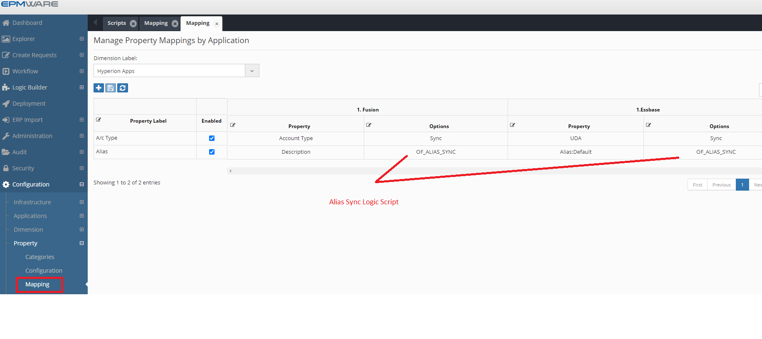

Input Parameters

The following table lists Input Parameters that are available for Property Mapping Logic Scripts.

Input Parameter | Description
g_user_id | Current logged User ID
g_lb_script_name | Logic Script Name being executed
g_request_id | Request ID
g_member_name | Member Name
g_parent_member_name | Parent Member’s Name
g_array_member_name | Member Name of the associated Alias or Languages (Such as Default, English etc.)
g_app_name | Application Name
g_dim_name | Dimension Name
g_mapped_app_name | Mapped Application Name
g_mapped_dim_name | Mapped Dimension Name
g_mapped_prop_label | Mapped Property Label
g_dim_class_name | Dimension Class Name
g_prop_name | Property Name (Source application)
g_prop_label | Property Label (Source application)
g_prop_value | Property Value (Source application)
g_wf_code | Workflow Code
g_wf_stage_name | Workflow Stage Name (if request is submitted in the workflow)
g_req_rec | Request Header Record
g_dim_rec | Dimension Record
Internal IDs
g_request_line_id | Request Line ID
g_hierarchy_id | Unique node id. Each combination of Parent Member/Member is given a unique internal numerical value called hierarchy_id
g_member_id | Unique member id. Each member in EPMware is given a unique internal numerical value called member_id
g_parent_member_id | Parent member’s Member ID
g_app_dimension_id | Application dimension ID
g_app_id | Application ID
g_prop_id | Property Configuration ID
g_array_member_id | Member ID of the Associated alias members (referred internally in EPMware as Array Members)
g_mapped_app_dimension_id | Used in Dimension and Property Mappings only. Dimension ID of the mapped application
g_mapped_hierarchy_id | Used in Property Mapping. Hierarchy ID of the node in the mapped dimension
g_wf_stage_task_id | Workflow Stage Task ID

Output Parameters

Output Parameter | Description
g_out_ignore_flag | Y or N to indicate whether action needs to be ignored in the mapped dimension or not. Default value is N.
g_out_prop_value | Property Value for the mapped dimension’s member for the property that is mapped in the Property Mapping configurations
g_status | Status Values are either ‘S’ for Success or ‘E’ for Error.  Alternatively use the following method to set values in your code.  ew_lb_api.g_status := ew_lb_api.g_success  OR  ew_lb_api.g_status := ew_lb_api.g_error
g_message | Error Message if the status is Error.

Example

Requirement: Assign Account type property value to the members of the Fusion Application based on the Account Type assigned to the PBCS application.

/* Version History -------------------------------------------------------------------
Date | Name | Notes ---------------------------------------------------------------------
08-Jul-20 | Deven | Initial Version ---------------------------------------------------------------------
*/
DECLARE
c_script_name VARCHAR2(50) := 'OF_ACCT_TYPE_PROP_MAPPING';
PROCEDURE log (p_msg IN VARCHAR2)
IS
BEGIN
ew_debug.log(p_text => p_msg
,p_source_ref => c_script_name
);
END;
BEGIN
IF ew_lb_api.g_prop_value = 'Asset'
THEN
ew_lb_api.g_out_prop_value := 'A';
ELSIF ew_lb_api.g_prop_value = 'Liability'
THEN
ew_lb_api.g_out_prop_value := 'L';
ELSIF ew_lb_api.g_prop_value = 'Equity'
THEN
ew_lb_api.g_out_prop_value := 'O';
ELSIF ew_lb_api.g_prop_value = 'Expense'
THEN
ew_lb_api.g_out_prop_value := 'E';
ELSIF ew_lb_api.g_prop_value = 'Revenue'
THEN
ew_lb_api.g_out_prop_value := 'R';
ELSE
ew_lb_api.g_out_prop_value := '';
END IF;
ew_debug.log('Set Fusion Account Type to : '||ew_lb_api.g_out_prop_value);
END;

Configurations

Define Property Mapping Logic Script as shown below.
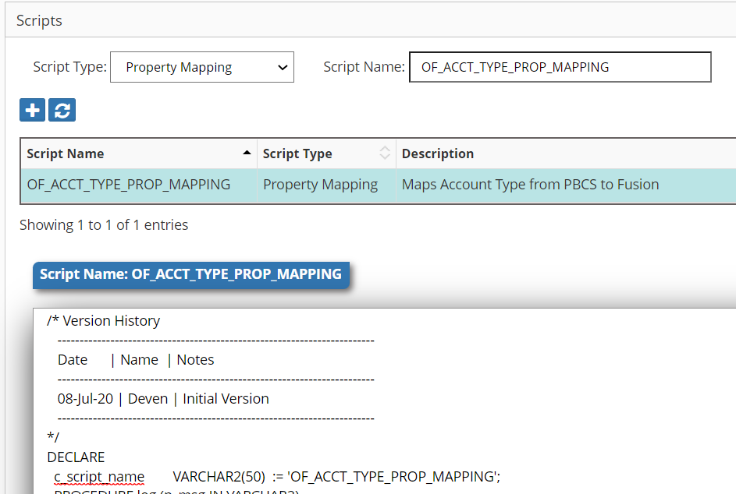

Assign Logic Script to Property Mapping as shown below.

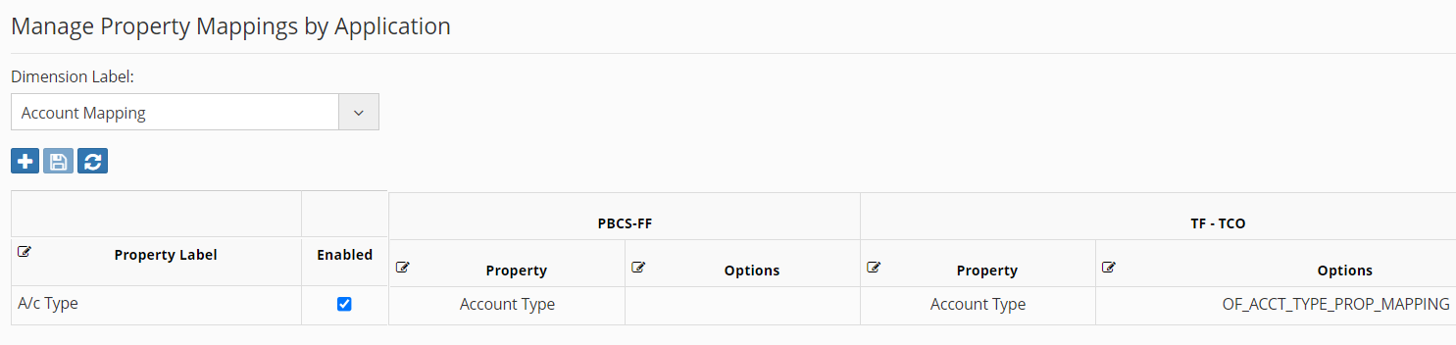

Property Derivations

Overview
Property Derivation scripts allow properties to be derived whenever a new member is being created or properties of an existing member are being updated.

These scripts are associated in the Property -> Derivations screen as shown below.

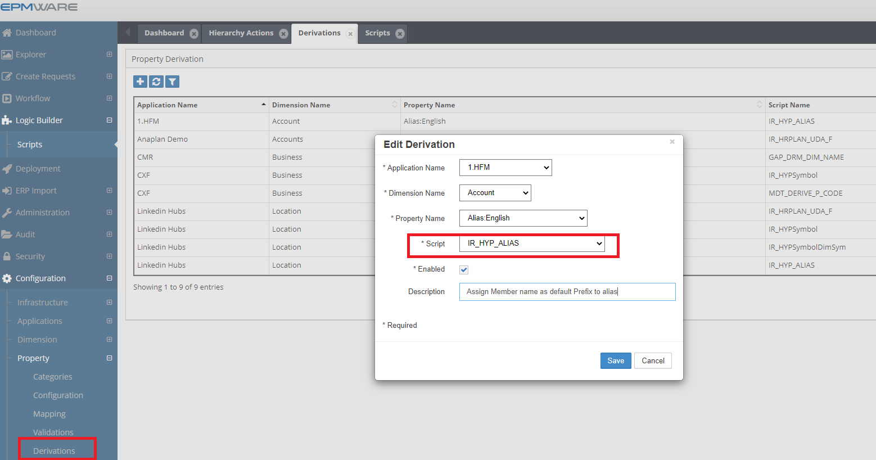

Input Parameters

The following table lists Input Parameters that are available for Property Derivation Logic Scripts.

Input Parameter | Description
g_user_id | Current logged User ID
g_lb_script_name | Logic Script Name being executed
g_request_id | Request ID
g_member_name | Member Name
g_parent_member_name | Parent Member’s Name
g_array_member_name | Member Name of the associated Alias or Languages (Such as Default, English etc.)
g_app_name | Application Name
g_dim_name | Dimension Name
g_dim_class_name | Dimension Class Name
g_prop_name | Property Name
g_prop_label | Property Label
g_wf_code | Workflow Code
g_wf_stage_name | Workflow Stage Name (if request is submitted in the workflow)
g_req_rec | Request Header Record
g_dim_rec | Dimension Record
Internal IDs
g_request_line_id | Request Line ID
g_hierarchy_id | Unique node id. Each combination of Parent Member/Member is given a unique internal numerical value called hierarchy_id
g_member_id | Unique member id. Each member in EPMware is given a unique internal numerical value called member_id
g_parent_member_id | Parent member’s Member ID
g_app_dimension_id | Application dimension ID
g_app_id | Application ID
g_prop_id | Property Configuration ID
g_array_member_id | Member ID of the Associated alias members (referred internally in EPMware as Array Members)
g_wf_stage_task_id | Workflow Stage Task ID
g_member_name | This flag (Y or N value) indicates whether member is a new member being created or not. Property Derivation Logic Script can use this information at the time of new member creation to apply certain business logic if needed.

Output Parameters

Output Parameter | Description
g_out_ignore_flag | Y or N to indicate whether action needs to be ignored in the mapped dimension or not. Default value is N.
g_out_prop_value | Property Value for the mapped dimension’s member for the property that is mapped in the Property Mapping configurations
g_status | Status Values are either ‘S’ for Success or ‘E’ for Error.  Alternatively use the following method to set values in your code.  ew_lb_api.g_status := ew_lb_api.g_success  OR  ew_lb_api.g_status := ew_lb_api.g_error
g_message | Error Message if the status is Error.

Example

Requirement : Whenever a new member is created, assign the member name with a dash character in its alias. Users will then assign text to the end for the alias.

To achieve this automation, we will use the “Property Derivation” Logic Script.

/* Author : Deven
Date | Modified by | Notes
-------------------------------------------------------
09-Oct-20 | Deven | Initial Version
-------------------------------------------------------
*/
DECLARE
C_SCRIPT_NAME VARCHAR2(100) := 'OF_NEW_MEMBER_ALIAS';
--
-- Local Procedure to create debugging information
PROCEDURE log (p_msg IN VARCHAR2)
IS
BEGIN
ew_debug.log(p_text => p_msg
,p_source_ref => c_script_name
);
END log;
BEGIN
ew_lb_api.g_status := ew_lb_api.g_success;
ew_lb_api.g_message := NULL;

log('Derive Alias for member : '||ew_lb_api.g_member_name);

-- If the member already has alias assigned then
-- no need to derive the alias. Otherwise assign default alias
IF ew_lb_api.g_prop_value IS NULL
THEN
ew_lb_api.g_out_prop_value := ew_lb_api.g_member_name||' - ';
ELSE
ew_lb_api.g_out_prop_value := ew_lb_api.g_prop_value;
END IF;

EXCEPTION
WHEN OTHERS THEN
log('Error : ' || SQLERRM);
ew_lb_api.g_status := ew_lb_api.g_error;
ew_lb_api.g_message := 'Unknown Error deriving Alias : '||SQLERRM;
END;

Assign this Logic Script to the Property Derivation configuration as shown below.



Property Validations

Overview
Property Validation scripts are invoked whenever the user modifies property values of a member that requires custom validation such as length or prefix of the member name, etc..

These scripts are associated in the Property -> Validations screen as shown below.

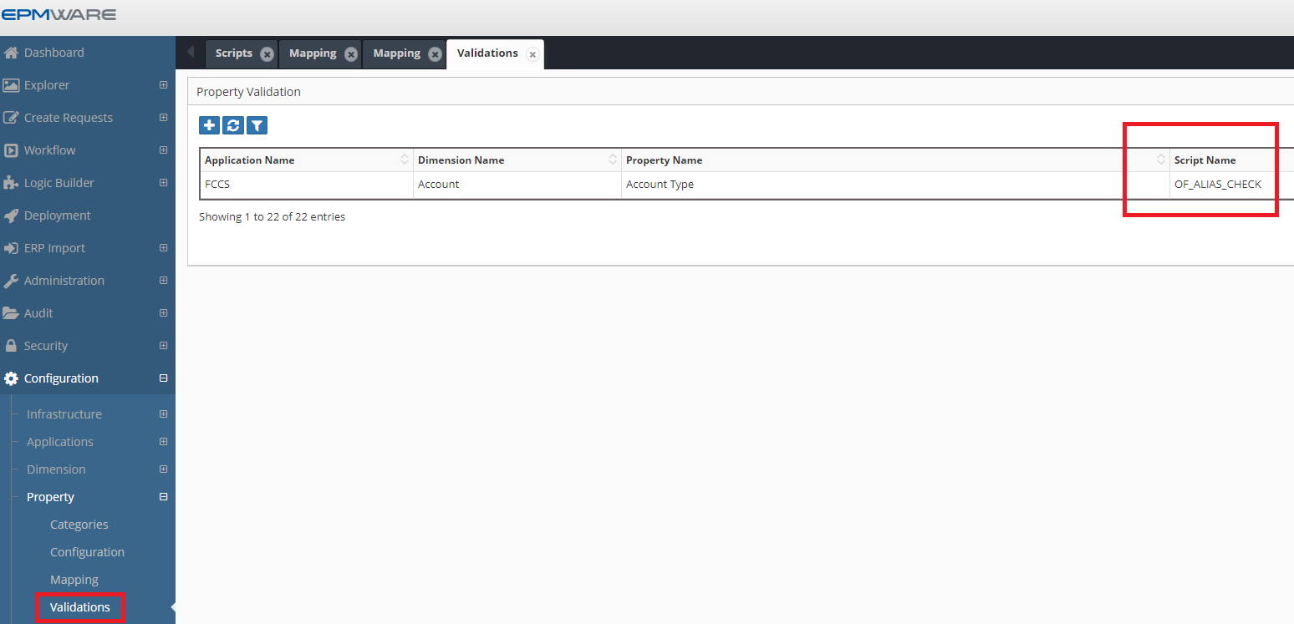

Input Parameters

The following table lists Input Parameters that are available for Property Mapping Logic Scripts.

Input Parameter | Description
g_user_id | Current logged User ID
g_lb_script_name | Logic Script Name being executed
g_request_id | Request ID
g_member_name | Member Name
g_parent_member_name | Parent Member’s Name
g_array_member_name | Member Name of the associated Alias or Languages (Such as Default, English etc.)
g_app_name | Application Name
g_dim_name | Dimension Name
g_dim_class_name | Dimension Class Name
g_prop_name | Property Name
g_prop_label | Property Label
g_prop_value | Property Value
g_wf_code | Workflow Code
g_wf_stage_name | Workflow Stage Name (if request is submitted in the workflow)
g_req_rec | Request Header Record
g_dim_rec | Dimension Record
Internal IDs
g_request_line_id | Request Line ID
g_hierarchy_id | Unique node id. Each combination of Parent Member/Member is given a unique internal numerical value called hierarchy_id
g_member_id | Unique member id. Each member in EPMware is given a unique internal numerical value called member_id
g_parent_member_id | Parent member’s Member ID
g_app_dimension_id | Application dimension ID
g_app_id | Application ID
g_prop_id | Property Configuration ID
g_array_member_id | Member ID of the Associated alias members (referred internally in EPMware as Array Members)
g_wf_stage_task_id | Workflow Stage Task ID

Output Parameters

Output Parameter | Description
g_out_ignore_flag | Y or N to indicate whether action needs to be ignored in the mapped dimension or not. Default value is N.
g_status | Status Values are either ‘S’ for Success or ‘E’ for Error.  Alternatively use the following method to set values in your code.  ew_lb_api.g_status := ew_lb_api.g_success  OR  ew_lb_api.g_status := ew_lb_api.g_error
g_message | Error Message if the status is Error.

Example

Requirement: Whenever a new member is created, ensure its prefix matches with its Parent Member prefix.

To achieve this automation, we will use the “Property Validation” Logic Script. This script will be assigned to the “Member Name” property of the dimension.

/* Author : Deven
Date | Modified by | Notes
-------------------------------------------------------
09-Oct-20 | Deven | Initial Version
-------------------------------------------------------
*/
DECLARE
C_SCRIPT_NAME VARCHAR2(100) := 'OF_NEW_MEMBER_CHECK';
--
-- Local Procedure to create debugging information
PROCEDURE log (p_msg IN VARCHAR2)
IS
BEGIN
ew_debug.log(p_text => p_msg
,p_source_ref => c_script_name
);
END log;
BEGIN
ew_lb_api.g_status := ew_lb_api.g_success;
ew_lb_api.g_message := NULL;

log('Validate member : '||ew_lb_api.g_new_member_name);

IF SUBSTR(ew_lb_api.g_parent_member_name,1,3) <>
SUBSTR(ew_lb_api.g_new_member_name,1,3)
THEN
ew_lb_api.g_message := 'Member Name Prefix does not match with its parent member prefix';
ew_lb_api.g_status := ew_lb_api.g_error;
END IF;

EXCEPTION
WHEN OTHERS THEN
log('Error : ' || SQLERRM);
ew_lb_api.g_status := ew_lb_api.g_error;
ew_lb_api.g_message := 'Unknown Error deriving Alias : '||SQLERRM;
END;

Assign this Logic Script to the Property Derivation configuration as shown below.

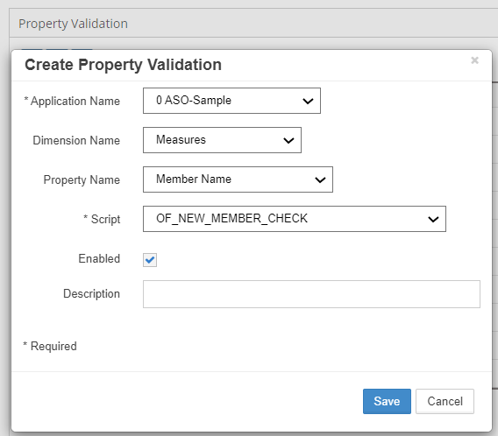

Standard Property Validations

The following Logic Scripts are of “Property Validation Types” and are automatically assigned to the Applications as soon as they are registered on the Application Configuration page.

Logic Script Name | Application Types
EW_ESSBASE_VALIDATIONS | Essbase (On Prem and Cloud)
EW_HFM_VALIDATIONS | HFM
EW_HP_VALIDATIONS | Planning (On Prem and Cloud)
EW_PCMCS_VALIDATIONS | Oracle PCMCS Cloud
EW_TRCS_VALIDATIONS | Oracle TRCS Cloud
EW_FDMEE_VALIDATIONS | Oracle FDMee (OR Data Management)
EW_FUSION_VALIDATIONS | Oracle EBS (Fusion)
EW_ONESTREAM_VALIDATIONS | OneStream Applications (On Prem and Cloud)

Pre-Hierarchy Actions

Overview
Pre-Hierarchy Actions are used when a logic builder script needs to be triggered before a hierarchy action is executed on the dimension in a Request. Pre-Hierarchy Action Logic scripts are associated with an application, dimension and a specific hierarchy action. The same Logic Script can be assigned to multiple hierarchy actions as well. The Logic Script can leverage an Action Code or Action Name if needed. Refer to Appendix B for the Hierarchy Action Codes and there names.

These scripts are associated in the Dimension -> Hierarchy Actions screen as shown below.

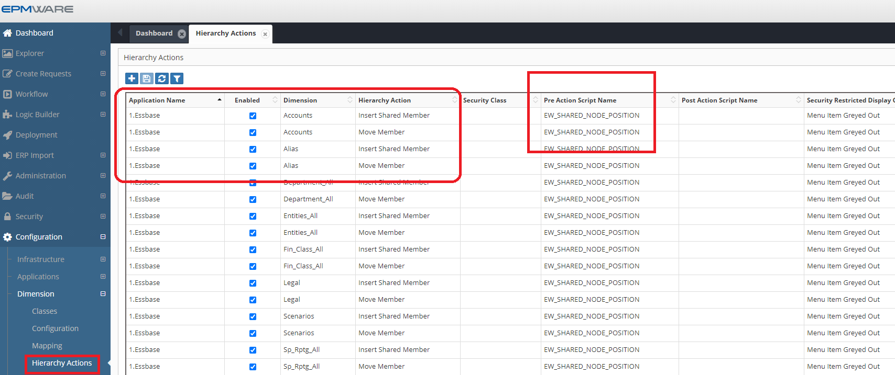

Input Parameters

The following table lists Input Parameters that are available for Property Mapping Logic Scripts.

Input Parameter | Description
g_user_id | Current logged User ID
g_lb_script_name | Logic Script Name being executed
g_request_id | Request ID
g_member_name | Member Name
g_parent_member_name | Parent Member’s Name
g_app_name | Application Name
g_dim_name | Dimension Name
g_dim_class_name | Dimension Class Name
g_wf_code | Workflow Code
g_wf_stage_name | Workflow Stage Name (if request is submitted in the workflow)
g_req_rec | Request Header Record
g_dim_rec | Dimension Record
Internal IDs
g_hierarchy_id | Unique node id. Each combination of Parent Member/Member is given a unique internal numerical value called hierarchy_id
g_member_id | Unique member id. Each member in EPMware is given a unique internal numerical value called member_id
g_parent_member_id | Parent member’s Member ID
g_app_dimension_id | Application dimension ID
g_app_id | Application ID
g_wf_stage_task_id | Workflow Stage Task ID

Output Parameters

Output Parameter | Description
g_out_ignore_flag | Y or N to indicate whether action needs to be ignored in the mapped dimension or not. Default value is N.
g_status | Status Values are either ‘S’ for Success or ‘E’ for Error.  Alternatively use the following method to set values in your code.  ew_lb_api.g_status := ew_lb_api.g_success  OR  ew_lb_api.g_status := ew_lb_api.g_error
g_message | Error Message if the status is Error.

Example

Requirement: Prevent existing Members from being promoted to a Parent Member.

/* Author : Deven (EPMWARE)
Date : 09-Dec-2020
Purpose: This script will check if an existing Entity is being promoted from a Base member to a Parent Member. However, if the current user is part of the HFM Admin group then promotion is allowed as an exception. Three actions can possibly make an existing member a Parent Member.
1> Create Member
2> Insert Shared Member
3> Move Member
Note: Ignore this if the Member is a new member being created in the current request.
------------------------------------------------------------------
Version History
------------------------------------------------------------------
Date | Name | Notes
------------------------------------------------------------------
09-Dec-20 | Deven | Initial Version
------------------------------------------------------------------
*/
DECLARE
C_SCRIPT_NAME VARCHAR2(50) := 'OF_ENTITY_BASE_TO_PARENT_PRE_HIER_CHECK';
C_REQUEST_ID NUMBER := ew_lb_api.g_request_id;
C_USER_ID NUMBER := ew_lb_api.g_user_id;
C_DIM_NAME VARCHAR2(100) := ew_lb_api.g_dim_name;
C_APP_DIM_ID NUMBER := ew_lb_api.g_app_dimension_id;
C_PARENT_MEMBER_NAME VARCHAR2(100) := ew_lb_api.g_parent_member_name;
C_PARENT_MEMBER_ID NUMBER := ew_lb_api.g_parent_member_id;
C_MOVED_TO_MEMBER_ID NUMBER := ew_lb_api.g_moved_to_member_id;
C_MOVED_TO_MEMBER_NAME VARCHAR2(100) := ew_lb_api.g_moved_to_member_name;
C_MEMBER_NAME VARCHAR2(100) := ew_lb_api.g_member_name;
C_MEMBER_ID NUMBER := ew_lb_api.g_member_id;
C_ACTION_CODE VARCHAR2(10) := ew_lb_api.g_action_code;
--
C_HFM_ADMIN_GROUP VARCHAR2(30) := 'OF_HFM_ADMIN';
--
l_new_mem_req_line_id NUMBER;
l_parent_member_name VARCHAR2(100);
l_parent_member_id NUMBER;
l_error_ex EXCEPTION;
l_allow_ex EXCEPTION;
--
PROCEDURE log (p_msg VARCHAR2)
IS
BEGIN
ew_debug.log(p_msg,ew_debug.show_always,C_SCRIPT_NAME);
END log;
--
BEGIN
-- Default values for return code
ew_lb_api.g_status := ew_lb_api.g_success;
ew_lb_api.g_message := NULL;

log('Check if Base Entity Member is being promoted to Parent. '||
'[Dimension : '||C_DIM_NAME||'] '||
'[Member : '||C_MEMBER_NAME||'] '||
'[Parent : '||C_PARENT_MEMBER_NAME||'] '||
'[Action Code : '||C_ACTION_CODE||'] '||
'[Request ID : '||C_REQUEST_ID||'] '
);

-- First check if the user is HFM Admin or not
IF ew_sec_api.is_user_in_group (p_group_name => C_HFM_ADMIN_GROUP
,p_user_id => C_USER_ID
) = 'Y'
THEN
RAISE l_allow_ex;
END IF;

IF C_ACTION_CODE = 'ZC' -- move member
THEN
l_parent_member_id := C_MOVED_TO_MEMBER_ID;
l_parent_member_name := C_MOVED_TO_MEMBER_NAME;
ELSIF C_ACTION_CODE IN ('CMC','ISMC')
THEN
l_parent_member_id := C_MEMBER_ID;
l_parent_member_name := C_MEMBER_NAME;
ELSIF C_ACTION_CODE IN ('CMS','ISMS')
THEN
l_parent_member_id := C_PARENT_MEMBER_ID;
l_parent_member_name := C_PARENT_MEMBER_NAME;
END IF;

log('Check whether parent member id ['||l_parent_member_id||' is a base member or not');

-- Check if the member is leaf or not
-- if leaf member and NOT created in the current request then throw error
IF ew_hierarchy.is_leaf(p_member_id => l_parent_member_id
,p_app_dimension_id => C_APP_DIM_ID
) = 'Y'
THEN
l_new_mem_req_line_id := ew_req_api.get_req_line_id
(p_request_id => C_REQUEST_ID
,p_app_dimension_id => C_APP_DIM_ID
,p_member_name => l_parent_member_name
,p_action_name => 'Create Member'
);
IF l_new_mem_req_line_id IS NULL
THEN
IF C_ACTION_CODE = 'ZC' -- move member
THEN
ew_lb_api.g_message := 'Moved to Member ['||C_MOVED_TO_MEMBER_NAME ||
'] will become a parent member which is not allowed.';
ELSE
ew_lb_api.g_message := 'Base Member ['||C_PARENT_MEMBER_NAME ||
'] will become a parent member which is not allowed.';
END IF;
RAISE l_error_ex;
ELSE
log('No error. Parent member is a new member being created in the current request. ID : '||l_new_mem_req_line_id);
END IF;
END IF;

EXCEPTION
WHEN l_allow_ex THEN
log('Allow the action as the current user is in the Admin Group');
WHEN l_error_ex THEN
ew_lb_api.g_status := ew_lb_api.g_error;
log(ew_lb_api.g_message);
WHEN OTHERS THEN
ew_lb_api.g_status := ew_lb_api.g_error;
ew_lb_api.g_message := 'Error Executing Logic Script : '||SQLERRM;
log(ew_lb_api.g_message);
END;

Configurations

Create Logic Script as shown below.
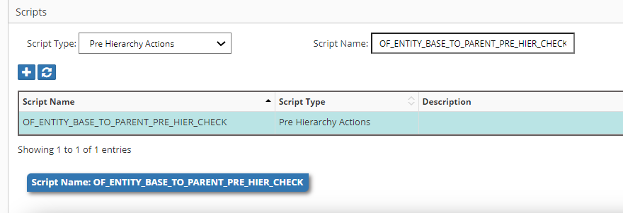

Assign Logic script to the three actions as shown below. (Hierarchy Action menu option is under Configuration -> Dimension menu)

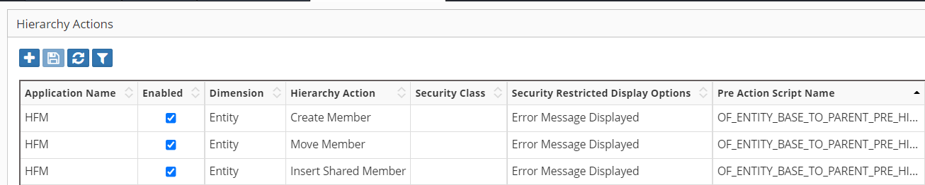

Seeded Script : EW_SHARED_NODE_POSITION
This Logic Script is assigned to Essbase and Planning Applications automatically for all dimensions for the “Insert shared Member” action. The purpose of this Logic Script is to prevent the creation of a shared node before its Primary instance in the hierarchy..

Post Hierarchy Actions

Overview
Post Hierarchy Actions are used when custom logic needs to be invoked after an action has been successfully executed on the dimension and a request line is created. Like Pre- Hierarchy Action Logic scripts, Post Hierarchy action scripts must be associated with application, dimension and a specific hierarchy action. The same Logic Script can be assigned to multiple hierarchy actions. A Logic Script can leverage an Action Code or Action name if needed. Refer to Appendix B for the Hierarchy Action Codes and their names.

These scripts are associated in the Dimension -> Hierarchy Actions screen as shown below.

Note: If a record for Pre hierarchy action has already been assigned and you need to assign a Post Hierarchy Action to the same dimension and action then you can combine these two actions for the same record in the “Hierarchy Action” configuration page.

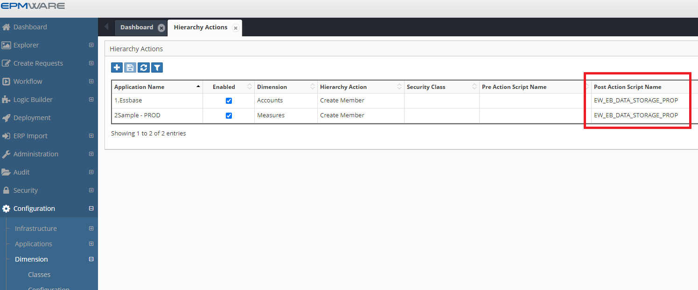

Input Parameters

The following table lists Input Parameters that are available for Property Mapping Logic Scripts.

Input Parameter | Description
g_user_id | Current logged User ID
g_lb_script_name | Logic Script Name being executed
g_request_id | Request ID
g_member_name | Member Name
g_parent_member_name | Parent Member’s Name
g_app_name | Application Name
g_dim_name | Dimension Name
g_dim_class_name | Dimension Class Name
g_wf_code | Workflow Code
g_wf_stage_name | Workflow Stage Name (if request is submitted in the workflow)
g_req_rec | Request Header Record
g_dim_rec | Dimension Record
Internal IDs
g_request_line_id | Request Line ID
g_hierarchy_id | Unique node id. Each combination of Parent Member/Member is given a unique internal numerical value called hierarchy_id
g_member_id | Unique member id. Each member in EPMware is given a unique internal numerical value called member_id
g_parent_member_id | Parent member’s Member ID
g_app_dimension_id | Application dimension ID
g_app_id | Application ID
g_wf_stage_task_id | Workflow Stage Task ID

Output Parameters

Output Parameter | Description
g_out_ignore_flag | Y or N to indicate whether action needs to be ignored in the mapped dimension or not. Default value is N.
g_status | Status Values are either ‘S’ for Success or ‘E’ for Error.  Alternatively use the following method to set values in your code.  ew_lb_api.g_status := ew_lb_api.g_success  OR  ew_lb_api.g_status := ew_lb_api.g_error
g_message | Error Message if the status is Error.

Example

Requirement: Automatically create a Shared instance whenever a new Base Member is created. A Base Member is identified when member name is having all numeric digits. Create Alternate nodes under fixed Parent Member "Alt Drinks"

/* Author : Deven
Purpose: Create a Shared instance automatically whenever a new Base Member is created.
Base Member is identified as the member name with all numeric digits.
Create Alternate nodes under fixed Parent Member "Alt Drinks"
-------------------------------------------------------
Date | Modified by | Notes
-------------------------------------------------------
09-Oct-20 | Deven | Initial Version
-------------------------------------------------------
*/
DECLARE
C_SCRIPT_NAME VARCHAR2(100) := 'OF_CREATE_SHARED_INSTANCE';
l_skip_ex EXCEPTION;
l_error_ex EXCEPTION;
l_branch VARCHAR2(2000);
l_sts VARCHAR2(1);
l_hierarchy_id NUMBER;
l_shared_to_hierarcy_id NUMBER;
l_member_name VARCHAR2(100);
l_parent_mem VARCHAR2(100);
l_prev_sibling_mem VARCHAR2(100);
l_member_id NUMBER;
l_app_dim_id NUMBER;
l_line_created VARCHAR2(1);
--
--
-- Local Procedure to create debugging information
PROCEDURE log (p_msg IN VARCHAR2)
IS
BEGIN
ew_debug.log(p_text => p_msg
,p_source_ref => c_script_name
);
END log;
BEGIN
ew_lb_api.g_status := ew_lb_api.g_success;
ew_lb_api.g_message := NULL;

-- Skip processing if Action is not create Member
IF ew_lb_api.g_action_code NOT IN ('CMC','CMS')
THEN
RAISE l_skip_ex;
END IF;

-- Skip processing if Member is not numeric
IF ew_string.is_numeric(ew_lb_api.g_member_name) = 'N'
THEN
RAISE l_skip_ex;
END IF;

-- Save current parent and prev. sibling member name
-- to be used for Insert Shared member line after move member line
l_app_dim_id := ew_lb_api.g_app_dimension_id;
l_parent_mem := ew_lb_api.g_parent_member_name;
l_member_name := ew_lb_api.g_member_name;

-- Get the Primary Hierarchy ID of the new member being created
l_hierarchy_id := ew_hierarchy.get_primary_hierarchy_id
(l_app_dim_id
,l_member_name
);

l_parent_mem := 'Alt Drinks';

-- Get the Primary Hirarchy ID of the InvBookGross Member
l_shared_to_hierarcy_id := ew_hierarchy.get_primary_hierarchy_id
(l_app_dim_id
,l_parent_mem
);

log('Create line for Insert Shared Member');

l_member_id := ew_hierarchy.get_member_id
(ew_lb_api.g_app_dimension_id
,l_member_name
);

l_sts := ew_req.create_shared_members
(p_user_id => ew_lb_api.g_user_id
,p_request_id => ew_lb_api.g_request_id
,p_app_dimension_id => l_app_dim_id
,p_action_code => 'ISMC' -- Insert Shared Member
,p_hierarchy_id => l_shared_to_hierarcy_id
,p_member_id_list => l_member_id
,x_msg => ew_lb_api.g_message
)
;

IF l_sts = 'N' THEN
RAISE l_error_ex;
ELSE
log('Member '||ew_lb_api.g_member_name||
' Inserted as Shared under '||l_parent_mem);
END IF;

EXCEPTION
WHEN l_skip_ex THEN
NULL;
WHEN l_error_ex THEN
ew_lb_api.g_status := ew_lb_api.g_error;
ew_debug.log('Logic Script Error : '||ew_lb_api.g_message);
WHEN OTHERS THEN
ew_lb_api.g_status := ew_lb_api.g_error;
ew_lb_api.g_message := SQLERRM;
END;

Configurations

Create Logic Script as shown below.
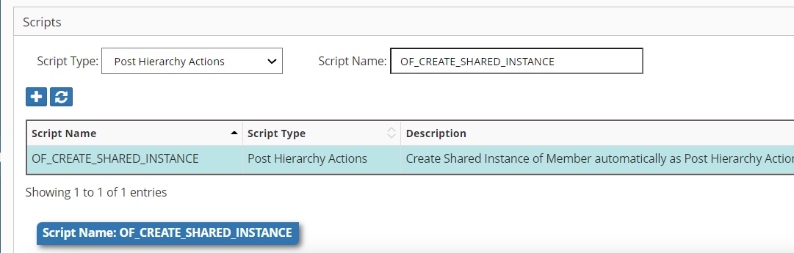

Assign a Logic script to the action as shown below. (Hierarchy Action menu option is under Configuration -> Dimension menu)

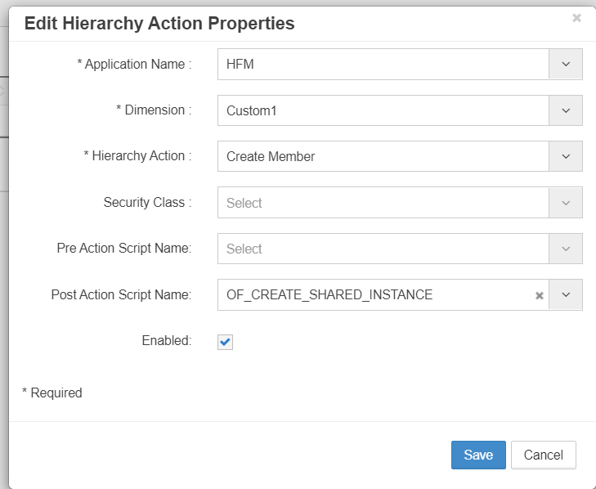

Seeded Script : EW_HFM_ENT_SEC_CLASS_AUTOMATION

This Logic Script is provided for all clients. It is mainly used by HFM Applications and for the Entity Dimension. The purpose of this Logic Script is to automatically create a new member in the “Security Class” dimension whenever a new Member in the Entity dimension is created.

Note: The script is available as a reference only. Please copy and modify it for your own use case and criteria.

Deployment Pre/Post Tasks

Overview
Pre or Post Deployment Logic Script types can be used to run custom scripts before deployments start or after deployments are completed. These scripts are associated in the Deployment manager screen as shown below.

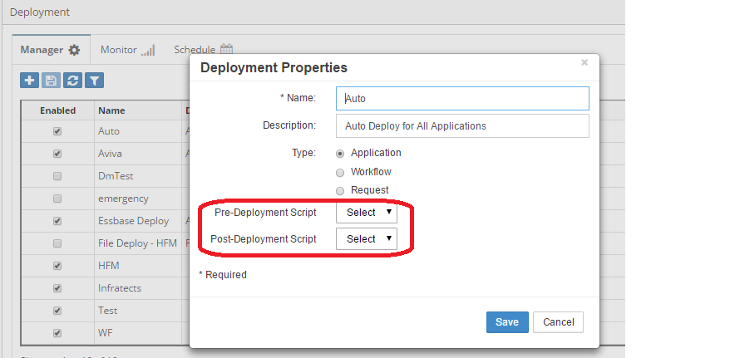

Input Parameters

The following table lists Input Parameters that are available for Property Mapping Logic Scripts.

Input Parameter | Description
g_user_id | Current logged User ID
g_lb_script_name | Logic Script Name being executed
g_dep_config_name | Deployment Configuration Name
g_deployment_id | Deployment ID
g_dep_scheduled_by_user_name | User who scheduled Deployment
g_dep_configured_by_user_name | User who configured the Deployment Manager
g_dep_request_id_list | PL/SQL table list of Request IDs which are part the Deployment Execution
g_dep_scheduled_by_user_id | User ID who scheduled Deployment
g_dep_configured_by_user_id | User ID who configured Deployment

Output Parameters

Output Parameter | Description
g_status | Status Values are either ‘S’ for Success or ‘E’ for Error.  Alternatively use the following method to set values in your code.  ew_lb_api.g_status := ew_lb_api.g_success  OR  ew_lb_api.g_status := ew_lb_api.g_error
g_message | Error Message if the status is Error.

Example

Requirement: Check whether the user who either configured or scheduled the current Deployment is not the same as the user who provided approvals in the workflow stage “Deploy Approve” for those requests which are part of that deployment.

This will be an example of a Pre Deployment Logic Script. If the above check fails then the deployment will not proceed.

DECLARE
c_script_name VARCHAR2(100) := 'OF_PRE_DEP_APPROVER_CHECK';
c_dep_config_name VARCHAR2(100) := ew_lb_api.g_dep_config_name;
c_deployment_id NUMBER := ew_lb_api.g_deployment_id;
c_dep_scheduled_by VARCHAR2(100) := ew_lb_api.g_dep_scheduled_by_user_name;
c_dep_scheduled_by_user_id NUMBER := ew_lb_api.g_dep_scheduled_by_user_id;
--
c_dep_configured_by VARCHAR2(100) := ew_lb_api.g_dep_configured_by_user_name;
c_dep_configured_by_user_id NUMBER := ew_lb_api.g_dep_configured_by_user_id;
--
c_wf_stage_name VARCHAR2(100) := 'Deploy Approve';
--
l_request_id NUMBER;
--
PROCEDURE log (p_msg VARCHAR2)
IS
BEGIN
ew_debug.log(p_msg,ew_debug.show_always,c_SCRIPT_NAME);
END log;
BEGIN
ew_lb_api.g_status := ew_lb_api.g_success;
ew_lb_api.g_message := NULL;

log('Pre Deployment Script - Start');

log('Deployment ID : '||c_deployment_id);
log('Deployment Name : '||c_dep_config_name);
log('Deployment Scheduled by : (ID: '||c_dep_scheduled_by_user_id||') (Name: '||c_dep_scheduled_by||')');
log('Deployment Configured by : (ID: '||c_dep_configured_by_user_id||') (Name: '||c_dep_configured_by||')');
log('Request count : '||ew_lb_api.g_dep_request_id_list.COUNT);

-- Check if deployment scheduler has approved any line in the
-- Deployment Review stage in the workflow
FOR i IN 1..ew_lb_api.g_dep_request_id_list.COUNT
LOOP
l_request_id := ew_lb_api.g_dep_request_id_list(i);
log('Request ID : '||l_request_id);
IF ew_req_api.chk_user_approved_stage
(p_request_id => l_request_id
,p_wf_stage_name => c_wf_stage_name
,p_user_id => c_dep_scheduled_by_user_id
) = 'Y'
THEN
log('check if deployment is scheduled by user who approved for Deployment');
ew_lb_api.g_status := ew_lb_api.g_error;
ew_lb_api.g_message := 'Pre Deployment Validation Failed. '||
'Request ['||l_request_id||'] '||
'is approved by the same user that '||
'scheduled UAT deployment for it.';
EXIT;
ELSIF ew_req_api.chk_user_approved_stage
(p_request_id => l_request_id
,p_wf_stage_name => c_wf_stage_name
,p_user_id => c_dep_configured_by_user_id
) = 'Y'
THEN
log('Check if Deployment is configured by user who approved for UAT Deployment');
ew_lb_api.g_status := ew_lb_api.g_error;
ew_lb_api.g_message := 'Pre Deployment Validation Failed. '||
'Request ['||l_request_id||'] '||
'is approved by the same user that '||
'configured requests in this deployment.';
EXIT;
ELSE
log('Request is Ok to be deployed..');
END IF;
END LOOP;

log('Pre Deployment Script - End');

EXCEPTION
WHEN OTHERS THEN
ew_lb_api.g_status := ew_lb_api.g_error;
ew_lb_api.g_message := 'Error : '||SQLERRM;
log(ew_lb_api.g_message);
END;

ERP Interface Tasks

Overview
There are two types of ERP Interface tasks (Pre-Import and Post Import) that are used by the ERP Import module. Pre-Import tasks are executed whenever new records for the ERP interface are found and before they are processed by the ERP Import execution. Post Import tasks are executed after records are processed for the ERP Interface.

These scripts are associated in the ERP Import -> Builder screen as shown below.

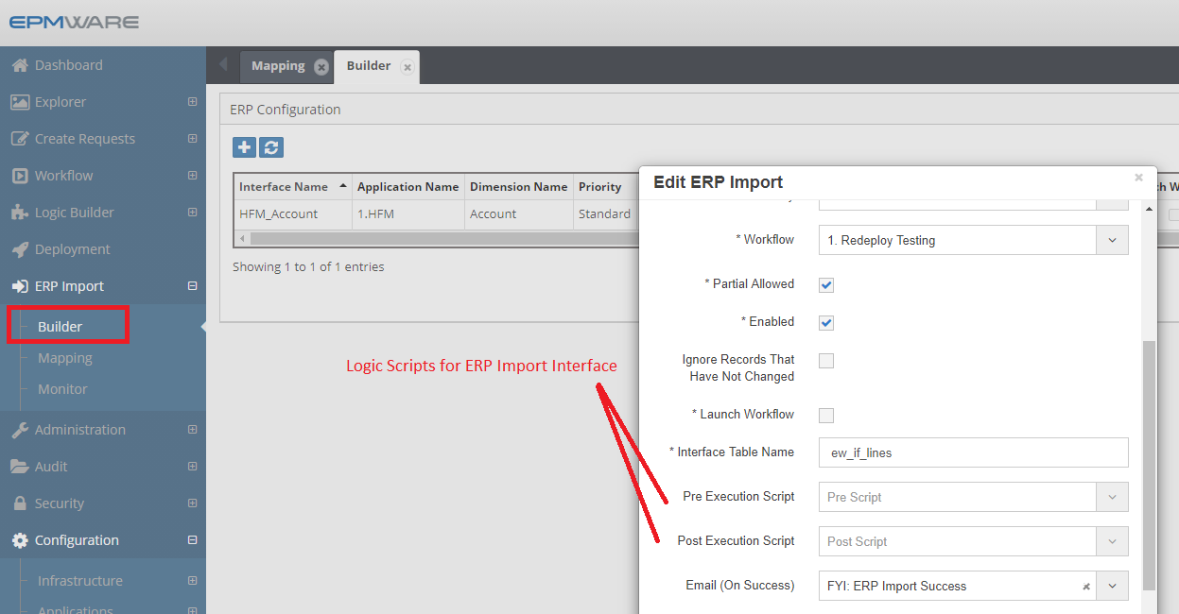

Input Parameters

The following table lists Input Parameters that are available for Property Mapping Logic Scripts.

Input Parameter | Description
g_user_id | Current logged User ID
g_lb_script_name | Logic Script Name being executed
g_if_config_name | ERP Import Configuration Name
g_app_name | Application Name
g_dim_name | Dimension Name
g_app_dimension_id | Dimension ID

Output Parameters

Output Parameter | Description
g_status | Status Values are either ‘S’ for Success or ‘E’ for Error.  Alternatively use the following method to set values in your code.  ew_lb_api.g_status := ew_lb_api.g_success  OR  ew_lb_api.g_status := ew_lb_api.g_error
g_message | Error Message if the status is Error.

Refer to Appendix C for table structure EW_IF_LINES

ERP Import interface table expects following values for the Action Code column in the table. This is useful when the user is populating records in the table either directly (for On Premise customers) OR via Pre ERP-Import logic script.

- Create
- Create or Edit
- Delete
- Edit
- Insert Shared
- Remove Shared
- Move
- Rename
- Reorder

Example
Requirement: Check if an Employee has moved in the ERP Interface table. If it has moved, then insert the move member action line in the interface table.

This is an example of a Pre ERP Interface-Logic Script. If the above check fails then the ERP Import will not proceed.

/*
Author : Deven Shah
Date : 27-Sep-2020
Purpose : Check if employee is moved or not
Version History
--------------------------------------------------------------------
Date | Name | Notes
--------------------------------------------------------------------
27-Sep-2020 | Deven | Initial Version
---------------------------------------------------------------------
*/
DECLARE
c_script_name VARCHAR2(50) := 'OF_EMP_PRE_IMPORT_ACTION';
c_user_id NUMBER := ew_lb_api.g_user_id;
c_if_config_name VARCHAR2(50) := ew_lb_api.g_if_config_name;
c_app_dim_id NUMBER := ew_lb_api.g_app_dimension_id;
--
--
PROCEDURE log (p_msg IN VARCHAR2)
IS
BEGIN
ew_debug.log(p_text => p_msg
,p_source_ref => c_script_name
);
END;
--
--
PROCEDURE move_members
IS
l_prev_sibling_member_name VARCHAR2(100);
--
-- Select records where Employee Parent Member passed is different
-- than the one in EPMWARE.. Hence, move the member
--
CURSOR cur
IS
SELECT DISTINCT
e.if_exec_id,e.if_config_id,e.name
,e.request_date,e.due_date,e.description
,e.requested_by,e.requestor_user_name
,e.member_name , h.parent_member_name
,e.parent_member_name moved_to_parent_member
,e.property1 Emp_name
,e.created_by,e.last_updated_by
,NVL(e.line_num,1)-1 line_num
FROM ew_if_lines e
,ew_if_configs i
,ew_hierarchy_details_v h
WHERE 1=1
AND e.name = c_if_config_name
AND e.status = 'N'
AND e.name = i.name
AND i.app_dimension_id = h.app_dimension_id
AND e.member_name = h.member_name
AND UPPER(e.parent_member_name) <> UPPER(h.parent_member_name)
-- Ensure member is not already moved
AND NOT EXISTS (SELECT 'Y'
FROM ew_hierarchy_details_v x
WHERE 1=1
AND x.member_id = h.member_id
AND UPPER(x.parent_member_name) = UPPER(e.parent_member_name)
)
ORDER BY e.parent_member_name
,e.property1 DESC
;
BEGIN
FOR rec IN cur
LOOP
log('Move : '||rec.member_name||' to Parent '||rec.moved_to_parent_member);

INSERT INTO ew_if_lines
(if_config_id,if_line_id,name
,request_date,due_date,description
,requested_by,requestor_user_name
,member_name,parent_member_name,moved_to_parent_member
,prev_sibling_member
,action_code
,line_num
,creation_date,created_by,last_update_date,last_updated_by
)
VALUES
(rec.if_config_id,ew_if_lines_s1.NEXTVAL,rec.name
,rec.request_date,rec.due_date,rec.description
,rec.requested_by,rec.requestor_user_name
,rec.member_name,rec.parent_member_name,rec.moved_to_parent_member
,l_prev_sibling_member_name
,'Move'
,rec.line_num -- Process Move Actions first
,SYSDATE,rec.created_by,SYSDATE,rec.last_updated_by
)
;
END LOOP;
END move_members;
--
BEGIN
ew_lb_api.g_status := ew_lb_api.g_success;
ew_lb_api.g_message := NULL;

log('Check if Employee Last Name is changed OR not.');

log('+ ERP Import Name : '||c_if_config_name);

-- Move Members if the Inbound ERP Import has different
-- Parent Member than the one already exists in EPMWARE

move_members;

COMMIT;

EXCEPTION
WHEN OTHERS THEN
ew_lb_api.g_status := ew_lb_api.g_error;
ew_lb_api.g_message := SQLERRM;
log(ew_lb_api.g_message);
END;

Configuration

Create Logic Script as shown below.

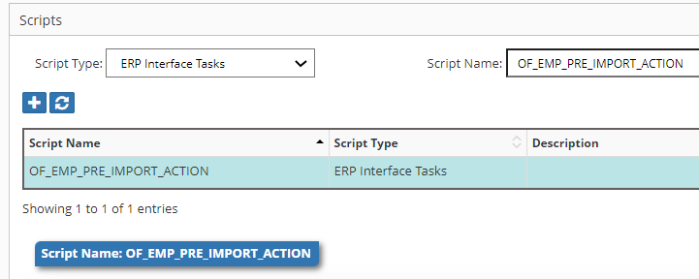

Assign this Logic script to the ERP Import Configuration as shown below.

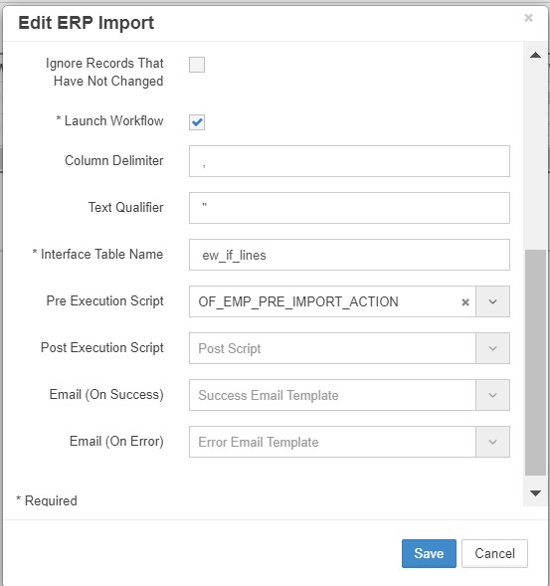

On Submit Workflow Task

Overview
On Submit Workflow custom tasks Logic Scripts can be used to perform custom tasks such as whether certain properties are populated for base members or parent members, or whether certain members have alternate (or shared) instances created.

These scripts are associated in the Workflow -> Builder screen as shown below.

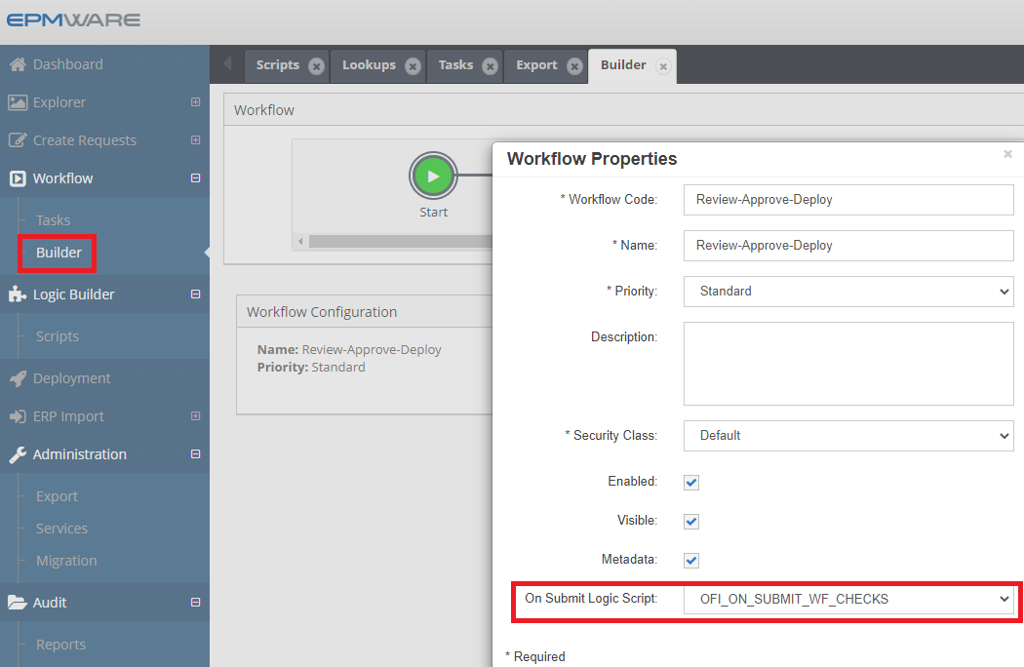

Input Parameters

The following table lists Input Parameters that are available for Property Mapping Logic Scripts.

Input Parameter | Description
g_user_id | Current logged User ID
g_lb_script_name | Logic Script Name being executed
g_request_id | Request ID
g_wf_code | Workflow Code

Output Parameters

Output Parameter | Description
g_status | Status Values are either ‘S’ for Success or ‘E’ for Error.  Alternatively use the following method to set values in your code.  ew_lb_api.g_status := ew_lb_api.g_success  OR  ew_lb_api.g_status := ew_lb_api.g_error
g_message | Error Message if the status is Error.

In order to show an error for each line, use the following API.

ew_lb_api.ins_req_val_rec
(p_line_num => <Request Line #>
,p_message => <Message>
,p_qa_name => <Logic Script Name>
);

Example

Requirement: Ensure Base Members under the Primary Branch have their shared instance under the Alternate branch. If not, then throw an error.

/* Version History ---------------------------------------------------------------------
Date | Name | Notes ---------------------------------------------------------------------
20-Jan-21 | Deven | Initial Version ---------------------------------------------------------------------
*/
DECLARE
c_script_name VARCHAR2(50) := 'OF_ON_SUBMIT_WF';
c_user_id NUMBER := ew_lb_api.g_user_id;
c_request_id VARCHAR2(50) := ew_lb_api.g_request_id;
c_app_name VARCHAR2(50) := 'OF_HFM';
--
--
PROCEDURE log (p_msg IN VARCHAR2)
IS
BEGIN
ew_debug.log(p_text => p_msg
,p_source_ref => c_script_name
);
END;
--
PROCEDURE add_err (p_line_num IN VARCHAR2, p_message IN VARCHAR2)
IS
BEGIN
ew_lb_api.ins_req_val_rec
(p_line_num => p_line_num
,p_message => p_message
,p_qa_name => c_script_name
);
ew_lb_api.g_status := ew_lb_api.g_error;
END add_err;
--
PROCEDURE chk_shared_members (p_dim_name IN VARCHAR2
,p_store_branch IN VARCHAR2
,p_share_branch IN VARCHAR2
)
IS
CURSOR cur
IS
SELECT *
FROM ew_request_line_members_v l
WHERE 1=1
AND l.request_id = c_request_id
AND l.status <> 'X' -- not cancelled lines
AND l.app_name = c_wmt_app_name
AND l.dim_name = p_dim_name
AND l.action_code IN ('CMC','CMS') -- Create member as Child or Sibling
AND ew_hierarchy.is_base_member(l.member_id) = 'Y'
-- Check whether the member exists under Primary branch
AND ew_hierarchy.chk_primary_branch_exists
(p_app_dimension_id => l.app_dimension_id
,p_parent_member_name => p_store_branch
,p_member_name => l.member_name
) = 'Y'
-- But not under Alternate branch
AND ew_hierarchy.chk_branch_exists
(p_app_dimension_id => l.app_dimension_id
,p_parent_member_name => p_share_branch
,p_member_name => l.member_name
) = 'N'
ORDER BY l.line_num
;
BEGIN
log('** Check Base '||p_dim_name||' missing Shared instance under '||p_share_branch||' branch');
FOR rec IN cur
LOOP
log('Line # '||rec.line_num||' Member name : '||rec.member_name);
add_err(rec.line_num, p_dim_name||' Base Member must have a Shared Instance under '||p_share_branch||' branch.');
END LOOP;
END chk_shared_members;
--
BEGIN

ew_lb_api.g_status := ew_lb_api.g_success;
ew_lb_api.g_message := NULL;

log('** Start: Validations Request ID : '||c_request_id);

-- Check for missing Shared members in specified branches
-- Parameters : Dimension Name
-- Primary Branch top Member name
-- Alternate Branch top Member name
--
chk_shared_members ('Detail_Account','A101_1','PK_01');

log('** End: Validations Request ID : '||c_request_id);

END;

Configuration

Create Logic Script as shown below.

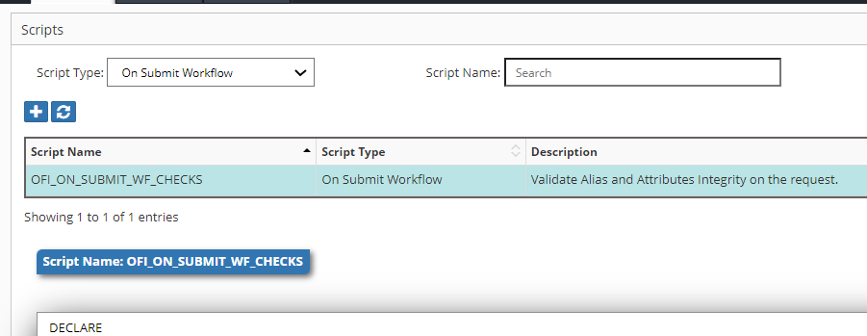

Assign this Log script to the Workflow Builder as shown below.

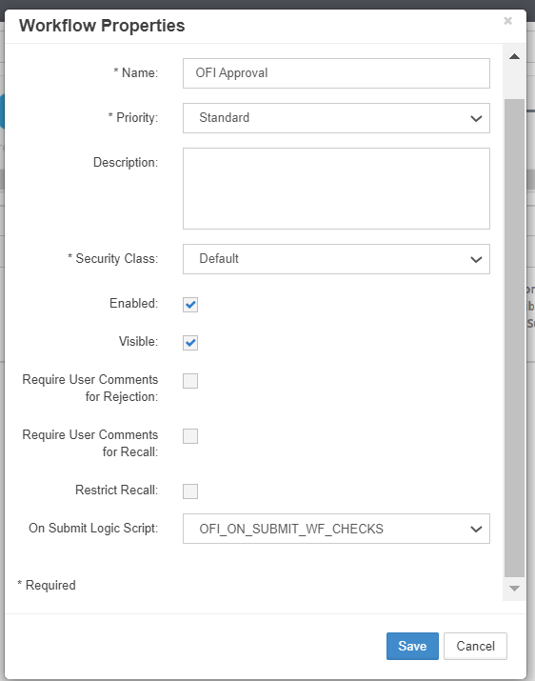

Workflow Custom Task

Overview
Workflow Custom Tasks Logic Scripts are used to perform custom tasks such as determining if a workflow stage should be removed based on certain conditions, perform specific validations, send emails if certain conditions satisfy or any other complex task that needs to be performed in the workflow in a specific stage. This task has one special parameter (out type) which you can optionally set to recall the request in the workflow to a prior stage.

These scripts are associated in the Workflow -> Tasks screen as shown below.

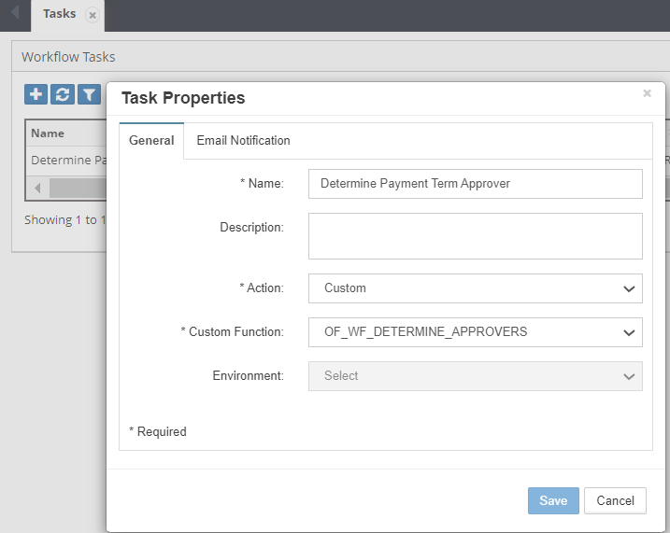

Input Parameters

The following table lists Input Parameters that are available for Property Mapping Logic Scripts.

Input Parameter | Description
g_user_id | Current logged User ID
g_lb_script_name | Logic Script Name being executed
g_request_id | Request ID
g_wf_code | Workflow Code
g_wf_stage_name | Workflow Stage Name
g_wf_stage_task_id | Workflow Stage Task Internal ID

Output Parameters

Output Parameter | Description
g_status | Status Values are either ‘S’ for Success or ‘E’ for Error.  Alternatively use the following method to set values in your code.  ew_lb_api.g_status := ew_lb_api.g_success  OR  ew_lb_api.g_status := ew_lb_api.g_error
g_message | Error Message if the status is Error.
g_out_rewind_stages | Optionally you can specify # of stages you would like to rewind the request in the workflow. For example, if you specify 1 then the request will get recalled to the one stage prior to the current stage.

Example

Requirement: Users are managing a customer dimension for an application called “Oracle EBS” where users specify Payment Terms for all customers. If the members (Customer records in this case) have standard Payment Terms such as (Net 30) then there is no need to receive approval from the Payment Term Approval team. In other words, special approval is needed only if the Payment Term is not Net 30 which is default for all new customers.

/* Author : Deven (EPMWARE)
Date : 19-Oct-2020
Purpose: Workflow Custom task to remove workflow stages
that are not required in the request depending on the
hierarchy changes applied in the request.
*/
DECLARE
C_SCRIPT_NAME VARCHAR2(50) := 'OF_WF_DETERMINE_APPROVERS';
C_REQUEST_ID NUMBER := ew_lb_api.g_request_id;
--
c_ora_app_name VARCHAR2(100) := 'Oracle EBS';
c_ora_cust_dim_name VARCHAR2(100) := 'Customers';
l_wf_stages_to_be_removed ew_global.g_char_tbl;
l_sts VARCHAR2(1);
l_msg VARCHAR2(2000);
l_error_ex EXCEPTION;
l_keep_task BOOLEAN := FALSE;
--
PROCEDURE log (p_msg VARCHAR2)
IS
BEGIN
ew_debug.log(p_msg,ew_debug.show_always,C_SCRIPT_NAME);
END log;
--
PROCEDURE chk_payment_term
IS
CURSOR cur
IS
SELECT l.*
FROM ew_request_line_members_v l
,ew_member_props_all_v p
WHERE 1=1
AND l.request_id = c_request_id
AND l.status <> 'X' -- not cancelled lines
AND l.app_name = c_ora_app_name
AND l.dim_name = c_ora_cust_dim_name
AND l.action_code IN ('CMC','CMS','P') -- Create member OR Edit properties
AND l.member_id = p.member_id
AND p.prop_label = 'Payment Terms'
AND p.prop_value <> 'NET30'
ORDER BY l.line_num
;
BEGIN
log('** Check customers having Special Payment Terms..');
FOR rec IN cur
LOOP
log('Line # '||rec.line_num||
' Member name : '||rec.member_name);
l_keep_task := TRUE;
END LOOP;
END chk_payment_term;
BEGIN
-- Default values for return code
ew_lb_api.g_status := ew_lb_api.g_success;
ew_lb_api.g_message := NULL;

log('Determine Payment Term for Request ID : '|| C_REQUEST_ID);

chk_payment_term;

IF NOT l_keep_task
THEN
-- Remove approver task as there is no request line
-- with Special Payment Term ( other than NET 30)
ew_req_api.upd_wf_stage_task_approval_cnt
(p_request_id => C_REQUEST_ID
,p_wf_stage_name => 'Primary Approver'
,p_wf_task_name => '10x Non Net 30 Approvals'
,p_num_of_approvals => 0
,x_sts => l_sts
,x_msg => l_msg
);
IF l_sts = ew_constants.g_err_code
THEN
ew_lb_api.g_message := l_msg;
RAISE l_error_ex;
ELSE
log('Workflow Task Removed');
END IF;
END IF;

EXCEPTION
WHEN l_error_ex THEN
ew_lb_api.g_status := ew_lb_api.g_error;
log(ew_lb_api.g_message);
WHEN OTHERS THEN
ew_lb_api.g_status := ew_lb_api.g_error;
ew_lb_api.g_message := 'Error Executing Logic Script : '||SQLERRM;
log(ew_lb_api.g_message);
END;

Pre/Post Export Tasks

Overview
Pre or Post Export Generation Tasks Logic Scripts are used to perform custom tasks while generating Export files.

These scripts are associated in the Administration -> Export screen as shown below.

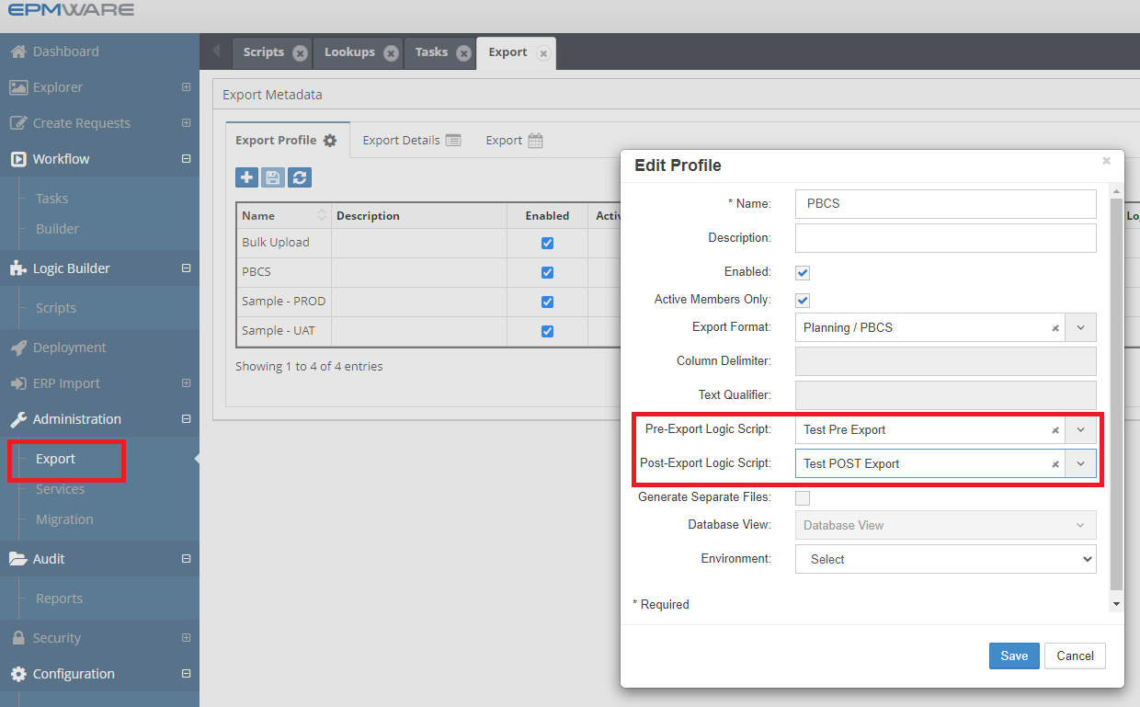

Input Parameters

The following table lists Input Parameters that are available for Property Mapping Logic Scripts.

Input Parameter | Description
g_user_id | Current logged User ID
g_lb_script_name | Logic Script Name being executed
g_exp_config_name | Export Name
g_exp_id | Export Execution ID

Output Parameters

Output Parameter | Description
g_status | Status Values are either ‘S’ for Success or ‘E’ for Error.  Alternatively use the following method to set values in your code.  ew_lb_api.g_status := ew_lb_api.g_success  OR  ew_lb_api.g_status := ew_lb_api.g_error
g_message | Error Message if the status is Error.

Example

Requirement: The PBCS application has seeded members for the Period Dimension that are not shown in the application but are included in the LCM Extract file and loaded in EPMWARE. For example, D-T-D, H-T-D, M-T-D, P-T-D. The Export should remove these members from the Export file.

/* Date : 13-Aug-2021
Author : Deven Shah (EPMWARE)
Purpose : Remove Period dimension time series related seeded members
---------------------------------------------------------------------
Modified Date | By | Notes
---------------------------------------------------------------------
13-Aug-2021 | Deven | Initial Version
30-Sep-2021 | Deven | Removed time series members from the export
---------------------------------------------------------------------
*/
DECLARE
--
--
c_script_name VARCHAR2(50) := 'OF_EXPORT_PBCS_DATA';
C_EXP_ID NUMBER := ew_lb_api.g_exp_id;
C_EXP_CONFIG_NAME VARCHAR2(50) := ew_lb_api.g_exp_config_name;

PROCEDURE log(p_msg IN VARCHAR2)
IS
BEGIN
ew_debug.log(p_msg,ew_debug.show_always,c_script_name);
END;

PROCEDURE del_period_time_series_mems
IS
BEGIN
log('Delete Time Series Members from the Period dimension');
DELETE
FROM ew_exp_members p
WHERE 1=1
AND p.exp_id = C_EXP_ID
AND p.member_name IN ('D-T-D','H-T-D','M-T-D','P-T-D'
,'Q-T-D','S-T-D','W-T-D','Y-T-D')
;
log('# of time series members removed : '||SQL%ROWCOUNT);
END del_period_time_series_mems;
BEGIN
-- Default values for return code
ew_lb_api.g_status := ew_lb_api.g_success;
ew_lb_api.g_message := NULL;

log('Export ID : '||C_EXP_ID);
log('Export Name : '||C_EXP_CONFIG_NAME);

-- Delete Time Series members from the Period dimension
-- For example, Y-T-D, H-T-D and so on
-- These members are not visible in the PBCS apps in the Metadata hierarchy
-- but PBCS adds them in the LCM Extract file and hence gets loaded in the EPMWARE app as well.
-- Hence, we need to remove it from the export to make it consistent for the downstream apps

del_period_time_series_mems;

COMMIT;

EXCEPTION
WHEN OTHERS THEN
ew_lb_api.g_status := ew_lb_api.g_error;
ew_lb_api.g_message := 'Error in Logic Script ['||c_script_name||'] '||
SQLERRM;
log(ew_lb_api.g_message);
END;

On Request Line Approval

Overview
These scripts are assigned to Workflow Review or Approve tasks and are executed when the user approves a line or mass approves lines in a Request. This event is useful especially to validate properties or actions taken in a request before it gets approved by the Reviewer or Approver.

Input Parameters

The following table lists Input Parameters that are available for Property Mapping Logic Scripts.

Input Parameter | Description
g_user_id | Current logged User ID
g_lb_script_name | Logic Script Name being executed
g_request_id | Request ID
g_request_line_id | Request Line ID
g_wf_code | Workflow Code
g_wf_stage_name | Workflow Stage Name

Output Parameters

Output Parameter | Description
g_status | Status Values are either ‘S’ for Success or ‘E’ for Error.  Alternatively use the following method to set values in your code.  ew_lb_api.g_status := ew_lb_api.g_success  OR  ew_lb_api.g_status := ew_lb_api.g_error
g_message | Error Message if the status is Error.

Example
Requirement: Attach a file to the request before it proceeds to the next stage in the workflow.

/* Date : 13-Jul-2020
Author : Deven Shah
Purpose : Check whether the user has attached a file or not before approving the line.
-------------------------------------------------------------------
Date | Name | Notes
------------------------------------------------------------------
13-Jul-2020 | Deven | Initial Version
------------------------------------------------------------------
*/
DECLARE
C_LB_SCRIPT VARCHAR2(50) := 'OF_REQ_LINE_APPROVAL_CHECK';
C_REQUEST_ID NUMBER := ew_lb_api.g_request_id;
C_REQUEST_LINE_ID NUMBER := ew_lb_api.g_request_line_id;
C_USER_ID NUMBER := ew_lb_api.g_user_id;
C_WF_STAGE_NAME VARCHAR2(100) := ew_lb_api.g_wf_stage_name;
--
l_hfm_review_stage VARCHAR2(100) := 'HFM Mapping Review and Approval';
l_fin_mgr_review_stage VARCHAR2(100) := 'Finance GL Manager Review';
--
l_error_ex EXCEPTION;
--
PROCEDURE log(p_msg IN VARCHAR2)
IS
BEGIN
ew_debug.log(p_msg,ew_debug.show_always,C_LB_SCRIPT);
END;

-- Add Message into Global Message
PROCEDURE add_msg (p_msg IN VARCHAR2)
IS
BEGIN
IF ew_lb_api.g_message IS NOT NULL
THEN
ew_lb_api.g_message := ew_lb_api.g_message || ' '|| CHR(10)||'<BR>';
ELSE
ew_lb_api.g_status := ew_lb_api.g_error;
END IF;

ew_lb_api.g_message := ew_lb_api.g_message || p_msg;

END add_msg;

/* ********************************************************************
Check if an attachment is added or not if the request has Company dimension changes. *******************************************************************/
PROCEDURE chk_attachments
IS
l_req_att VARCHAR2(1);
l_HFM_mapping_comp VARCHAR2(100);
l_Attachment_checkbox VARCHAR2(100);

CURSOR cur
IS
SELECT l.*
FROM ew_request_line_members_v l -- This view will provide details for all request lines
,ew_req_line_wf_actions_v w -- This view will check if user can approve line or not
WHERE 1=1
AND l.request_id = c_request_id
AND l.status <> 'X' -- not cancelled lines
AND l.app_name = 'Oracle EBS'
AND l.dim_name = 'Company'
-- Ensure current user is Approver for the request line
AND l.request_line_id = w.request_line_id
AND w.action_code = 'A' -- Approve action
AND w.action_allowed = 'Y'
AND w.user_id = C_USER_ID
--
ORDER BY l.line_num
;
BEGIN
-- Check whether request has any attachment or not
-- (Y or N flag)
l_req_att := ew_req_api.chk_req_has_attachments(C_REQUEST_ID);

IF l_req_att = 'N'
THEN
log('Request does not have any attachments.. Check if there is any change for Company dimension..');
FOR rec IN cur
LOOP
log('Line # '||rec.line_num||' Member name : '||rec.member_name);
l_attachment_checkbox := ew_lb_api.get_member_prop_value
(p_member_id => rec.member_id
,p_prop_label => 'Attachment Required');

log('Checkbox value: '||l_Attachment_checkbox);

IF l_attachment_checkbox = 'Y'
THEN
add_msg ('Request needs attachment if Company dimension is modified. '||
'Check Line # '||rec.line_num ||'.');
END IF;
END LOOP;
END IF;

END chk_attachments;

BEGIN
-- Default values for return code
ew_lb_api.g_status := ew_lb_api.g_success;
ew_lb_api.g_message := NULL;

log('Request ID : '||C_REQUEST_ID);
log('Workflow Stage Name : '||C_WF_STAGE_NAME);

chk_attachments;

IF ew_lb_api.g_status = ew_lb_api.g_error
THEN
log(ew_lb_api.g_message);
ELSE
log('No Error..');
END IF;

EXCEPTION
WHEN l_error_ex THEN
log(ew_lb_api.g_message);
WHEN OTHERS THEN
ew_lb_api.g_status := ew_lb_api.g_error;
ew_lb_api.g_message := 'Error Executing Logic Script : '||SQLERRM;
log(ew_lb_api.g_message);
END;

Logic Builder API Library

This section will provide a list of Logic Builder APIs and database views that are used to build Custom Logic Scripts. All APIs and database views are based on the Oracle PL/SQL Language.

Database Views

EW_APPS_V

This view holds information about applications setup in the EPMware application.

Key columns are as mentioned below:
Column Name | Meaning
APP_ID | Primary key identifier of the App Table
NAME | Application Name
TARGET_APP_NAME | Target Application Name
ENABLED_FLAG | Y/N to indicate whether application is enabled or disabled
USER_NAME | Application Username

EW_APP_DIMENSIONS_V

This table holds information about dimensions in the EPMware application.

Key columns are as mentioned below:
Column Name | Meaning
APP_DIMENSION_ID | Primary key identifier of the Dimensions Table
APP_ID | Application ID
APP_NAME | Application Name
TARGET_APP_NAME | Target Application Name
ENABLED_FLAG | Y/N to indicate whether dimension is enabled or disabled
APP_ENABLED_FLAG | Y/N to indicate whether application is enabled or disabled
APP_TYPE | Internal code for Application Type
DIM_CLASS_NAME | Dimension Class Name

EW_REQUEST_LINE_MEMBERS_V
This view provides all request lines and its member’s data. Key columns are as mentioned below:

Column Name | Meaning
REQUEST_ID | Request ID
LINE_NUM | Request Line #
ACTION_CODE | Internal Code Request Line Actions
ACTION_NAME | Action Name such as “Create Member”, “Edit Properties”.
APP_DIMENSION_ID | Primary key identifier of the Dimensions Table
APP_ID | Primary key identifier of the App Table
CHILDLESS_PARENT_MEMBER_NAME | Parent Member Name if it is Childless
DEPLOY_DATE | Deploy Date of the request line
DIM_CLASS_NAME | Dimension Class Name
DIM_NAME | Dimension Name
HIERARCHY_ID | Primary identifier of the table that stores nodes.
MEMBER_ALIAS | Member Description
MEMBER_ID | Member ID. Primary identifier of the table that stores members
MEMBER_NAME | Member Name
MOVED_FROM_MEMBER_ID | Moved from the Member ID if the line action is Move Member
MOVED_FROM_MEMBER_NAME | Moved from the Member Name if the line action is Move Member
ORIG_MEMBER_NAME | Original Member name if the line action is Rename Member
PARENT_MEMBER_ID | Parent Member id. Primary identifier of the table that stores members
PARENT_MEMBER_NAME | Parent Member Name
PREV_SIBLING_MEMBER_NAME | Previous Sibling Member Name
PREV_SIBLING_PRIMARY_FLAG | Y/N flag to indicate whether previous member is a primary member or not
PRIMARY_FLAG | Y/N flag to indicate whether member is a primary instance or not
RELATED_LINE_ID | Request line id to which this line is related to
REQUEST_LINE_ID | Request Line id
REQUEST_LINE_MEMBER_ID | Request Line Member ID
SORT_ORDER | Sort order of the member
STATUS | Status of the request line
TARGET_APP_NAME | Target Application Name

EW_MEMBERS_V
This view provides member data. Key columns are as mentioned below:

Column Name | Meaning
APP_NAME | Application Name
DIM_NAME | Dimension Name
APP_DIMENSION_ID | Primary key identifier of the Dimensions Table
APP_ID | Primary key identifier of the App Table
MEMBER_ID | Primary identifier for the member
MEMBER_NAME | Member Name. Member name has to be unique within the dimension.
STATUS | Status of the Member  A -> Active (No pending activity)  W -> Work in Progress (Some pending activity)
ROOT_FLAG | Y/N flag to indicate whether the member is a root member of the dimension
CREATION_DATE | Date member was created
LAST_UPDATE_DATE | Last update date on the member

EW_HIERARCHY_MEMBERS_V
This view provides node data. Key columns are as mentioned below. Node is a combination of member id and parent member id combination. This combination is a unique combination.

Column Name | Meaning
HIERARCHY_ID | Primary identifier of the view
APP_DIMENSION_ID | Primary key identifier of the Dimensions Table
MEMBER_ID | Member ID. Primary identifier of the table that stores members
MEMBER_NAME | Member Name
MEMBER_STATUS | Status of the Member  A -> Active (No pending activity)  W -> Work in Progress (Some pending activity)
HIERARCHY_STATUS | Status of the Member  A -> Active (No pending activity)  W -> Work in Progress (Some pending activity)
PARENT_MEMBER_ID | Parent Member id
PARENT_MEMBER_NAME | Parent Member Name
PARENT_ROOT_FLAG | Y/N flag to indicate whether the member is a root member of the dimension
SORT_ORDER | Sort order of the member within its parent member
PRIMARY_FLAG | Y/N flag to indicate whether a member is a primary instance of the parent member.  Y -> Primary  N -> Shared Instance

EW_LOOKUP_CODES_V

This view provides lookup codes. Procedure APIs are also available. In case all records and other attributes such as TAG or Description are needed, then a view can be useful too.

For example,

SELECT lookup_code,meaning, description,seq_num,tag
FROM ew_lookup_codes_v
WHERE lookup_name = ‘<Your lookup Name>’
ORDER BY lookup_code

Record types

EW_LB_API.G_WF_TASK_REC

Ew_lb_api.g_wf_task_rec is based on the database view EW_WF_STAGE_TASKS_C_V. Columns of this record type are mentioned below.

- ACTION
- ACTION_CODE
- CYCLE_STATUS
- DESCRIPTION
- EMAIL_TEMPLATE
- EMAIL_TEMPLATE_ID
- ENFORCED_FLAG
- FREEZE_FLAG
- GROUP_ID
- GROUP_NAME
- LB_SCRIPT_ID
- METADATA_FLAG
- NUM_OF_APPROVALS
- PRIORITY_CODE
- REQUEST_ID
- SCRIPTS_FLAG
- STAGE_NAME
- STAGE_NUM
- STAGE_STATUS
- STAGE_TASK_MESSAGE
- STAGE_TASK_SEQ_NUM
- STAGE_TASK_STATUS
- STAGE_TASK_STATUS_MEANING
- TASK_ACTION_CODE
- TASK_DESCRIPTION
- TASK_NAME
- WF_CYCLE_ID
- WF_ID
- WF_STAGE_ID
- WF_STAGE_TASK_ID
- WF_TASK_ID
- WORKFLOW_NAME

Database Package APIs

In Memory Functions

Package : EW_LB_API

This package provides functions that provide information for in-memory values which are not yet committed to the database and scripts may need access to these values for automation or validations.

These functions can be referred to as ew_lb_api.<Function Name>..

Get New Member Property Value
-- Return Member property value for new members for which
-- Logic Script is being invoked
FUNCTION get_new_member_prop_value (p_prop_label IN VARCHAR2)
RETURN VARCHAR2;

Get Member Property Value
-- Return Member property value for current hierarchy for which
-- Logic Script is being invoked
-- Pass either Property Label OR Property Name

FUNCTION get_member_prop_value (p_prop_label IN VARCHAR2)
RETURN VARCHAR2;

Get Parent Member Property Value

-- Return Parent Member’s property value for current hierarchy
-- for which Logic Script is being invoked
-- Pass either Property Label OR Property Name

FUNCTION get_parent_prop_value (p_prop_label IN VARCHAR2)
RETURN VARCHAR2;

Get Member Property Value from Archive

-- Return Member property value for current hierarchy for which
-- Logic Script is being invoked during Property Validation
-- Pass either Property Label OR Property Name

FUNCTION get_member_prop_value_archive (p_prop_label IN VARCHAR2)
RETURN VARCHAR2;

-- This function will use current property which is being validated
FUNCTION get_member_prop_value_archive
RETURN VARCHAR2;

Is value Numeric
-- This function will check if the given string is numeric or not.
-- If numeric then return TRUE or else FALSE
FUNCTION is_numeric (p_string IN VARCHAR2)
RETURN BOOLEAN;

Is current member Base Member
-- Check if current member is leaf or not
FUNCTION is_leaf
RETURN BOOLEAN;

Get Descendants Count
-- This function provides count of direct descendants for a given member id
FUNCTION get_descendants_count (p_member_id IN NUMBER)
RETURN NUMBER;

-- This function provides count of direct descendants for a given member name and application dimension id
FUNCTION get_descendants_count (p_app_dimension_id IN NUMBER
,p_member_name IN VARCHAR2
)
RETURN NUMBER;

Get Request Attribute

FUNCTION get_req_attrib (p_request_id IN NUMBER
,p_what IN VARCHAR2
)
RETURN VARCHAR2
;

p_what | Value
UDF1 (or UDF2 or UDF3) | Returns value from UDF(1 to3) field of Request Header
REQUESTED_BY | Returns User Name of the Requestor on the request
PRIORITY_CODE | Provides code the Priority from the Request Header
WORKFLOW_NAME | Provides name of the workflow from the request header
DESCRIPTION | Provides description value from the request header
REQUEST_DATE | Provides request date in the format DD-MON-RRRR
DUE_DATE | Provides request due date in the format DD-MON-RRRR

-- Provides request attribute for the current request
-- for which logic builder script is being executed
FUNCTION get_req_attrib (p_what IN VARCHAR2)
RETURN VARCHAR2
;

Email APIs

Package: EW_EMAIL_API

These functions can be referred to as ew_email_api.<Function Name>..

Get User Email

Two functions are provided to get the User’s email by passing either User ID or passing User Name’

FUNCTION get_user_email(p_user_id IN NUMBER) RETURN VARCHAR2;

FUNCTION get_user_email(p_user_name IN VARCHAR2) RETURN VARCHAR2;

Send Email (Specify Recipients)

-- return Success / Failure code in x_result out parameter
-- x_result -> success = 0 failure = 1
PROCEDURE send_email (p_recipients IN VARCHAR2
,p_subject IN VARCHAR2
,p_body IN VARCHAR2
,p_send_addr IN VARCHAR2 DEFAULT NULL
,p_ccs IN VARCHAR2 DEFAULT NULL
,p_bccs IN VARCHAR2 DEFAULT NULL
,x_result OUT NUMBER
)

Send Email (Email Template)

PROCEDURE send_email (p_request_id IN NUMBER
,p_email_template_name IN VARCHAR2
,p_email_vars IN g_email_vars
);

G_email_vars is a global variable in the Email API Package with type reference as mentioned below. This parameter can be used to specify the Name/Value type of parameter that can be passed to the template. Email Templates can refer to these variables and replace values in the template.

If the Request ID is passed, then request id-related information can be referenced in the email template.

TYPE g_email_vars IS TABLE OF VARCHAR2(2000) INDEX BY VARCHAR2(50);

Request API Functions

Package: EW_REQ_API

These functions can be referred to as ew_req_api.<Function Name>

Get Request Header Attribute

/* Get information from Request Header
Valid parameter values for p_what are
UDF1, UDF2, UDF3, REQUESTED_BY, PRIORITY_CODE
WORKFLOW_NAME, DESCRIPTION, REQUEST_DATE, DUE_DATE
*/
FUNCTION get_req_attrib (p_request_id IN NUMBER
,p_what IN VARCHAR2
)
RETURN VARCHAR2;

Insert Request Note

PROCEDURE ins_req_note
(p_user_id IN NUMBER
,p_request_id IN NUMBER
,p_notes IN VARCHAR2
);

Check if Request has any file attached

/* Return Y if the request has at least one file attached.
*/
-- Check if the Request has files attached or not
-- Optionally check to exclude Zero byte attachments as well as
check
-- files having specific extensions (Separated by comma char)
for example
-- xls, xlsx and so on
-- In addition it can also check if filename without extension
matches
-- and file having string or not. (File has to be non-binary)
FUNCTION chk_req_has_attachments
(p_request_id IN NUMBER
,p_exclude_null_atts IN VARCHAR2 DEFAULT 'N'
,p_file_extensions IN VARCHAR2 DEFAULT NULL
,p_file_name_without_ext IN VARCHAR2 DEFAULT NULL
,p_file_search_str IN VARCHAR2 DEFAULT NULL
)
RETURN VARCHAR2;

Check if Request has a line for a Specific Application

/* Return Y if the request has at least one non canceled line in the request for the given application.
Return N if no such line is found.
*/
FUNCTION chk_req_has_app_lines (p_request_id IN NUMBER
,p_app_name IN VARCHAR2
)
RETURN VARCHAR2;

Check if Request has a line for a Specific Dimension

/* Return Y if the request has at least one non canceled line in the request for the given application and its specific dimension.
Return N if no such line is found.
*/
FUNCTION chk_req_has_dim_lines (p_request_id IN NUMBER
,p_app_name IN VARCHAR2
,p_dim_name IN VARCHAR2
)
RETURN VARCHAR2;

Check if Request has a line for a Specific Hierarchy Action

/* Return Y if the request has at least one non canceled line in the request for the given application and its specific dimension and specific Action Name. See full list of Action Names in Appendix B
Return N if no such line is found.
*/
FUNCTION chk_req_has_action_lines(p_request_id IN NUMBER
,p_app_name IN VARCHAR2
,p_dim_name IN VARCHAR2
,p_action_name IN VARCHAR2
)
RETURN VARCHAR2;

Check User Action Allowed

Return Values are Y if action is allowed. Else N.
X_msg -> Will return an error message if any is encountered.

FUNCTION chk_action_allowed
(p_user_id IN NUMBER
,p_request_id IN NUMBER
,p_app_dimension_id IN NUMBER
,p_action_code IN VARCHAR2
,p_hierarchy_id IN NUMBER
,p_new_member_name IN VARCHAR2
,p_moved_to_member_id IN NUMBER
,p_chk_line_exists IN VARCHAR2
,x_msg IN OUT VARCHAR2
)
RETURN VARCHAR2;

Parameters

Parameter Name | Description
p_user_id | User ID performing the action
p_request_id | Request ID on which action check is being performed
p_app_dimension_id | Application Dimension ID on which action check is being performed
p_action_code | Action Code. See table for complete list of action codes  .  Please check with your target application to ensure which actions are valid or not.
p_hierarchy_id | Hierarchy ID on which action is being taken upon
p_new_member_name | New Member Name (pass NULL if the action is not creating a new member)
p_moved_to_member_id | Moved to Member ID (Pass NULL if the action is not moved member)
p_chk_line_exists | Pass Y or N to Check if the line already exists with the same action on the dimension
x_msg | OUT parameter  Returns error message if the function encountered any unexpected error

Check Pending Action from a User

Returns Y or N

FUNCTION chk_user_action_required
(p_request_id IN NUMBER
,p_user_id IN NUMBER
)
RETURN VARCHAR2;

Check User Action Allowed

Return Y or N

FUNCTION chk_hier_action_allowed
(p_user_id IN NUMBER
,p_request_id IN NUMBER
,p_app_dimension_id IN NUMBER
,p_action_code IN VARCHAR2
)
RETURN VARCHAR2;

Parameters

Parameter Name | Description
p_user_id | User ID performing the action
p_request_id | Request ID on which action check is being performed
p_app_dimension_id | Application Dimension ID on which action check is being performed
p_action_code | Action Code. See table for complete list of action codes  .  Please check with your target application to ensure which actions are valid or not.

Check if user Approved any line in a request for a Stage

-- This API will pass Y or N if the user has approved any
-- request line in given workflow stage of a given request id
FUNCTION chk_user_approved_stage (p_request_id IN NUMBER
,p_wf_stage_name IN VARCHAR2
,p_user_id IN NUMBER
)
RETURN VARCHAR2;

Check if a member is in Create or Edit mode

/* Check if the given hierarchy id is in Create or Edit mode in the given request.
Return Request Line Id and flag to indicate Y/N if line exists.
*/
PROCEDURE get_mem_prop_line_id
(p_request_id IN NUMBER
,p_app_dimension_id IN NUMBER
,p_hierarchy_id IN NUMBER
,x_request_line_id OUT NUMBER
,x_line_exists OUT VARCHAR2
);

Get Request Line Number
FUNCTION get_req_line_num
(p_request_id IN NUMBER
,p_app_dimension_id IN NUMBER
,p_member_name IN VARCHAR2
,p_action_name IN VARCHAR2 DEFAULT NULL
)
RETURN NUMBER;

FUNCTION get_req_line_num
(p_request_id IN NUMBER
,p_app_name IN VARCHAR2
,p_dim_name IN VARCHAR2
,p_member_name IN VARCHAR2
,p_action_name IN VARCHAR2 DEFAULT NULL
)
RETURN NUMBER;

Get Request Line Record

PROCEDURE get_req_line_rec (p_request_line_id IN NUMBER
,x_rec OUT ew_request_lines%ROWTYPE
);

Get Request Header Record

PROCEDURE get_req_rec
(p_request_id IN NUMBER
,x_rec OUT ew_request_headers%ROWTYPE
);

Get Request Line ID

This API will provide an internal Request line ID for a given set of parameters (Application name, Dimension Name, Member Name, Parent Member Name and Action Name).

/*Get non canceled request line ID within a request which
Matches given member name and Action Name
Following Action Names can be used as a parameter
Activate Member
Inactivate Member
Create Member
Delete Member
Edit Properties
Move Member
Insert Shared Member
Remove Shared Member
Rename Member
Reorder Children
*/
FUNCTION get_req_line_id (p_request_id IN NUMBER
,p_app_dimension_id IN NUMBER
,p_member_name IN VARCHAR2
,p_action_name IN VARCHAR2
)
RETURN NUMBER;

FUNCTION get_req_line_id (p_request_id IN NUMBER
,p_app_name IN VARCHAR2
,p_dim_name IN VARCHAR2
,p_member_name IN VARCHAR2
,p_action_name IN VARCHAR2
)
RETURN NUMBER;

FUNCTION get_req_line_id (p_request_id IN NUMBER
,p_app_dimension_id IN NUMBER
,p_member_name IN VARCHAR2
,p_parent_member_name IN VARCHAR2
,p_action_name IN VARCHAR2
)
RETURN NUMBER;

Get Request Status

FUNCTION get_req_status
(p_request_id IN NUMBER
)
RETURN VARCHAR2;

Valid Values returned:
- Cancelled
- Completed
- New
- Submitted

Get Request Status Code

FUNCTION get_req_status_code
(p_request_id IN NUMBER
)
RETURN VARCHAR2;

Valid Values returned:
- X (Cancelled)
- C (Completed)
- N (New requests not submitted in the workflow)
- S (Open Requests Submitted in the workflow)

Get User ID

FUNCTION get_user_id (p_user_name IN VARCHAR2)
RETURN NUMBER;

Get Request Header Workflow Status

FUNCTION get_req_hdr_wf_status
(p_request_id IN NUMBER
)
RETURN VARCHAR2;

Get Request Line Workflow Status

FUNCTION get_req_line_wf_status
(p_request_id IN NUMBER
,p_request_line_id IN NUMBER
)
RETURN VARCHAR2;

Check if workflow stage exists.

Returns Y if the stage exists else Returns N

FUNCTION chk_wf_stage_exists (p_request_id IN NUMBER
,p_wf_stage_name IN VARCHAR2
) ;

Get Current Workflow Stage

FUNCTION get_req_current_wf_stage
(p_request_id IN NUMBER
)
RETURN VARCHAR2;

Get Pending Action Group Name

Valid if the given Request is in the Review or Approve stage of the workflow.

/* Return Group Name of pending action from for a request
*/
FUNCTION get_pending_action_from
(p_request_id IN NUMBER
)
RETURN VARCHAR2;

Is property value modified

-- Return Y or N if property is modified in the given request
-- for given hierarchy id and property name
FUNCTION is_prop_value_modified
(p_request_id IN NUMBER
,p_hierarchy_id IN NUMBER
,p_prop_name IN VARCHAR2
)
RETURN NUMBER;

Get Request Lines Count

FUNCTION get_req_lines_count
(p_request_id IN NUMBER
,p_app_name IN VARCHAR2 DEFAULT NULL
,p_dim_name IN VARCHAR2 DEFAULT NULL
,p_ignore_cancelled IN VARCHAR2 DEFAULT 'Y'
)
RETURN NUMBER

Get Request Line ID

This API will return Request Line ID if a line exists in the request for a given dimension, member and specific action which is not canceled. There are four different versions of this API (Overloaded functions) with different parameters to provide this functionality.

FUNCTION get_req_line_id (p_request_id IN NUMBER
,p_app_dimension_id IN NUMBER
,p_member_name IN VARCHAR2
,p_action_name IN VARCHAR2
)
RETURN NUMBER;

FUNCTION get_req_line_id (p_request_id IN NUMBER
,p_app_name IN VARCHAR2
,p_dim_name IN VARCHAR2
,p_member_name IN VARCHAR2
,p_action_name IN VARCHAR2
)
RETURN NUMBER;

FUNCTION get_req_line_id
(p_request_id IN NUMBER
,p_app_dimension_id IN NUMBER
,p_member_name IN VARCHAR2
,p_parent_member_name IN VARCHAR2
,p_action_name IN VARCHAR2
,p_moved_from_member_name IN VARCHAR2 DEFAULT NULL
)
RETURN NUMBER;

Delete Line

This API will delete the given request line id.

/* Return Y if line is deleted successfully else return N and error message in the x_msg OUT variable*/
FUNCTION delete_line
(p_user_id IN NUMBER
,p_request_id IN NUMBER
,p_request_line_id IN NUMBER
,x_msg IN OUT VARCHAR2
)
RETURN VARCHAR2;

Cancel Line

This API will cancel the given request line id.

/* Return Y if line is canceled successfully else return N and error message in the x_msg OUT variable*/
FUNCTION cancel_line
(p_user_id IN NUMBER
,p_request_id IN NUMBER
,p_request_line_id IN NUMBER
,x_msg IN OUT VARCHAR2
)
RETURN VARCHAR2;

Get Request Line Members

This procedure will provide a list of members upon which specific hierarchy actions are performed for a given application and dimension. The function will return a list of member names in an array.

Refer to Hierarchy Action Codes list in Appendix A

Note: Pass CM to get Create Members (As Child or as Sibling both). Similarly, Pass ISM to get Shared Members created as a Child or as a Sibling.

FUNCTION get_req_line_members
(p_request_id IN NUMBER
,p_app_name IN VARCHAR2
,p_dim_name IN VARCHAR2
,p_action_code IN VARCHAR2
)
RETURN ew_global.g_char_tbl;

Create Request Header Record

-- Returns Y or N. If Y then request ID is created successfully
-- x_request_id and x_msg are OUT parameters
FUNCTION create_request_header
(p_requestor_user_name IN VARCHAR2
,p_priority_code IN VARCHAR2
,p_wf_code IN VARCHAR2
,p_request_date IN DATE DEFAULT SYSDATE
,p_due_date IN DATE DEFAULT NULL
,p_description IN VARCHAR2 DEFAULT NULL
,p_udf1 IN VARCHAR2 DEFAULT NULL
,p_udf2 IN VARCHAR2 DEFAULT NULL
,p_udf3 IN VARCHAR2 DEFAULT NULL
,x_request_id OUT NUMBER
,x_msg OUT VARCHAR2
)
RETURN VARCHAR2;

Workflow Priority codes are configured in the Lookup ‘Workflow Priorities” as shown below:

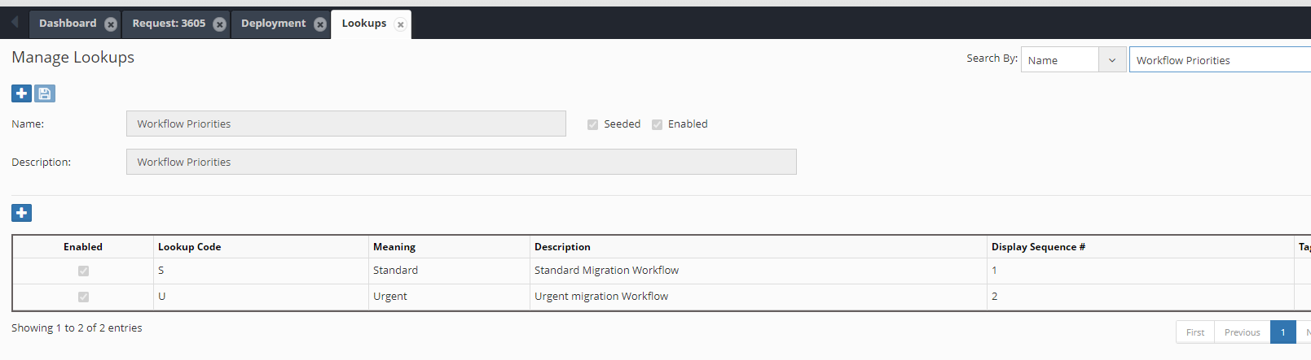

Create Request Lines

Using the EW_REQ_API package, various hierarchy actions can be performed, and corresponding request lines can be created using Logic Scripts.

P_related_line_id is an optional parameter and, if passed, can link the new request line to this request line id. Linked request lines cannot be deleted or cancelled by themselves. If their parent request lines are deleted or cancelled, then these linked lines automatically get deleted or cancelled.

Delete Member

FUNCTION create_line_delete_member
(p_user_id IN NUMBER
,p_request_id IN NUMBER
,p_app_dimension_id IN NUMBER
,p_member_name IN VARCHAR2
,p_related_line_id IN NUMBER DEFAULT NULL
,p_chk_security IN VARCHAR2 DEFAULT 'Y'
,x_msg IN OUT VARCHAR2
)
RETURN VARCHAR2;

Remove Shared Member

FUNCTION create_line_remove_shared_mem
(p_user_id IN NUMBER
,p_request_id IN NUMBER
,p_app_dimension_id IN NUMBER
,p_parent_member_name IN VARCHAR2
,p_member_name IN VARCHAR2
,p_related_line_id IN NUMBER DEFAULT NULL
,p_chk_security IN VARCHAR2 DEFAULT 'Y'
,x_msg IN OUT VARCHAR2
)
RETURN VARCHAR2;

Rename Member

FUNCTION create_line_rename_member
(p_user_id IN NUMBER
,p_request_id IN NUMBER
,p_app_dimension_id IN NUMBER
,p_member_name IN VARCHAR2
,p_new_member_name IN VARCHAR2
,p_related_line_id IN NUMBER DEFAULT NULL
,p_chk_security IN VARCHAR2 DEFAULT 'Y'
,x_msg IN OUT VARCHAR2
)
RETURN VARCHAR2;

Create New Member

FUNCTION create_line_new_member
(p_user_id IN NUMBER
,p_request_id IN NUMBER
,p_app_dimension_id IN NUMBER
,p_parent_member_name IN VARCHAR2
,p_new_member_name IN VARCHAR2
,p_prev_sibling_member_name IN VARCHAR2
,p_related_line_id IN NUMBER DEFAULT NULL
,p_chk_security IN VARCHAR2 DEFAULT 'Y'
,x_msg IN OUT VARCHAR2
)
RETURN VARCHAR2;

Move Member

FUNCTION create_line_move_member
(p_user_id IN NUMBER
,p_request_id IN NUMBER
,p_app_dimension_id IN NUMBER
,p_member_name IN VARCHAR2
,p_moved_to_member_name IN VARCHAR2
,p_new_prev_sibling_member IN VARCHAR2 -- New Prev Sibling
,p_related_line_id IN NUMBER DEFAULT NULL
,p_chk_security IN VARCHAR2 DEFAULT 'Y'
,x_msg IN OUT VARCHAR2
)
RETURN VARCHAR2;

Reorder Children

FUNCTION create_line_reorder_children
(p_user_id IN NUMBER
,p_request_id IN NUMBER
,p_app_dimension_id IN NUMBER
,p_parent_member_name IN VARCHAR2
,p_member_name IN VARCHAR2
,p_new_prev_sibling_member IN VARCHAR2
,p_related_line_id IN NUMBER DEFAULT NULL
,p_chk_security IN VARCHAR2 DEFAULT 'Y'
,x_msg IN OUT VARCHAR2
)
RETURN VARCHAR2;

Reorder Member
This API can be used to reposition a newly created member or after moving a member under its parent member automatically using either member name or description as a criterion.
For example, if you create a new member as a child member under a parent and you prefer to position this new member at a correct location based on its name then calling this API in the Post Hierarchy Action Logic script can achieve that task.

-- p_reorder_criteria -> 'MEMBER_NAME' OR 'MEMBER_DESCRIPTION'
FUNCTION reorder_member
(p_user_id IN NUMBER
,p_request_id IN NUMBER
,p_app_dimension_id IN NUMBER
,p_parent_member_name IN VARCHAR2
,p_member_name IN VARCHAR2
,p_reorder_criteria IN VARCHAR2 DEFAULT 'MEMBER_NAME'
,x_msg IN OUT VARCHAR2
)
RETURN VARCHAR2;

Edit Property

This API will create a request line for a given member in the Edit mode. It will not change any member property values.

FUNCTION create_line_edit_action
(p_user_id IN NUMBER
,p_request_id IN NUMBER
,p_app_dimension_id IN NUMBER
,p_parent_member_name IN VARCHAR2
,p_member_name IN VARCHAR2
,p_related_line_id IN NUMBER DEFAULT NULL
,p_chk_security IN VARCHAR2 DEFAULT 'Y'
,x_msg IN OUT VARCHAR2
)
RETURN VARCHAR2;

Edit Property Value
This API will create a request line for a given member in the Edit mode and change the property value of a given property. If Parent Member Name is not provided, then the API will use Primary Instance of the member.

/*
p_create_for_changed_val_only -> Create Request line only if new property value is different from the existing property value.
Default : Create line regardless of value same or different
*/
FUNCTION create_line_edit_prop
(p_user_id IN NUMBER
,p_request_id IN NUMBER
,p_app_dimension_id IN NUMBER
,p_parent_member_name IN VARCHAR2 DEFAULT NULL
,p_member_name IN VARCHAR2
,p_prop_label IN VARCHAR2
,p_prop_value IN VARCHAR2
,p_related_line_id IN NUMBER DEFAULT NULL
,p_chk_security IN VARCHAR2 DEFAULT 'Y'
, p_create_for_changed_val_only IN VARCHAR2 DEFAULT 'N'
,x_msg IN OUT VARCHAR2
)
RETURN VARCHAR2;

Edit Property Value Without Request Line
This API will update member’s properties directly without creating request lines. This API is useful when no audit trail is required and many member’s properties to be updated directly for performance benefits.
If the property is Hierarchy Type (meaning property is configured as Hierarchy Type) then hierarchy_id parameter is required. Hierarchy ID basically points to Member and Parent Member.

This API will return three variables.
X_prop_changed (Y or N) to indicate whether property is indeed different from what is passed.
X_old_value will return the existing property value before it gets updated with the new value.
X_msg in case API fails and returns N.

If the API is able to successfully update the property value then it will return Y.

FUNCTION upd_member_prop_direct
(p_app_dimension_id IN NUMBER
,p_member_id IN NUMBER
,p_hierarchy_id IN NUMBER DEFAULT NULL
,p_prop_name IN VARCHAR2
,p_prop_value IN VARCHAR2
,p_array_member_name IN VARCHAR2 DEFAULT NULL
,x_prop_changed OUT VARCHAR2
,x_old_value OUT VARCHAR2
,x_msg OUT VARCHAR2
)
RETURN VARCHAR2;

Insert Shared Member
FUNCTION create_line_shared_member
(p_user_id IN NUMBER
,p_request_id IN NUMBER
,p_app_dimension_id IN NUMBER
,p_parent_member_name IN VARCHAR2
,p_member_name IN VARCHAR2
,p_prev_sibling_member IN VARCHAR2
,p_related_line_id IN NUMBER DEFAULT NULL
,p_chk_security IN VARCHAR2 DEFAULT 'Y'
,x_msg OUT VARCHAR2
)
RETURN VARCHAR2;

Create Line (Multiple Actions)
--This is a generic API to create a request line. Depending on the action code various
-- parameters will need to be passed. Such as if the Action code is RM (Rename Member)
-- then New Member name parameters will be required to be passed.
FUNCTION create_line
(p_user_id IN NUMBER
,p_request_id IN NUMBER
,p_app_name IN VARCHAR2
,p_dim_name IN VARCHAR2
,p_action_code IN VARCHAR2
,p_member_name IN VARCHAR2
,p_parent_member_name IN VARCHAR2
,p_moved_to_member_name IN VARCHAR2
,p_prev_sibling_member_name IN VARCHAR2
,p_new_member_name IN VARCHAR2
,p_related_line_id IN NUMBER DEFAULT NULL
,p_chk_security IN VARCHAR2 DEFAULT 'Y'
,x_msg IN OUT VARCHAR2
)
RETURN VARCHAR2;

Create New Member using Application and Dimension Names

Create a Request line to add a new member by calling the following function.

FUNCTION create_line_new_member_app
(p_user_id IN NUMBER
,p_request_id IN NUMBER
,p_app_name IN VARCHAR2
,p_dim_name IN VARCHAR2
,p_parent_member_name IN VARCHAR2
,p_new_member_name IN VARCHAR2
,p_prev_sibling_member_name IN VARCHAR2
,p_related_line_id IN NUMBER DEFAULT NULL
,x_msg IN OUT VARCHAR2
)
RETURN VARCHAR2; – Y for success and N for Error

Create Rename Member line using Application and Dimension Names
Create a Request line to rename a member by calling the following function.

FUNCTION create_line_rename_member_app
(p_user_id IN NUMBER
,p_request_id IN NUMBER
,p_app_name IN VARCHAR2
,p_dim_name IN VARCHAR2
,p_member_name IN VARCHAR2
,p_new_member_name IN VARCHAR2
,p_related_line_id IN NUMBER DEFAULT NULL
,p_chk_security IN VARCHAR2 DEFAULT 'Y'
,x_msg IN OUT VARCHAR2
)
RETURN VARCHAR2;

Update Hierarchy Property
/* Returns Y if the API is successful. Else returns N */
FUNCTION update_hierarchy_prop
(p_user_id IN NUMBER
,p_request_id IN NUMBER
,p_app_dimension_id IN NUMBER
,p_hierarchy_id IN NUMBER
,p_prop_label IN VARCHAR2
,p_prop_value IN VARCHAR2
,p_prop_value_clob IN CLOB DEFAULT NULL
,p_vary_by_member_names IN VARCHAR2 DEFAULT NULL
,p_related_line_id IN NUMBER DEFAULT NULL
,x_msg OUT VARCHAR2
)
RETURN VARCHAR2;

Sync Member Properties using Property Mapping Configurations
-- Sync Member Properties using API
/* This API will be useful when regular Dimension Mapping based Property Mapping is not applicable, but process need to rely on other events like property values to trigger property mapping across dimensions */

FUNCTION sync_member_prop_mappings
(p_source_app_dimension_id IN NUMBER
,p_source_member_name IN VARCHAR2
,p_target_app_dimension_id IN NUMBER
,p_target_member_name IN VARCHAR2
,x_msg OUT VARCHAR2
)
RETURN VARCHAR2 –-- Y for Success and N for Error

Create Sync Nodes

This API will synchronize node creation from the source application to the target application depending on the mapping value for the parent member passed in the parameter. This is very useful when members are mapped depending on the custom property being used to specify parent members of the mapped (target) dimension in the source application.

Supports the following actions for synchronization:

- Create Member
- Edit Properties
- Rename Member
- Shared Instances

FUNCTION create_line_sync_node
(p_user_id IN NUMBER
,p_request_id IN NUMBER
,p_source_app_name IN VARCHAR2
,p_source_dim_name IN VARCHAR2
,p_member_name IN VARCHAR2
,p_target_app_name IN VARCHAR2
,p_target_dim_name IN VARCHAR2
,p_target_parent_member IN VARCHAR2
,p_orig_member_name IN VARCHAR2 DEFAULT NULL
,p_prev_sibling_member_name IN VARCHAR2 DEFAULT NULL
,p_target_delete_member IN VARCHAR2 DEFAULT 'N'
,p_create_related_line_link IN VARCHAR2 DEFAULT 'Y'
,p_source_request_line_id IN NUMBER DEFAULT NULL
,p_shared_instance IN VARCHAR2 DEFAULT 'N'
,p_curr_target_shared_parent IN VARCHAR2 DEFAULT NULL
,x_msg IN OUT VARCHAR2
)
RETURN VARCHAR2;

Example:

Requirement: A Client has two applications, called HFM and Essbase. Whenever a user creates or edits a member in the HFM application, corresponding members in the Essbase application need to be updated or new members need to be created in the Essbase application. Members in the Essbase application do not have the same rollups, so parent members can be totally different from the HFM application. Therefore, standard dimension mapping is not used in this scenario and hence the user provides which parent member will be used in the target Essbase application.

Implementation: Create a custom property called “Essbase Parent Member” and assign it to the HFM dimension. The List of Values assigned to this property will show the values from the Essbase application. Please refer to the Property Configurations chapter in the Administrator’s Guide. You can use the Property Associations tab to show members from the Essbase application.

Create a Logic Script of the Property Validation type and assign it to this custom property. Whenever a user selects an Essbase member in this property (or changes from a previously selected value) it will automatically synchronize it in the Essbase application. For example, if Essbase Parent “A” was selected for the first time then new members will be created under that parent. If a user changes this property to Essbase Parent “B” then this script will automatically place the member under the new parent member in the Essbase application.

Recall Request

Recall requests to a specific workflow stage:

FUNCTION recall_request
(p_user_id IN NUMBER
,p_request_id IN NUMBER
,p_wf_stage_name IN VARCHAR2 -- recall to this WF stage
,p_notes IN VARCHAR2 DEFAULT NULL
,x_msg IN OUT VARCHAR2
)
RETURN VARCHAR2;

Rewind Stages

Recall requests to a specific workflow stage by specifying how many stages to rewind. Default value is 1 which means the request will be recalled to the stage before the current stage.

FUNCTION rewind_stages
(p_user_id IN NUMBER
,p_request_id IN NUMBER
,p_num_of_stages IN NUMBER DEFAULT 1
,p_notes IN VARCHAR2 DEFAULT NULL
,x_msg IN OUT VARCHAR2
)
RETURN VARCHAR2 ;

Remove Lines from Workflow Approvals

This API removes a given request line from needing Approvals for a specific Workflow Stage and its Task.

For example, if the requirement is to conditionally require approval for lines that have specific property values, then the following API can be called by a workflow custom task that would precede the Review or Approve stage.

API : ew_req_api.remove_req_line_wf_approvals

-- Remove lines from approvals required
PROCEDURE remove_req_line_wf_approvals
(p_request_id IN NUMBER
,p_wf_stage_name IN VARCHAR2
,p_wf_task_name IN VARCHAR2
,p_line_num IN NUMBER
,x_sts OUT VARCHAR2
,x_msg OUT VARCHAR2
)

Add Lines for Workflow Approvals

This API adds an Approval requirement for a specific request line, Workflow Stage and Task which were removed previously using a custom Logic Script.

For example, if the requirement is to conditionally require approval for lines that have specific property values, then the following API can be called in a workflow custom task that would precede the Review or Approve stage.

API : ew_req_api.add_req_line_wf_approvals

-- Add lines from approvals required
PROCEDURE add_req_line_wf_approvals
(p_request_id IN NUMBER
,p_wf_stage_name IN VARCHAR2
,p_wf_task_name IN VARCHAR2
,p_line_num IN NUMBER
,x_sts OUT VARCHAR2
,x_msg OUT VARCHAR2
)

Check if Line Requires Workflow Approvals

This API checks whether a given request line requires Approvals for a specific Workflow Stage and its Task.

API : ew_req_api.chk_line_needs_approvals
Returns Y if lines are part of the Approval requirement. Else N,

-- Remove lines from approvals required
FUNCTION chk_line_needs_approvals
(p_request_id IN NUMBER
,p_wf_stage_name IN VARCHAR2
,p_wf_task_name IN VARCHAR2
,p_line_num IN NUMBER
)
RETURN VARCHAR2

Send Reminder Email

PROCEDURE send_reminder_email
(p_user_id IN NUMBER
,p_request_id IN NUMBER
,p_email_to_user_id IN NUMBER
,p_notes IN VARCHAR2
,x_status OUT VARCHAR2
,x_message OUT VARCHAR2
);

Update Workflow Task Approvals Count

Using this API, you can update the # of Approvals required to be zero or any other integer value for the Request’s workflow task.

Note: This API does not affect workflow configuration but only the instance of it associated with the request itself.

PROCEDURE upd_wf_stage_task_approval_cnt
(p_request_id IN NUMBER
,p_wf_stage_name IN VARCHAR2
,p_wf_task_name IN VARCHAR2
,p_num_of_approvals IN NUMBER
,x_sts OUT VARCHAR2
,x_msg OUT VARCHAR2
);

Remove Workflow Stage

Using this API, you can remove the workflow stage from the Request’s workflow.

Note: This API does not affect workflow configuration but only the instance of it associated with the given request id.

PROCEDURE remove_wf_stage_name
(p_request_id IN NUMBER
,p_wf_stage_name IN VARCHAR2
,x_sts OUT VARCHAR2 -- S or E Success/Error
,x_msg OUT VARCHAR2
);

Add Workflow Stage

Using this API, you can add the workflow stage back in the request’s workflow.

Note: This API does not affect workflow configuration but only the instance of it associated with the given request ID.

PROCEDURE add_wf_stage_name
(p_request_id IN NUMBER
,p_wf_stage_name IN VARCHAR2
,x_sts OUT VARCHAR2 -- S or E Success/Error
,x_msg OUT VARCHAR2
);

Submit Request in the Workflow
Using this API request can be submitted in the Workflow. This function will return Y if action is successful else N along with Error Message.

FUNCTION submit_wf
(p_user_id IN NUMBER
,p_request_id IN NUMBER
,x_msg IN OUT VARCHAR2
)
RETURN VARCHAR2

Split Request
Using this API request can be split into multiple requests.

p_src_line_num_list : This Parameter provides an array of Line Numbers that need to be removed from the Source Request and moved to the new Request.

FUNCTION split_request
(p_src_request_id IN NUMBER
,p_src_line_num_list IN ew_global.g_num_tbl
,p_requestor_user_name IN VARCHAR2
,p_priority_code IN VARCHAR2
,p_wf_code IN VARCHAR2
,p_request_date IN DATE DEFAULT SYSDATE
,p_due_date IN DATE DEFAULT NULL
,p_description IN VARCHAR2 DEFAULT NULL
,p_udf1 IN VARCHAR2 DEFAULT NULL
,p_udf2 IN VARCHAR2 DEFAULT NULL
,p_udf3 IN VARCHAR2 DEFAULT NULL
,p_submit_wf IN VARCHAR2 DEFAULT 'N'
,p_source_ref_code IN VARCHAR2 DEFAULT NULL
,x_request_id OUT NUMBER
,x_msg OUT VARCHAR2
)
RETURN VARCHAR2

Hierarchy API Functions

Package: EW_HIERARCHY

These functions can be referred to as ew_hierarchy.<Function Name>.

Get Application Name

FUNCTION get_app_name (p_app_id IN VARCHAR2)RETURN VARCHAR2;

Get Dimension ID

FUNCTION get_app_dimension_id (p_app_name IN VARCHAR2
,p_dim_name IN VARCHAR2
)
RETURN NUMBER;

Get Dimension Information

/* p_what will accept following parameter values
APP_ID
APP_NAME
DIMENSION_NAME
DIM_CLASS_NAME
APP_AND_DIM_NAME
*/
get_app_dim_attrib (p_app_dimension_id IN NUMBER
,p_what IN VARCHAR2
);

For example, if the app dimension id of application “ASO” is 123 then depending on parameter p_what following values will be returned by this function.

Assumptions: App ID is 1, App Dimension id is 123, dimension class is Measures.

P_WHAT | Returned Values | Example (Apply ew_hierarchy package prefix to function. For example, ew_hierarchy.get_app_dim_attrib)
APP_ID | 1 | get_app_dim_attrib(123,’APP_ID’)
APP_NAME | ASO | get_app_dim_attrib(123,’APP_NAME’)
DIMENSION_NAME | Accounts | get_app_dim_attrib(123,’DIMENSION_NAME’)
DIM_CLASS_NAME | Measures | get_app_dim_attrib(123,’DIM_CLASS_NAME’)
APP_AND_DIM_NAME | ASO/Accounts | get_app_dim_attrib(123,’APP_AND_DIM_NAME’)

Get Property Display Value

/* Provide Display value for a given member's LOV type Property codes
For example, the Internal stored property value for Data Storage property is X (Dynamic Calc) and you need to determine the display value which is “Dynamic Calc” then use this function.
*/

FUNCTION get_prop_disp_value (p_app_dimension_id IN NUMBER
,p_prop_id IN NUMBER
,p_prop_value IN VARCHAR2
)
RETURN VARCHAR2;

Is Leaf (OR Base member)

/* Check if member is leaf (OR Base Member) or not */
FUNCTION is_leaf(p_member_id IN NUMBER
,p_app_dimension_id IN NUMBER
)
RETURN VARCHAR2;

FUNCTION is_leaf(p_app_name IN VARCHAR2
,p_dim_name IN VARCHAR2
,p_member_name IN VARCHAR2
)
RETURN VARCHAR2;

Get Member Property Value

FUNCTION get_member_prop_value
(p_app_name IN VARCHAR2
,p_dim_name IN VARCHAR2
,p_member_name IN VARCHAR2
,p_prop_label IN VARCHAR2
);

Get Ancestors Having Property Value

/*
Provide list of Ancestors separated by comma (OR any other character) having a specific property value for a specific prop.
p_list_or_count parameter will accept the following options.
LIST, COUNT, EXISTS, FIRST, LAST
LIST will provide member names separated by a comma
*/

FUNCTION ancestors_having_prop_value (p_app_dimension_id IN NUMBER
,p_member_name IN VARCHAR2
,p_prop_name IN VARCHAR2
,p_prop_value IN VARCHAR2
,p_sep IN VARCHAR2 DEFAULT ','
,p_list_or_count IN VARCHAR2 DEFAULT 'LIST'
,p_append_wildcard IN VARCHAR2 DEFAULT 'N'
)
RETURN VARCHAR2;

/*
Provide list of Ancestors separated by comma (OR any other character) having a specific property value for a specific prop.
p_list_or_count parameter will accept the following options.
LIST, COUNT, EXISTS, FIRST, LAST
LIST will provide member names separated by a comma
(SAME as above but accepts parent_member_name as an additional parameter). Use this function if the branch on which this function need to be executed has Shared Instances of a member.
*/

FUNCTION ancestors_having_prop_value (p_app_dimension_id IN NUMBER
,p_parent_member_name IN VARCHAR2
,p_member_name IN VARCHAR2
,p_prop_name IN VARCHAR2
,p_prop_value IN VARCHAR2
,p_sep IN VARCHAR2 DEFAULT ','
,p_list_or_count IN VARCHAR2 DEFAULT 'LIST'
,p_append_wildcard IN VARCHAR2 DEFAULT 'N'
)
RETURN VARCHAR2;

Get Descendants Having Property Value

-- Provide list or count of Descendants having value for specific prop
-- p_list_or_count parameter will accept the following options.
-- LIST, COUNT, EXISTS, FIRST, LAST
FUNCTION descendants_having_prop_value
(p_app_dimension_id IN NUMBER
,p_member_name IN VARCHAR2
,p_prop_name IN VARCHAR2
,p_prop_value IN VARCHAR2
,p_sep IN VARCHAR2 DEFAULT ','
,p_list_or_count IN VARCHAR2 DEFAULT 'LIST'
,p_append_wildcard IN VARCHAR2 DEFAULT 'N'
)
RETURN VARCHAR2;

Check All Descendants Having Same Property Value

-- Return Y or N if all descendants have same property value or not
-- for a given property name
-- If p_prop_value parameter is provided then all descendants must have
-- that value for that property.
FUNCTION descendants_having_same_prop_value
(p_app_dimension_id IN NUMBER
,p_member_name IN VARCHAR2
,p_prop_name IN VARCHAR2
,p_prop_value IN VARCHAR2 DEFAULT NULL
)
RETURN VARCHAR2

Get Children Having Property Value

-- Provide list or count of children having value for specific property
-- p_list_or_count parameter will accept the following options.
-- LIST, COUNT, EXISTS, FIRST, LAST
FUNCTION children_having_prop_value
(p_app_dimension_id IN NUMBER
,p_member_name IN VARCHAR2
,p_prop_name IN VARCHAR2
,p_prop_value IN VARCHAR2
,p_sep IN VARCHAR2 DEFAULT ','
,p_list_or_count IN VARCHAR2 DEFAULT 'LIST'
,p_append_wildcard IN VARCHAR2 DEFAULT 'N'
)
RETURN VARCHAR2;

Get Parent Members
FUNCTION get_parent_members
(p_app_dimension_id IN NUMBER
,p_member_name IN VARCHAR2
,p_top_member_name IN VARCHAR2 DEFAULT NULL
,p_node_type IN VARCHAR2 DEFAULT 'ALL'
,p_sep IN VARCHAR2 DEFAULT ','
)
RETURN VARCHAR2;

Get Branch Member

/* Get a specific branch ember for given member name in a dimension
If level is +ve number then level is counted from top
1 is the top node, 2 is the immediate parent member and so on until the current member is reached.
If level is -ve number then current member level is -1 and its parent is -2 and so on.
*/
FUNCTION get_branch_member (p_app_dimension_id IN NUMBER
,p_member_name IN VARCHAR2
,p_level IN NUMBER
)
RETURN VARCHAR2

Get Branch Members that Qualify

/* Get specific branch Member for given member name in a dimension
within a specific branch
Levels are counted from top
1 is the root node and so on till the current member is reached.
This is useful in Derived Properties when member’s primary or shared branch(es) need to be scanned for a specific level.
As members can have multiple shared branches, top level members can be used to determine a specific branch of the member.
Qualification criteria is a list of members the branch member of that level must match.
You can specific multiple levels separated by ~ character
Example,
p_levels => 3,5,8,6
p_level_lists => A101,A102~A501~A601~A701,A702
Function will return member name if one of the levels qualify in the order specified.
In this example, if Level 3 qualifies meaning if it is either A101 OR A102 then return that member. If not then check if Level 5 is A501 and so on.
If nothing is qualified then return null.
*/
FUNCTION get_branch_member_qualified
(p_app_dimension_id IN NUMBER
,p_top_member_name IN VARCHAR2
,p_member_name IN VARCHAR2
,p_levels IN VARCHAR2 -- Example : 3,5,8,6
,p_level_lists IN VARCHAR2 -- A101,A102~A501~A601~A701,A702
)
RETURN VARCHAR2

Get Member Dimension Name
/*
Return Dimension Name of member in the application.
If there are multiple dimensions having the same member then the function will return ALL dimensions separated by a comma. Optionally you can specify the Dimension Class Name to search for the member in dimensions of that class only.
*/
FUNCTION get_member_dim_names
(p_app_id IN NUMBER
,p_member_name IN VARCHAR2
,p_dim_class_name IN VARCHAR2 DEFAULT NULL
)
RETURN VARCHAR2;

Get Ancestor having Specific Property Value

-- Criteria : LIST, COUNT, EXISTS, FIRST, LAST
-- FIRST or LAST (while traversing from bottom to top)
-- * in prop value means any non null value in properties
-- Note: This function uses Primary instance of the given member
-- for getting ancestors having specific property value.
-- For All (Primary as well as Shared instances) of a node
-- having ancestors with specific property values use overloaded
-- function specified in the next section (Same Function name).
FUNCTION get_ancestor_having_prop_value
(p_app_dimension_id IN NUMBER
,p_member_name IN VARCHAR2
,p_prop_name IN VARCHAR2
,p_prop_value IN VARCHAR2
,p_criteria IN VARCHAR2 DEFAULT 'FIRST'
,p_append_wildcard IN VARCHAR2 DEFAULT 'N'
)
RETURN VARCHAR2

/*This is an overloaded API with one additonal parameter p_parent_member_name
This will help when ancestors of a Shared nodes need to be derived.
*/
FUNCTION get_ancestor_having_prop_value
(p_app_dimension_id IN NUMBER
,p_parent_member_name IN VARCHAR2
,p_member_name IN VARCHAR2
,p_prop_name IN VARCHAR2
,p_prop_value IN VARCHAR2
,p_criteria IN VARCHAR2 DEFAULT 'FIRST'
,p_append_wildcard IN VARCHAR2 DEFAULT 'N'
)
RETURN VARCHAR2

Get Descendant having Specific Property Value

-- Criteria : LIST, COUNT, EXISTS, FIRST, LAST
-- FIRST or LAST (while traversing from immediate descendant to the last base member)
FUNCTION get_descendant_having_prop_value
(p_app_dimension_id IN NUMBER
,p_member_name IN VARCHAR2
,p_prop_name IN VARCHAR2
,p_prop_value IN VARCHAR2
,p_criteria IN VARCHAR2 DEFAULT 'FIRST'
,p_append_wildcard IN VARCHAR2 DEFAULT 'N'
)
RETURN VARCHAR2;

Get Descendants Count

Pass Member ID as input parameter.

FUNCTION get_descendants_count (p_member_id IN NUMBER)
RETURN NUMBER;

Pass Dimension ID and Member Name as input parameters.

FUNCTION get_descendants_count (p_app_dimension_id IN NUMBER
,p_member_name IN VARCHAR2
)
RETURN NUMBER;

Get Descendants

Retrieves all descendants into a PL/SQL Collection (Array).
A Collection is an array of records. Record type is ew_hierarchy_members_v.

Node Type Parameter options are: BASE_MEMBERS, PARENT_MEMBERS or ALL

PROCEDURE get_descendants
(p_app_dimension_id IN NUMBER
,p_member_id IN NUMBER
,p_node_type IN VARCHAR2
,x_hier_members_tbl IN OUT g_hier_members_tbl
)
G_hier_members_tbl is type defined in the EW_HIERARCHY Package as
TYPE g_hier_members_tbl IS TABLE OF ew_hierarchy_members_v%ROWTYPE
INDEX BY BINARY_INTEGER;
Most useful Columns of the record:
- Member_id
- Member_Name
- Parent_member_id
- Parent_Member_name
- Primary_flag (Y or N)
- App_Dimension_id
- Member_Status

Get Member Property Value

There are four functions to retrieve a member's specific property value.

If the property is an alias type (in EPMware it is also referred to as an Array type) then optionally specify the alias table name (or Array member Name) with a colon (:) as a separator.
For example, property Label parameters can be Alias, Alias:Default or Description:English.

FUNCTION get_member_prop_value
(p_prop_label IN VARCHAR2
,p_hierarchy_id IN NUMBER
,p_app_dimension_id IN NUMBER
)
RETURN VARCHAR2;

/* Get Property Value for a given member
*/
FUNCTION get_member_prop_value
(p_app_name IN VARCHAR2
,p_dim_name IN VARCHAR2
,p_member_name IN VARCHAR2
,p_prop_label IN VARCHAR2
)
RETURN VARCHAR2;

-- Get Value using App Dimension ID , Member name and Property Name
-- (Rather Property Label)
FUNCTION get_member_prop_value
(p_app_dimension_id IN NUMBER
,p_member_name IN VARCHAR2
,p_prop_name IN VARCHAR2
)

/* Get Property Value for a given member and its parent member
This is used for getting property values for Shared nodes where property can have a different value for its shared nodes. For example, Data Storage property will be “Shared” for Shared instances in Essbase and Planning apps.
*/
FUNCTION get_node_prop_value
(p_app_name IN VARCHAR2
,p_dim_name IN VARCHAR2
,p_member_name IN VARCHAR2
,p_parent_member_name IN VARCHAR2
,p_prop_label IN VARCHAR2
)
RETURN VARCHAR2;

Get Ancestor Property Value

ew_hierarchy.get_ancestor_prop_value
(p_app_dimension_id => <app_dimension_id>
,p_member_name => <member_name>
,p_prop_name => <prop_name>
,p_level => <Level>
)

/* Level 1 → root node
Level 2 → Members under the Root node and so on
*/

Get Child Nodes Count

-- Get # of shared OR primary or total nodes for a parent member
/*
NODE_TYPE -> ALL Primary and Shared
PRIMARY_ONLY
SHARED_ONLY
*/
FUNCTION get_child_nodes_count
(p_app_dimension_id IN NUMBER
,p_parent_member_name IN VARCHAR2
,p_node_type IN VARCHAR2 DEFAULT 'ALL'
)
RETURN NUMBER;

Get Primary Parent Member

Use one of the following functions to retrieve the Primary Parent Member Name or ID of a Member.

FUNCTION get_primary_parent_name(p_app_dimension_id IN NUMBER
,p_member_name IN VARCHAR2
)
RETURN VARCHAR2;

/* Get Parent member of Primary node of given member
*/
FUNCTION get_primary_parent_name(p_app_name IN VARCHAR2
,p_dim_name IN VARCHAR2
,p_member_name IN VARCHAR2
)
RETURN VARCHAR2;

FUNCTION get_primary_hierarchy_rec (p_member_id IN NUMBER)
RETURN ew_hierarchy_members_v%ROWTYPE;

FUNCTION get_primary_hierarchy_id (p_member_id IN NUMBER)
RETURN NUMBER;

FUNCTION get_primary_hierarchy_id
(p_app_dimension_id IN NUMBER
,p_member_name IN VARCHAR2
,p_case_match IN VARCHAR2 DEFAULT 'N'
)
RETURN NUMBER;

Get Parent Members List

This procedure will provide a list of parent members by scanning the hierarchy starting from the given top member name (default is root). Optionally, filter records by specifying node type (Primary versus all shared nodes or both).

/* Get All Parent Member Names
NODE_TYPE -> ALL Primary and Shared
PRIMARY_ONLY
SHARED_ONLY
*/
PROCEDURE get_parent_members
(p_app_dimension_id IN NUMBER
,p_member_name IN VARCHAR2
,p_top_member_name IN VARCHAR2 DEFAULT NULL
,p_node_type IN VARCHAR2 DEFAULT 'ALL'
,x_parent_members OUT ew_global.g_char_tbl
)

Returned value is an array of VARCHAR2(2000).
TYPE g_char_tbl IS TABLE OF VARCHAR2(2000) INDEX BY BINARY_INTEGER;
Note: You can declare a variable in your Logic Script for this type as

L_parent_members ew_global.g_char_tbl;

Check Ancestor having Property Value

If you need to determine if any of the ancestors of a given member has a specific property value for specific property. If found, then the member name of that ancestor will be returned.

/* Get Property Value for any ancestor of a given member and if it matches then return that ancestor name
*/
FUNCTION chk_ancestor_prop_value
(p_prop_label IN VARCHAR2
,p_member_id IN NUMBER
,p_app_dimension_id IN NUMBER
,p_prop_value IN VARCHAR2
,p_direction IN VARCHAR2 DEFAULT 'TOP' -- or BOTTOM
)
RETURN VARCHAR2

Check Node Exists

The Following are multiple functions to determine whether a node exists in the application or not.

-- Check whether a node exists or not in given App / Dim Name
FUNCTION chk_node_exists
(p_app_name IN VARCHAR2
,p_dim_name IN VARCHAR2
,p_parent_member_name IN VARCHAR2
,p_member_name IN VARCHAR2
)
RETURN VARCHAR2; – Y or N

-- Check whether a node exists or not in given Dimension ID
FUNCTION chk_node_exists
(p_app_dimension_id IN NUMER
,p_parent_member_name IN VARCHAR2
,p_member_name IN VARCHAR2
)
RETURN VARCHAR2; – Y or N

Get Member having Property Value

/* Scan the app across one or more dimensions to find member having
a specific value for the given property.
Returns the first member that qualifies the criteria.
If dimension name is specified in parameter
then return Member Name only.
For example : Cash
If dimension name is NOT specified in parameter
then return Dimension and Member Name both.
For example : SummaryAccounts:Cash
*/
FUNCTION get_member_having_prop_value
(p_app_name IN VARCHAR2
,p_prop_label IN VARCHAR2
,p_prop_value IN VARCHAR2
,p_exclude_member_name IN VARCHAR2
,p_exclude_array_member_name IN VARCHAR2 DEFAULT NULL
,p_dim_name IN VARCHAR2 DEFAULT NULL
,p_append_wildcard IN VARCHAR2 DEFAULT 'N'
)
RETURN VARCHAR2;

Get Members having Property Value

/* Scan the app across one or more dimensions to detect member having
a specific property value for the given property.
Returns all members that qualifies the criteria.
If dimension name is specified in parameter
then return Member Name only
For example : Cash~Cash101
If dimension name is NOT specified in parameter
then return Member Name and Dimension name both
For example : SummaryAccounts:Cash~DetailAccounts:Cash101
*/
FUNCTION get_members_having_prop_value
(p_app_name IN VARCHAR2
,p_prop_label IN VARCHAR2
,p_prop_value IN VARCHAR2
,p_exclude_member_name IN VARCHAR2
,p_exclude_array_member_name IN VARCHAR2 DEFAULT NULL
,p_dim_name IN VARCHAR2 DEFAULT NULL
,p_append_wildcard IN VARCHAR2 DEFAULT 'N'
)

Get Member having Property Value for Alias Type Properties

/* Scan the app across dimensions to detect members having
property value for the given property within given array member
name.
Mainly useful for Essbase Alias uniqueness check
Returns dimension and member name as concatenated value
*/
FUNCTION get_member_array_prop_value
(p_app_name IN VARCHAR2
,p_prop_label IN VARCHAR2
,p_prop_value IN VARCHAR2
,p_array_member_name IN VARCHAR2
,p_exclude_member_name IN VARCHAR2
)
RETURN VARCHAR2;

Get Primary Branch Members
/* Get all the member names start from root
for a given member in dimension (Primary Branch)
Member names are separated by Tilde characters ~
*/
FUNCTION get_primary_branch_members (p_app_dimension_id IN NUMBER
,p_member_name IN VARCHAR2
)
RETURN VARCHAR2;

Get Last Child of a Parent Member

/* Get the last member for a given parent member using Dimension ID
*/
FUNCTION get_last_member_name(p_app_dimension_id IN NUMBER
,p_parent_member_name IN VARCHAR2
)
RETURN VARCHAR2;

/* Get the last member for a given parent member using App and Dim Names
*/
FUNCTION get_last_member_name(p_app_name IN VARCHAR2
,p_dim_name IN VARCHAR2
,p_parent_member_name IN VARCHAR2
)
RETURN VARCHAR2;

Check if the member is in the Branch

Determine if a member is under a specific top level parent member.
For example, in the following hierarchy, this function will return “Y” for A111100 for top Parent Member A110000. But it will return “N” for member the A121000. However, the function will return for both members if the top member passed is A105000.

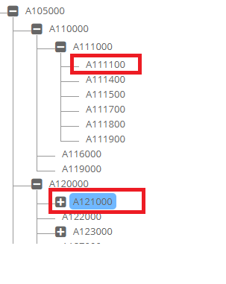

/* Return Y or N if the branch exists that contains a member and parent member at any level.
If the member is deleted and you need to check if the deleted member was part of the branch, then pass value Y to p_chk_deleted parameter.
*/
FUNCTION chk_primary_branch_exists
(p_app_dimension_id IN NUMBER
,p_parent_member_name IN VARCHAR2
,p_member_name IN VARCHAR2
,p_chk_deleted IN VARCHAR2 DEFAULT 'N'
)
RETURN VARCHAR2;

FUNCTION chk_primary_branch_exists
(p_app_name IN VARCHAR2
,p_dim_name IN VARCHAR2
,p_parent_member_name IN VARCHAR2
,p_member_name IN VARCHAR2
,p_chk_deleted IN VARCHAR2 DEFAULT 'N'
)
RETURN VARCHAR2;

Is Member a Parent Member

FUNCTION is_parent_member (p_member_id IN NUMBER)
RETURN VARCHAR2;

Is Member a Base Member

FUNCTION is_base_member (p_member_id IN NUMBER)
RETURN VARCHAR2;

FUNCTION is_base_member (p_app_name IN VARCHAR2
,p_dim_name IN VARCHAR2
,p_member_name IN VARCHAR2
)
RETURN VARCHAR2;

Is Node Primary

There are multiple APIs to determine whether a given node is Primary or not. Each API will have different input parameters and will return Y or N or NULL values.

Return “Y” if the node is Primary, “N” if it is not.
If the node does not exist, then return the NULL (blank) value.

FUNCTION is_hierarchy_primary (p_hierarchy_id IN NUMBER)
RETURN VARCHAR2;

FUNCTION is_hierarchy_primary (p_app_dimension_id IN NUMBER
,p_parent_member_id IN NUMBER
,p_member_id IN NUMBER
)
RETURN VARCHAR2;

FUNCTION is_node_primary (p_app_dimension_id IN NUMBER
,p_parent_member_name IN VARCHAR2
,p_member_name IN VARCHAR2
)
RETURN VARCHAR2;

Check Member passes Custom Logic Script Validation or not

/* Validate Property Value and return Y/N along with message
for Properties which have Logic Script associated with it.
*/
FUNCTION chk_prop_val_custom(p_request_id IN NUMBER
,p_request_line_id IN NUMBER
,p_app_dimension_id IN NUMBER
,p_action_code IN VARCHAR2
,p_hierarchy_id IN NUMBER
,p_parent_member_name IN VARCHAR2
,p_prop_id IN NUMBER
,p_prop_label IN VARCHAR2
,p_prop_value IN VARCHAR2
,p_array_member_id IN NUMBER
,p_prop_value_clob IN CLOB
,p_vary_by_member_names IN VARCHAR2
,p_source IN VARCHAR2
,x_msg OUT VARCHAR2
)
RETURN VARCHAR2 -- Y/N

Check Member Status
If a member is being locked in any request, then this function will return “N”. If this member is not being locked by any hierarchy action, then this function will return “Y”.

FUNCTION is_member_active (p_member_id IN NUMBER)

Get Member Description

FUNCTION get_member_desc (p_app_dimension_id IN NUMBER
,p_member_id IN NUMBER)
RETURN VARCHAR2;

FUNCTION get_member_desc (p_member_id IN NUMBER)
RETURN VARCHAR2;

FUNCTION get_member_desc (p_app_name IN VARCHAR2
,p_dim_name IN VARCHAR2
,p_member_name IN VARCHAR2
)
RETURN VARCHAR2;

Get Member Name using Description

FUNCTION get_member_name_using_desc
(p_app_dimension_id IN NUMBER
,p_member_desc IN VARCHAR2
)
RETURN VARCHAR2;

Get Parent Member Name

/* Get Parent Member Name
*/
FUNCTION get_parent_member_name (p_app_dimension_id IN NUMBER
,p_member_name IN VARCHAR2
)
RETURN VARCHAR2
;

Get Member Name

Following function (3 options) to check and get back actual member name within an application using either Dimension Class OR Dimension name OR member ID.

/* Check Member Name (ignore case) - If found return member name
using Dim Class
*/
FUNCTION get_member_name (p_app_id IN NUMBER
,p_dim_class_name IN VARCHAR2
,p_member_name IN VARCHAR2
)
RETURN VARCHAR2;

FUNCTION get_member_name(p_member_id IN NUMBER)
RETURN VARCHAR2;

/* Check Member Name (ignore case) - If found return member name
*/
FUNCTION get_member_name (p_app_dimension_id IN NUMBER
,p_member_name IN VARCHAR2
)
RETURN VARCHAR2
;

Get Members

This API will provide Members for a given application and dimension and member name wildcard.

There are two overloaded functions for this API. First one will provide members in an array and the second one will provide members in one string (members are concatenated by a character).

/* Returns Members found in an array
P_remove_search_str if enabled (Y) then it will remove Search string from
the members found.
For example, if you are searching for members that begin with string US*
and members found are US101, US102 and so on then it will return
101, 102 and so on if this parameter (p_remove_search_str) is set to Y.

If set to N (Default) then it will return actual member names found.
In this case US101,US102 and so on.

Note: Search is case insensitive.
*/

PROCEDURE get_members (p_app_name IN VARCHAR2
,p_dim_name IN VARCHAR2
,p_search_str IN VARCHAR2
,p_wildcard_char IN VARCHAR2 DEFAULT '*'
,x_member_list OUT ew_global.g_char_tbl
,p_remove_search_str IN VARCHAR2 DEFAULT 'N'
)

/* Returns Members found in a string concatenated by given character
*/
FUNCTION get_members (p_app_name IN VARCHAR2
,p_dim_name IN VARCHAR2
,p_search_str IN VARCHAR2
,p_wildcard_char IN VARCHAR2 DEFAULT '*'
,p_concate_char IN VARCHAR2 DEFAULT ','
,p_remove_search_str IN VARCHAR2 DEFAULT 'N'
)
RETURN VARCHAR2;

Get Member ID

FUNCTION get_member_id (p_app_dimension_id IN NUMBER
,p_member_name IN VARCHAR2
)
RETURN NUMBER;

Get Previous Sibling Member
-- Get Previous Sibling member Name
FUNCTION get_prev_sibling (p_app_dimension_id IN NUMBER
,p_parent_member_id IN NUMBER
,p_member_id IN NUMBER
)
RETURN VARCHAR2;

FUNCTION get_prev_sibling (p_app_dimension_id IN NUMBER
,p_parent_member_name IN VARCHAR2
,p_member_name IN VARCHAR2
)
RETURN VARCHAR2;

PROCEDURE get_prev_sibling(p_app_dimension_id IN NUMBER
,p_parent_member_id IN NUMBER
,p_member_id IN NUMBER
,x_member_name OUT VARCHAR2
,x_primary_flag OUT VARCHAR2
)

Get Hierarchy ID

FUNCTION get_hierarchy_id (p_app_dimension_id IN NUMBER
,p_parent_member_name IN VARCHAR2
,p_member_name IN VARCHAR2
)
RETURN NUMBER;

FUNCTION get_hierarchy_id (p_app_dimension_id IN NUMBER
,p_parent_member_id IN NUMBER
,p_member_id IN NUMBER
)
RETURN NUMBER;

Get Dimension Property

This function will return the Dimension’s property value. Dimension properties are configured under the Configuration -> Dimension -> Configuration screen and Properties tab.

FUNCTION get_app_dim_prop_value (p_app_dimension_id IN NUMBER
,p_prop_name IN VARCHAR2
)
RETURN VARCHAR2;

Check member Exists

The Following are multiple functions to determine whether a member exists in the application or not.

-- Check whether a member already exists in the application
-- after excluding specific member id
FUNCTION chk_member_exists_in_app
(p_member_name IN VARCHAR2
,p_app_name IN VARCHAR2
,p_exclude_member_id IN NUMBER
)
RETURN VARCHAR2; -- Return Dimension name where it exists

-- Check whether a member exists in the application (application name)
FUNCTION chk_member_exists
(p_member_name IN VARCHAR2
,p_app_name IN VARCHAR2
)
RETURN VARCHAR2; -- Y/N

-- Check whether a member exists in the application (application id)
FUNCTION chk_member_exists
(p_member_name IN VARCHAR2
,p_app_id IN NUMBER
)
RETURN VARCHAR2; -- Y/N

-- Check whether a member exists in the dimension (id)
FUNCTION chk_member_exists
(p_app_dimension_id IN NUMBER
,p_member_name IN VARCHAR2
,p_case_match IN VARCHAR2 DEFAULT 'N'
)
RETURN VARCHAR2;

-- Check whether a member exists in the dimension (name)
FUNCTION chk_member_exists
(p_app_name IN VARCHAR2
,p_dim_name IN VARCHAR2
,p_member_name IN VARCHAR2
,p_case_match IN VARCHAR2 DEFAULT 'N'
)
RETURN VARCHAR2;

-- Check whether a member exists in the application. If it exists
-- then return its name
FUNCTION chk_and_get_member_name
(p_app_name IN VARCHAR2
,p_dim_name IN VARCHAR2
,p_member_name IN VARCHAR2
,p_case_match IN VARCHAR2 DEFAULT 'N'
)
RETURN VARCHAR2;

-- Check whether member exists in the dimension Class
-- Return Dimension Name where member exists
FUNCTION chk_member_exists_in_dim_class
(p_app_name IN VARCHAR2
,p_dim_class_name IN VARCHAR2
,p_member_name IN VARCHAR2
,p_case_match IN VARCHAR2 DEFAULT 'N'
)
RETURN VARCHAR2;

Get Member Active Flag

-- For Generic Apps Member has Active Flag property
FUNCTION get_member_active_flag (p_app_name IN VARCHAR2
,p_dim_name IN VARCHAR2
,p_member_name IN VARCHAR2
)
RETURN VARCHAR2;

FUNCTION get_member_active_flag (p_member_id IN NUMBER)
RETURN VARCHAR2;

FUNCTION get_member_active_flag (p_app_dimension_id IN NUMBER
,p_member_name IN VARCHAR2
)
RETURN VARCHAR2;

Copy Member Properties

Copy member Properties from Source member to the Target Member.

This API is very useful when a solution is required to copy member properties from a source application to the target application without having dimension mapping logic.

Two APIs, one with IDs and the second with names.

-– Return Y if no errors else return N with error message
FUNCTION copy_member_properties_id
(p_source_member_id IN NUMBER
,p_source_app_dim_id IN NUMBER
,p_target_member_id IN NUMBER
,p_target_app_dim_id IN NUMBER
,p_target_hierarchy_id IN NUMBER
,x_msg IN OUT VARCHAR2
)
RETURN VARCHAR2

-- Return Y if no errors else return N with error message
FUNCTION copy_member_properties_name
(p_source_member_name IN VARCHAR2
,p_source_app_name IN VARCHAR2
,p_source_dim_name IN VARCHAR2
--
,p_target_member_name IN VARCHAR2
,p_target_app_name IN VARCHAR2
,p_target_dim_name IN VARCHAR2
,x_msg IN OUT VARCHAR2
)
RETURN VARCHAR2;

Set Dimension Mapping Method

If we are using Dimension Mapping Logic Script and, in that script, if we need to set Logic Script variables for SYNC or SMARTSYNC method then this API will do that task.

For example, we need to map certain branches of a dimension between two applications then the first thing we do in the script is apply those conditions. Once those conditions determine that mapping needs to continue then setting Logic Script variables (OUT variables) gets complicated and this API can resolve this problem.

ew_hierarchy.set_dim_mapping_method
(p_mapping_method => 'SMARTSYNC' – OR ‘SYNC’
,x_status => ew_lb_api.g_status
,x_message => ew_lb_api.g_message
);

Hierarchy Statistics API Functions

This package contains some useful functions for getting statistical information for a given member OR a node (Parent/Child combination is referred to here as a Node).

In this package we refer to Generations and Levels. Generations are # ancestors starting from the root and Levels are counted from the base members (Level 0 is a base member) and counted upwards towards the root member.

Generations count from the top (# 1) whereas Levels are counted from the bottom (# 0).

For Example:
Hierarchy | Generation # / Level #
- Accounts  - Balance Sheet  - Assets  - A10101  - A10102  - Liabilities  - L20101  - L20102 | - 1 / 3  - 2 / 2  - 3 / 1  - 4 / 0  - 4 / 0  - 3 / 1  - 4 / 0  - 4 / 0

Package: EW_HIER_STATS

Get Member Name for a Specific Generation Number

-- Provide Member name at specific Generation for a given node
FUNCTION get_generation_member(p_app_dimension_id IN NUMBER
,p_hierarchy_id IN NUMBER
,p_generation_num IN NUMBER
)
RETURN VARCHAR2;

Get Parent Member Name

-- Provide Parent Member for a given node
FUNCTION get_parent_name (p_hierarchy_id IN NUMBER)
RETURN VARCHAR2;

Get Generation Number for a specific node

-- Provide Generation # for given node
FUNCTION get_generation (p_app_dimension_id IN NUMBER
,p_hierarchy_id IN NUMBER
)
RETURN VARCHAR2;

Get Level # for a specific Node

-- Provide Level # for given node
FUNCTION get_level (p_app_dimension_id IN NUMBER
,p_hierarchy_id IN NUMBER
)
RETURN NUMBER;

-- Provide Level # for given member
FUNCTION get_level (p_app_dimension_id IN NUMBER
,p_member_name IN VARCHAR2
)
RETURN NUMBER;

Get Child Member Count

-- Provide # of Child members for a given member id
-- Optionally pass Member name Wildcard Parameters
-- Search String applies to the member name and Wildcard char
-- by default is %
FUNCTION get_child_count (p_app_dimension_id IN NUMBER
,p_parent_member_id IN NUMBER
,p_search_str IN VARCHAR2 DEFAULT NULL
,p_wildcard_char IN VARCHAR2 DEFAULT ‘*’
)
RETURN NUMBER;

Get Descendants Count under given member id

-- Provide # of Descendants (Traverse entire branch)
-- for a given member id
FUNCTION get_descendant_count (p_app_dimension_id IN NUMBER
,p_parent_member_id IN NUMBER
)
RETURN NUMBER;

Get Sibling Count for a given member id

-- Provide # of Sibling members for a given member id
FUNCTION get_sibling_count (p_app_dimension_id IN NUMBER
,p_parent_member_id IN NUMBER
)
RETURN NUMBER;

Get Level Zero (Base Members) Count under given member id

-- Provide # of Level 0 members (Traverse entire branch)
-- for a given member id
FUNCTION get_level_zero_count (p_app_dimension_id IN NUMBER
,p_parent_member_id IN NUMBER
,p_primary_only IN VARCHAR2
)
RETURN NUMBER;

Get Descendants List (Concatenated list)

-- Provide list of Descendants separated by separator character
-- String will be limited upto 32K characters
FUNCTION get_descendants
(p_app_name IN VARCHAR2
,p_dim_name IN VARCHAR2
,p_parent_member_name IN VARCHAR2
,p_base_members_only IN VARCHAR2 DEFAULT 'N'
,p_primary_members_only IN VARCHAR2 DEFAULT 'N'
,p_active_members_only IN VARCHAR2 DEFAULT 'N'
,p_separator_char IN VARCHAR2 DEFAULT ','
,p_enclosed_by_char IN VARCHAR2 DEFAULT NULL
)
RETURN VARCHAR2;

Get Descendants List (In Table format)

-- Provide list of Descendants in PL/SQL Table type format
FUNCTION get_descendants_tbl
(p_app_name IN VARCHAR2
,p_dim_name IN VARCHAR2
,p_parent_member_name IN VARCHAR2
,p_base_members_only IN VARCHAR2 DEFAULT 'N'
,p_primary_members_only IN VARCHAR2 DEFAULT 'N'
,p_active_members_only IN VARCHAR2 DEFAULT 'N'
,p_separator_char IN VARCHAR2 DEFAULT ','
,p_enclosed_by_char IN VARCHAR2 DEFAULT NULL
)
RETURN ew_member_tab_type PIPELINED;

Get Descendants information for a given member id

PROCEDURE get_descendants_info
(p_app_dimension_id IN NUMBER
,p_parent_member_id IN NUMBER
,x_hierarchy_ids OUT ew_global.g_num_tbl
,x_member_names OUT ew_global.g_char_tbl
,x_parent_member_names OUT ew_global.g_char_tbl
);

Get Ancestors for a given member id

-- Generation is Top to bottom ancestors and
-- Level is from bottom to the top
FUNCTION get_ancestors(p_app_dimension_id IN NUMBER
,p_hierarchy_id IN NUMBER
,p_order_type IN VARCHAR2 DEFAULT 'LEVEL'
,p_include_member IN VARCHAR2 DEFAULT 'N'
)
RETURN VARCHAR2;

Application API Functions
This package contains some useful functions for getting Application-Level information.

Package: EW_APP

Get Application Property Value

/* Get Application-Level Property Value for a given Application and its Property Name */
FUNCTION get_app_prop (p_app_id IN NUMBER
,p_prop_name IN VARCHAR2)
RETURN VARCHAR2;

Get Target Application Name

/* Get Target Application Name for a given application ID */
FUNCTION get_target_app_name (p_app_id IN NUMBER)
RETURN VARCHAR2;

Get Dimension Property Value

/* Get Dimension Level Property Value*/
FUNCTION get_app_dim_prop_value (p_app_id IN NUMBER
,p_dim_name IN VARCHAR2
,p_prop_name IN VARCHAR2
)
RETURN VARCHAR2;

FUNCTION get_app_dim_prop_value (p_app_dimension_id IN NUMBER
,p_prop_name IN VARCHAR2
)
RETURN VARCHAR2;

Workflow API Functions
Workflow API Functions - This package contains some useful functions for Workflow Information as well as automation like conditional approvals, skip tasks based on certain conditions etc.

Package: EW_WF_API

These functions can be referred to as ew_wf_api.<Function Name>.

Request’s Current Workflow Stage

This procedure will provide information about the current stage of the workflow for a given request ID.

PROCEDURE get_req_curr_wf_stage_info
(p_request_id IN NUMBER
,x_wf_cycle_id OUT NUMBER
,x_wf_stage_id OUT NUMBER
,x_stage_name OUT VARCHAR2
,x_stage_num OUT NUMBER
,x_action_code OUT VARCHAR2
,x_action OUT VARCHAR2
,x_status OUT VARCHAR2
);

Request’s Current Workflow Stage Action Code

This procedure will provide information about the current stage action code of the workflow for a given request id.

FUNCTION get_req_curr_wf_action_code(p_request_id IN NUMBER)
RETURN VARCHAR2;

Request’s Current Workflow Stage Action Name

This procedure will provide information about the current stage action name of the workflow for a given request id.

FUNCTION get_req_curr_wf_action(p_request_id IN NUMBER)
RETURN VARCHAR2;

Request’s Current Workflow Stage Name

This procedure will provide information about the current stage name of the workflow for a given request ID.

FUNCTION get_req_curr_wf_stage_name(p_request_id IN NUMBER)
RETURN VARCHAR2;

This procedure will provide information about the current stage ID of the workflow for a given request ID.

FUNCTION get_req_curr_wf_stage_id(p_request_id IN NUMBER)
RETURN NUMBER;

This procedure will provide information about the current stage number of the workflow for a given request ID.

FUNCTION get_req_curr_wf_stage_num(p_request_id IN NUMBER)
RETURN NUMBER;

String API Functions

This package contains some useful functions for string manipulations. Oracle PL/SQL provides very rich string functions but these are some additional functions.

Package: EW_STRING

These functions can be referred to as ew_string.<Function Name>.

IS_ALPHA String

Pass a string to determine whether the string has all characters which are between A-Z, a-z, 0-9 and an underscore character. If it is then return “Y” else return “N”. Second parameter is optional which allows space to be eligible character or not.

FUNCTION is_alpha_str (p_str IN VARCHAR2
,p_allow_space IN VARCHAR2 DEFAULT 'Y'
)
RETURN VARCHAR2; -- Return Y or N

IS_NUMERIC

Pass a string to determine whether the string is a valid number. If it is then return “Y” else return “N”.

FUNCTION is_numeric (p_str IN VARCHAR2)
RETURN VARCHAR2; -- Return Y or N

SPLIT String

If a string contains multiple values separated by a character such as a comma, then you can use the “cut” function as shown below to separate each value from the string into an array.

Output from this procedure is an array type. You will need to define a local variable of values_list type.

/*
** cut - to take a string and split it into a table of values where the values are separated by and enclosed by specified characters
*/
PROCEDURE cut (p_string IN VARCHAR2
,p_sep IN VARCHAR2
,p_encl IN VARCHAR2
,p_list OUT NOCOPY values_list
)

TYPE values_list IS TABLE OF VARCHAR2(4000) INDEX BY BINARY_INTEGER;

Note: Refer to EW_SHARED_NODE_POSITION Logic Script as an example of this procedure.

Declaration of local variables of values_list type (l_primary_sorts as an example)

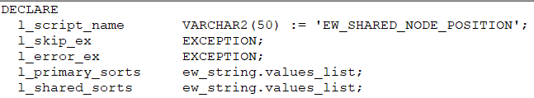

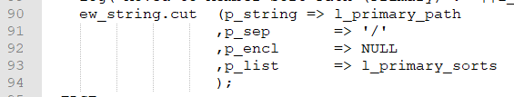

SPLIT_NUMERIC String

If a string contains a numerical value but has either a prefix or suffix or both with some alphanumerical values, then this procedure will split into three parts and return three components in return values.

-- From a given string split numerical value and prefix and suffix values
-- For example,
-- AB1000 will return 1000, AB as prefix nothing for suffix
-- 1000CD will return 1000, nothing for prefix CD for suffix
-- 190000 will return 190000, nothing for both prefix and suffix
-- AB1000CD will return 1000, AB for prefix and CD for suffix
PROCEDURE split_numeric(p_str IN VARCHAR2
,x_number OUT NUMBER
,x_prefix OUT VARCHAR2
,x_suffix OUT VARCHAR2
);

REPLACE_ALPHA_STR
The purpose of this function is to remove Alphanumeric characters and return remaining characters from a string. One of the main purposes of this function is to determine whether a string has any special characters or not. For example, customers may prefer a member name or a description to have only Alphanumeric values and if they have any other characters then throw validation errors. This API can help build such validations.

/*
** replace_alpha_str - Replace Alpha chars from the string and Return Remaining Chars. Replace characters A - Z, a - z, 0 - 9 or _and space. Additionally specify chars that are to be removed, like # * $ and so on.
*/
FUNCTION replace_alpha_str (p_str IN VARCHAR2
,p_allow_space IN VARCHAR2 DEFAULT 'Y'
,p_repl_chars IN VARCHAR2 DEFAULT NULL
)
RETURN VARCHAR2;

KEEP_ALPHA_STR
The purpose of this function is to remove non-Alphanumeric characters and return remaining characters from a string. One of the main purposes of this function is to remove non-alphanumeric values from the given string.

/*
** keep_alpha_str - Replace non-Alpha chars from the string and return remaining Chars. Keep characters A - Z, a - z, 0 - 9 or _ and space. Additionally specify chars that are to be kept, like #*$ and so on.
*/
FUNCTION keep_alpha_str (p_str IN VARCHAR2
,p_allow_space IN VARCHAR2 DEFAULT 'N'
,p_keep_chars IN VARCHAR2 DEFAULT NULL
)
RETURN VARCHAR2;

APPEND_STR
The purpose of this function is to append a string to the given string and return a concatenated string. If the separator character is not provided, then comma will be used as a default separator character.

PROCEDURE append_str(p_add IN VARCHAR2
,x_str IN OUT VARCHAR2
,p_sep IN VARCHAR2 DEFAULT ','
);

GET_POSITION_IN_STR

The purpose of this function is to provide the position (Element #) of a string in a given string.

-- Get position of a string in a list
-- For example, A101,A102,A103 is a given string and we need to know in this list
-- position of A102 which is # 2
--
FUNCTION get_position_in_str (p_string IN VARCHAR2
,p_value IN VARCHAR2
,p_sep IN VARCHAR2 DEFAULT ','
,p_encl IN VARCHAR2 DEFAULT '"'
)
RETURN NUMBER;

COMPARE_VALUE

The purpose of this function is to compare values of two strings either numerically OR text basis and return Y or N. p_str1 is compared with p_str2 string. P_str2 can be a multi value string separated by a character (for example comma) and if that is the case p_str1 will be compared with each element of p_str2. For example, p_str1 => ‘A’ and p_str2 => ‘X,’Y,’A’.

FUNCTION compare_value (p_str1 IN VARCHAR2
,p_str2 IN VARCHAR2
,p_numerical IN VARCHAR2 DEFAULT 'N'
,p_case_match IN VARCHAR2 DEFAULT 'Y'
,p_sep IN VARCHAR2 DEFAULT NULL
,p_encl IN VARCHAR2 DEFAULT NULL
)
RETURN VARCHAR2;

Lookup Functions

Package: EW_GLOBAL

These functions can be referred to as ew_global.<Function Name>.

Get All Lookup Codes

/* Fetch all lookup codes of a given lookup type and return then in
comma (or any other char) separated list.
*/
FUNCTION get_lookup_codes_list
(p_name IN VARCHAR2
,p_enabled_only IN VARCHAR2 DEFAULT 'Y'
,p_sep IN VARCHAR2 DEFAULT ','
,p_encl IN VARCHAR2 DEFAULT NULL
)
RETURN VARCHAR2;

Get All Lookup Meanings

/* Fetch all lookup meanings of a given lookup type and return them in a comma (or any other char) separated list.
*/
FUNCTION get_lookup_meanings_list
(p_name IN VARCHAR2
,p_enabled_only IN VARCHAR2 DEFAULT 'Y'
,p_sep IN VARCHAR2 DEFAULT ','
,p_encl IN VARCHAR2 DEFAULT '"'
)
RETURN VARCHAR2;

Get Lookup meaning

FUNCTION get_lookup_meaning
(p_lookup_name IN VARCHAR2
,p_code IN VARCHAR2
)
RETURN VARCHAR2;

Get Lookup Code

FUNCTION get_lookup_code
(p_name IN VARCHAR2
,p_meaning IN VARCHAR2
,p_ignore_case IN VARCHAR2
)
RETURN VARCHAR2;

Get Lookup Tag

FUNCTION get_lookup_tag
(p_name IN VARCHAR2,
p_code IN VARCHAR2
)
RETURN VARCHAR2;

Get Lookup Description

FUNCTION get_lookup_description
(p_name IN VARCHAR2,
p_code IN VARCHAR2
)
RETURN VARCHAR2;

Get Lookup Display Sequence Number

FUNCTION get_lookup_disp_seq_number
(p_name IN VARCHAR2,
p_code IN VARCHAR2
)
RETURN VARCHAR2;

Check lookup code exists

-- check whether lookup code exists or not in a given lookup
-- Return Y or N
FUNCTION chk_lookup_code_exists
(p_name IN VARCHAR2
,p_code IN VARCHAR2
,p_ignore_case IN VARCHAR2 DEFAULT 'N'
)
RETURN VARCHAR2; --Y/N

Security API Functions

Package: EW_SEC_API

These functions can be referred to as ew_sec_api.<Function Name>.

The following table provides common use functions for various Security Module related actions:

Purpose | Function Name | Input Parameters | Output Parameters
Get Group names separated by comma in which contains given user | get_user_groups | User_id (if not passed then current logged in user id is used) | List of group names separated by commas which consist of user id.
Check if the user is in the given group name or not | is_user_in_group | Group Name (Required)  User ID (if not passed then current logged in user id is used) | Y if the user is in Group else N
Check if the user is Active or Disabled | chk_user_active | User Name (Required) | Y if the user is Active else N
Get Access Type for the Deployment module | get_dep_access_type | User ID (if not passed then current logged in user id is used) | R or W or N  R -> Read access  W -> Write access  N -> No access
Get Access Type for the Workflow module | get_wf_access_type | User ID (if not passed then current logged in user id is used) | R or W or N  R -> Read access  W -> Write access  N -> No access
Check if user has Read or Write access to Workflow module | chk_wf_access | User ID (if not passed then current logged in user id is used) | Y if user has access  N if user has no access
Check if user has Read or Write access to Deployment module | chk_dep_access | User ID (if not passed then current logged in user id is used) | Y if user has access  N if user has no access
Check whether the user has access to the App dimension or not. | chk_app_dim_access | App_id  App_dimension_id  User ID (if not passed then current logged in user id is used)  Access Type (Default is R)  Valid Values : R or W | Y if user has access  N if user has no access
Check whether the user has access to the Security Class or not | chk_sec_class_access | Security Class ID  User ID (if not passed then current logged in user id is used)  Access Type (Default is R)  Valid Values: R or W | Y if user has access  N if user has no access
Check if user has given role or not | chk_user_role | Role Type Code  R -> Requestor  V -> Reviewer  A -> Approver  D -> Default  User ID (if not passed then current logged in user id is used) | Y if the user has been assigned the role else N
Check whether Group has Read or Write access for given Security Class | chk_group_sec_class_access | p_sec_class_name p_group_name  p_access_type | Returns Y if the group has access, otherwise N.
Get User ID for a given user name | get_user_id | User Name | Function will return user id for a given user_name
Get User Name for a given user id | get_user_name | User ID | Function will return user name for a given user id

User Management Security APIs

Package: EW_SEC_API

These functions can be referred to as ew_sec_api.<Function Name>.

These functions in the Security API package will help automate various functions to manage and maintain Users/Groups and their assignments within the EPMware application.

All of these functions will return “Success” if the task is completed successfully. If not, then it will return “Error:<Error Message>”.

Purpose | Function Name | Input Parameters
Create new User | create_user | - User Name  - First Name  - Last Name  - Email Address  - Native Flag (Y/N) (If N then Password is not required as its MSAD or LDAP user)  - Password  - Description
Enable User | enable_user | - User Name
Disable User | disable_user | - User Name
Create New Group | create_group | - Group Name
Enable Group | enable_group | - Group Name
Disable Group | disable_group | - Group Name
Assign user to Group | assign_user_to_group | - User Name  - Group Name
Unassign user to Group | unassign_user_to_group | - User Name  - Group Name

Export API Functions

Package: EW_EXP_API

The purpose of this package is to run Export Profiles or Export Books.
For example, customer wants to run an Export when request reaches at a specific stage. More advanced customization requires these export files to be sent to external system like Databricks or AWS S3 bucket or SFTP server. Post Export Logic Scripts can help transfer export files, but submission of the Export itself will happen using these APIs as part of the custom workflow tasks.

-- Execute Export
PROCEDURE run_export
(p_user_id IN NUMBER
,p_name IN VARCHAR2 -- Export Profile Name
,x_task_id OUT NUMBER
,x_status OUT VARCHAR2 -- S or E
,x_message OUT VARCHAR2
);

-- Execute Export Book
PROCEDURE run_export_book
(p_user_id IN NUMBER
,p_name IN VARCHAR2 -- Export Book Name
,x_task_id OUT NUMBER
,x_status OUT VARCHAR2 -- S or E
,x_message OUT VARCHAR2
);

Agent API Functions

Package: EW_AGENT_API

The purpose of this package is to invoke custom agent scripts from the Logic Builder. Custom tasks in the workflow can leverage this API to execute certain commands on the remote server using the EPMware agent. This API you can also transfer/send files for servers which have On- Prem Agents as well as those which do not have agents but SSH is enabled on those servers and its username and password or Identity key is provided in EPMWARE.

Run Remote Script

These functions can be referred as ew_agent_api.exec_agent_cmd

Before calling this function the following prerequisites need to be satisfied:
- On the target server, add the name with the full path of the script to be executed by this remote agent in the file “ew_custom_agent_scripts.lst”. This file is located in the home directory of the EPMware target Agent.
- Commands passed to the Agent API entered in this file will be matched and if they exist it will be executed. This will prevent calling any unauthorized script from the Agent API.

For example, as shown below, “ew_test.sh” is a remote script that could be executed by the Agent API.

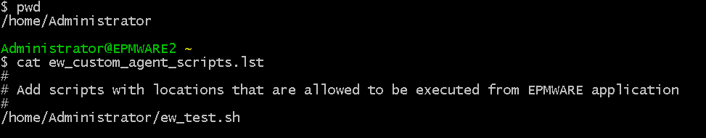.

exec_agent_cmd
(p_app_name IN VARCHAR2
,p_agent_cmd IN VARCHAR2
,p_agent_type IN VARCHAR2 DEFAULT 'D' -- Reserved
,p_send_files IN VARCHAR2 DEFAULT 'N'
,p_output_file_name IN VARCHAR2 DEFAULT NULL
,p_output_file_loc IN VARCHAR2 DEFAULT NULL
,p_dep_file_loc IN VARCHAR2 DEFAULT 'stage'
,p_agent_cmd_type IN VARCHAR2 DEFAULT NULL
,p_timeout_minutes IN NUMBER DEFAULT 15
,p_param_name_1 IN VARCHAR2 DEFAULT NULL
,p_param_value_1 IN VARCHAR2 DEFAULT NULL
,p_param_name_2 IN VARCHAR2 DEFAULT NULL
,p_param_value_2 IN VARCHAR2 DEFAULT NULL
,p_param_name_3 IN VARCHAR2 DEFAULT NULL
,p_param_value_3 IN VARCHAR2 DEFAULT NULL
,p_param_name_4 IN VARCHAR2 DEFAULT NULL
,p_param_value_4 IN VARCHAR2 DEFAULT NULL
,p_param_name_5 IN VARCHAR2 DEFAULT NULL
,p_param_value_5 IN VARCHAR2 DEFAULT NULL
,p_param_name_6 IN VARCHAR2 DEFAULT NULL
,p_param_value_6 IN VARCHAR2 DEFAULT NULL
,p_param_name_7 IN VARCHAR2 DEFAULT NULL
,p_param_value_7 IN VARCHAR2 DEFAULT NULL
,p_param_name_8 IN VARCHAR2 DEFAULT NULL
,p_param_value_8 IN VARCHAR2 DEFAULT NULL
,p_param_name_9 IN VARCHAR2 DEFAULT NULL
,p_param_value_9 IN VARCHAR2 DEFAULT NULL
,p_param_name_10 IN VARCHAR2 DEFAULT NULL
,p_param_value_10 IN VARCHAR2 DEFAULT NULL
,x_status OUT VARCHAR2
,x_message OUT VARCHAR2
);

Parameter Name | Expected Value | Required
p_app_name | Application Name | Yes
p_agent_cmd | Remote Script name with full path.  Note: This should match with the entry in the file “ew_custom_agent_scripts.lst” on the remote (Target) server. | Yes
p_agent_type | D (Reserved for future use) | Yes
p_send_files | N (Reserved for future use) | Yes
p_output_file_name | Name of the output file generated by the custom script.  Note: If value is not provided then default name will be generated based on TASK_ID and assigned. | No
p_output_file_loc | Location of the output file generated by the custom script  .  Note: If the value is not provided then the default location under “stage” folder will be used. | No
p_dep_file_loc | Stage (Reserved for future use) | No
p_agent_cmd_type | Agent Command Type (Reserved for future use) | No
p_timeout_minutes | Maximum Time (in Minutes) allocated for the Remote Agent script to complete its task. Default value is 15 minutes | No
p_param_name_<nn> | Parameter Name.  Note: Agent API Script will pass values for optional parameters. Parameter names are stored for audit purposes in EPMware. Only Values are passed. | No
p_param_value_<nn> | Parameter Value.  Note: Agent API Script will pass values for optional parameters. Parameter names are stored for audit purposes in EPMware. Only Values are passed. | No
x_status | RETURN Status code. S for success and E for Error | N/A
x_message | RETURN Error Message | N/A

Remote Custom Script requirements

Remote scripts will be passed the following parameters
- Fixed Parameters
  - Task ID (There will be a folder created under the stage folder on the remote server automatically with this task id as the folder name. This folder can be used to generate log or output files by the custom script if needed).
  - Application Type
  - Action (Fixed value passed: CUSTOM)
  - Application Name
  - Application Version
  - Application User Name
  - Application Password
- Script Parameters
  - Parameter values (1 to 10) passed to the Agent API

Send Files

Using ew_agent_api.send_files you can send files from EPMWARE to remote servers.
Pre-requisites
- Server has to be registered in the EPMWARE application under the Infrastructure/Servers page. If the server does not have an On-Premise Agent installed and configured then the Username and password or Identity Key should be provided.
- “Test Connection” should be successful before attempting to send files.

API : ew_agent_api.send_files

API Parameters

Parameter Name | Expected Value | Required
p_app_name | Application Name | Yes
p_server_name | Server Name (EPMWARE Name of the Servers ) | Yes
p_file_name | File Name to be sent | Yes
p_file_data | File Data to be sent (BLOB type) | Yes
p_remote_loc | Remote Location where file to be saved | No
x_agent_task_id | RETURNS Agent Task ID | N/A
x_status | RETURN Status code. S for success and E for Error | N/A
x_message | RETURN Error Message | N/A

Get Files

Using ew_agent_api.get_files you can retrieve files from remote servers.

Pre-requisites:
- Server has to be registered in the EPMWARE application under the Infrastructure/Servers page. If the server does not have an On-Premise Agent installed and configured then Username and Password or Identity Key should be provided.
- “Test Connection” should be successful before attempting to send files.

API : ew_agent_api.get_files

API Parameters

Parameter Name | Expected Value | Required
p_app_name | Application Name | Yes
p_server_name | Server Name (EPMWARE Name of the Servers ) | Yes
p_file_wildcard | Files to be retrieved matching this wildcard (Use * as a wildcard) | Yes
p_remote_loc | Remote Location where file to be saved | No
p_delete_after_receive | Should files be deleted after successfully retrieving (Default is N) | Yes
p_archive_loc | Directory where files are archived on the remote location after successfully retrieving (if Delete is not enabled). This is an optional parameter. | No
x_file_count | RETURNS # of files retrieved | N/A
x_files_tbl | RETURNS List of files retrieved  Data Type is ew_agent_api.g_files_tbl  This is a table of Records.  Record fields are  File_name  File_data (BLOB)  file_id | N/A
x_agent_task_id | RETURNS Agent Task ID | N/A
x_status | RETURN Status code. S for success and E for Error | N/A
x_message | RETURN Error Message | N/A

Execute Deployment

Using ew_agent_api.exec_direct_deploy API Direct Deployment can be triggered for a dimension and optionally for a request, request line. Example, if user wants to run an Export and use files generated by Export as a source for deployment then this API becomes useful. Another example is if users want to deploy metadata to a specific application from the custom task in a workflow.

Pre-requisites:
- Deployment Manager already exists as specified in the parameter.

API : ew_agent_api. exec_direct_deploy

PROCEDURE exec_direct_deploy
(p_app_name IN VARCHAR2
,p_app_dimension_id IN NUMBER DEFAULT NULL
,p_request_line_id IN NUMBER DEFAULT NULL
,p_dep_file_name IN VARCHAR2
,p_dep_file_data IN BLOB
,p_override_agt_params IN ew_global.g_value_tbl
,p_dep_config_name IN VARCHAR2
,p_user_id IN NUMBER
,x_deployment_id OUT NUMBER
,x_status OUT VARCHAR2
,x_message OUT VARCHAR2
);

API Parameters

Parameter Name | Expected Value | Required
p_app_name | Application Name | Yes
p_app_dimension_id | Dimension ID (Can be Null) | No
P_request_line_id | Request Line ID (Can be Null) | No
P_dep_file_name | Deployment File Name | Yes
P_dep_file_data | Deployment File Data (BLOB type) | Yes
P_override_agt_params | Override Default Agent Parameters that are used for Direct Deployment of the Application  (Can be Null) | Yes
P_user_id | User ID for audit trail | Yes
x_deployment_id | RETURN Deployment ID submitted by the API | N/A
x_status | RETURN Status code. S for success and E for Error | N/A
x_message | RETURN Error Message | N/A

Example: In this example, whenever an export is executed for one of the OneStream dimension for specific members of a dimension then it should automatically load that exported metadata into a custom table in OneStream application.
This script registered as a “Post Export Generation Tasks” Logic Script once attached to a specific Export will invoke this Direct Deploy API. It is assumed that OneStream Business Rule is already created in the OneStream Application.

/*
Author : Deven Shah
Purpose : Export Metadata to Custom Table after Export is executed
History
--------------------------------------------------------------------
Date | By | Notes
--------------------------------------------------------------------
19-May-25 | Deven| Initial Version
*/
DECLARE
c_script_name VARCHAR2(50) := 'EW_SPEND_EXPORT_TO_CUSTOM_TABLE';
c_exp_id NUMBER := ew_lb_api.g_exp_id;
c_dep_config_name VARCHAR2(100) := 'OS_Export_Custom_Table';
c_os_dm_sequence_step VARCHAR2(100) := 'EPMWARE_LOAD_CUSTOM_TABLE';
--
l_message VARCHAR2(2000);
l_status VARCHAR2(1);
l_deployment_id NUMBER;
l_override_agt_params ew_global.g_value_tbl;
--
CURSOR cur_exp
IS
SELECT c.app_name,e.output_file, e.output_file_name,e.created_by
FROM ew_exp_executions e
,ew_exp_config_dims_v c
WHERE 1=1
AND e.exp_config_id = c.exp_config_id
AND e.exp_id = c_exp_id
;
PROCEDURE log(p_msg IN VARCHAR2)
IS
BEGIN
ew_debug.log(p_msg,ew_debug.show_always,c_script_name);
END;
BEGIN
ew_lb_api.g_status := ew_lb_api.g_success;
ew_lb_api.g_message := NULL;

l_override_agt_params('OS_BIZ_RULE_SEQUENCE_NAME') := c_os_dm_sequence_step;
FOR rec IN cur_exp
LOOP
ew_agent_api.exec_direct_deploy
(p_app_name => rec.app_name
,p_app_dimension_id => NULL
,p_request_line_id => NULL
,p_dep_file_name => rec.output_file_name
,p_dep_file_data => rec.output_file
,p_override_agt_params => l_override_agt_params
,p_dep_config_name => c_dep_config_name
,p_user_id => rec.created_by
,x_deployment_id => l_deployment_id
,x_status => l_status
,x_message => l_message
);
ew_debug.log('Deployment : '||l_deployment_id|| ' ' ||
l_status||' '||l_message);
END LOOP;
END;

Appendix A

Request Line Action Codes

The following is a list of Hierarchy Action codes that can be referenced in various Logic Scripts such as Dimension Mapping and Pre/Post Hierarchy Actions.

Action Code | Action Name
CMC | Create Member - As Child
CMS | Create Member - As Sibling
DM | Delete Member
RM | Rename Member
ISMC | Insert Shared Member - As Child
ISMS | Insert Shared Member - As Sibling
P | Edit Properties
ZC | Move Member
RC | Reorder Children
RSM | Remove Shared Member
AC | Activate Member
IC | Inactivate Member

Appendix B - Out of the box Logic Scripts

Standard Validation Scripts

This section will provide a list of all standard validation Logic Scripts that are supplied as out of the box Logic Scripts and also get automatically assigned when their corresponding applications are registered in EPMWARE.

Note: If you need to modify any of these scripts, either create a new one by making a copy of it or create a new one with additional logic in it. It is possible that EPMware updates or Patch releases may modify these scripts in future releases.

Standard Property Validations

The following Logic Scripts are of “Property Validation Types” and are automatically assigned to the Applications as soon as they are registered under Application Configuration page.

Logic Script Name | Application Types
EW_ESSBASE_VALIDATIONS | Essbase (On Prem and Cloud)
EW_HFM_VALIDATIONS | HFM
EW_HP_VALIDATIONS | Planning (On Prem and Cloud)
EW_PCMCS_VALIDATIONS | Oracle PCMCS Cloud
EW_TRCS_VALIDATIONS | Oracle TRCS Cloud
EW_FDMEE_VALIDATIONS | Oracle FDMee (OR Data Management)
EW_FUSION_VALIDATIONS | Oracle EBS (Fusion)
EW_ONESTREAM_VALIDATIONS | OneStream Applications (On Prem and Cloud)

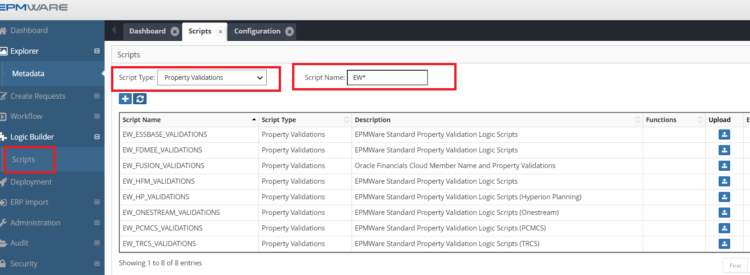

Pre-Hierarchy Action Logic Scripts
The following Logic Scripts are of “Pre-Hierarchy Action Types” and are automatically assigned to the Essbase Applications as soon as they are imported into EPMWARE. The purpose of this Logic Script is to ensure Shared Nodes do not come prior to its Primary instance in the hierarchy.

Script : EW_SHARED_NODE_POSITION

Application Types: Essbase (On Prem and Cloud), Planning, PBCS

Purpose : Check whether a Shared Instance of a member comes before to its Primary instance.

Configuration: This script gets assigned automatically to all dimensions of Essbase and Planning applications when these applications are imported into EPMWARE. Please see below an example of an assignment of this configuration.

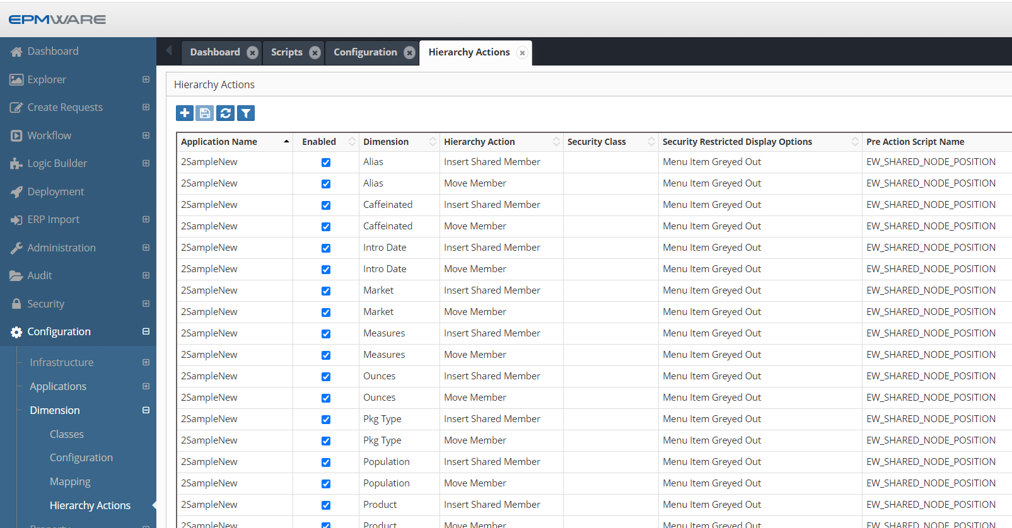

Script: EW_ONESTREAM_SHARED_NODE_CHECK

Application Types: OneStream

Purpose: Logic Script “EW_ONESTREAM_SHARED_NODE_CHECK” is a standard logic script and will be assigned automatically to all “Extended” dimensions of the OneStream when application is imported. This script will prevent users from creating a shared instance of a member in the extended dimension if that shared instance is not the one that belongs to the extended dimension itself.

Configuration: Assignment of this logic script to all Extended Dimensions.

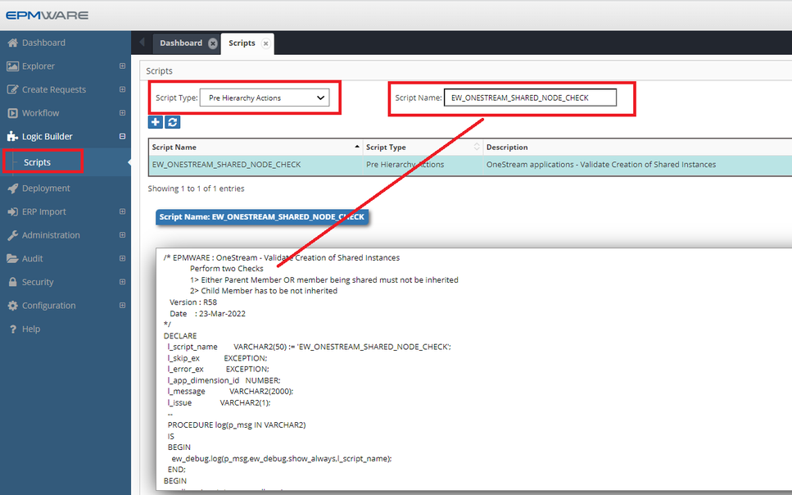

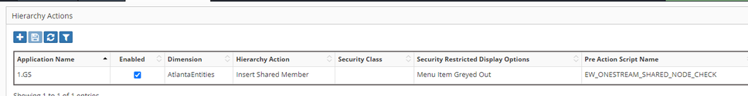

Post-Hierarchy Action Logic Scripts

The following Logic Scripts are of “Post Hierarchy Action Types” and are not automatically assigned to the target Applications. They need to be assigned manually if required..

Script : EW_EB_DATA_STORAGE_PROP

Application Types: Essbase (On Prem and Cloud)

Purpose : For Essbase applications, ensure the “Data Storage” property is “Dynamic Calc” as soon as a Base member becomes a Parent Member.

Configuration: A Manual Configuration step is required as shown below:

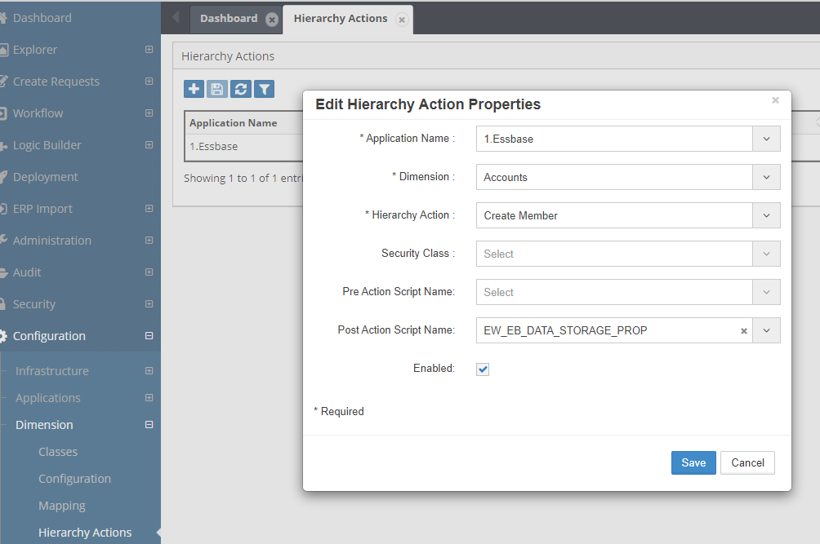

Script : EW_HFM_ENT_SEC_CLASS_AUTOMATION

Application Types: HFM

Purpose : Automatically create Security Classes for Entities. This script is provided as an example only. In this script it is assumed that the user wants to create new security class for all new entities which conform to the syntax E#####. (E followed by a 5 digit numerical value).

Note : Clone this script and modify as needed. Assign this script to the Hierarchy actions such as “Create Member”.

Configuration: A Manual Configuration step is required as shown below:

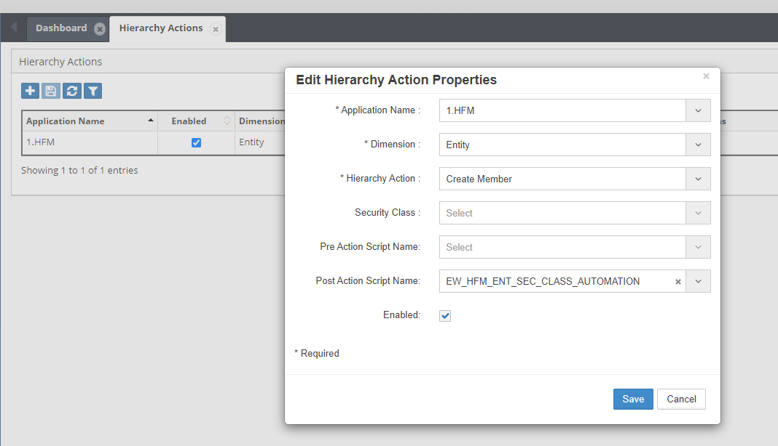

Appendix C - ERP Import table EW_IF_LINES

This table can be referred to by Pre / Post ERP Import Logic scripts for adding custom logic based on the data uploaded by either file (using REST API) or direct insert into this table (for On Premise customers). Columns which are marked Yes for “System Managed” can be ignored by the developer as ERP Import engine will manage values in those columns.

Column(s) | Required | System Managed | Description | Example
NAME | Yes |  | ERP Import Name | EW_LOAD_EMPLOYEES
STATUS | Yes |  | Status of Records  N for New Records | N
IF_LINE_ID |  | Yes
IF_CONFIG_ID |  | Yes
IF_EXEC_ID |  | Yes
MESSAGE |  | Yes
REFERENCE_NUMBER |  |  | Future use
REQUESTOR_USER_NAME |  | Yes | ERP Import Header level Mapping can provide value for this column
REQUESTED_BY |  | Yes | System will assign user id of the requestor
REQUEST_ID |  |  | If one request is being created then this column hold request id
REQUEST_DATE |  |  | Request Date (in case new request is being created)
DUE_DATE |  |  | Due Date (in case new request is being created)
DESCRIPTION |  |  | Description (in case new request is being created)
UDF1 to UDF3 |  |  | User Defined Fields (1 to 3) (in case new request is being created)
LINE_NUM |  |  | Either system assigned OR user assigned request line numbers
ACTION_CODE | Yes |  | Either mapping assigns value for the Hierarchy Action Code in this column or Logic builder API assigns it (Mapping type Import for Action Code)  Refer to the Next Section for list of Action Codes
PARENT_MEMBER_NAME |  |  | Specify Parent member
MEMBER_NAME |  |  | Specify member name
PREV_SIBLING_MEMBER |  |  | Specify Previous Sibling Member name
MOVED_TO_PARENT_MEMBER |  |  | For “Move Member’ action this is a required column
APP_DIMENSION_ID |  | Yes | Dimension ID auto populated for each row by the system
MEMBER_ID |  | Yes | Member ID
PARENT_MEMBER_ID |  | Yes | Parent Member ID
PREV_SIBLING_MEMBER_ID |  | Yes | Member ID of the Previous Sibling member
MOVED_TO_MEMBER_ID |  | Yes | Member ID of the Moved to member Name
PROPERTY1 to PROPERTY30 |  |  | 30 Properties user can populated with values
NEW_MEMBER_NAME |  |  | New Member Name for Rename Action Code
SORT_ORDER |  |  | Assign new Sort order of the node
TASK_ID |  | Yes | System will assign runtime Task ID
FILE_NAME |  |  | If ERP Import is run by users uploading file then its file name is saved for each line in this interface table

